Smart Professional Surveillance System User’s Manual

Version 1.16.0
Table of Contents
1. Overview and Environment 1
1.1 Overview 1
1.2 Performance 1
1.3 Environments 1
2. Installation and Upgrade 2
2.1 Installation 2
2.2 Un-installation 5
3. Setting 7
3.1 Login Interface 7
3.2 Homepage 8
3.3 General 8
3.3.1 File Path 10
3.3.2 Alarm 11
3.3.3 Version 12
3.4 Account 12
3.4.1 Add role 12
3.4.2 Add user 14
3.5 Device Manager 15
3.6 Device CFG 20
3.6.1 General 20
3.6.1.1 Network 20
3.6.1.2 Remote 21
3.6.1.3 Encode 23
3.6.1.4 Image 26
3.6.1.5 PTZ Control 26
3.6.2 Event 27
3.6.2.1 Video Detect 27
3.6.2.2 Alarm 31
3.6.2.3 Abnormality 35
3.6.2.4 Smart Config 38
3.6.3 Record/Storage 42
3.6.3.1 Schedule 42
3.6.3.2 Disk 44
3.6.4 Maintenance 46
3.6.4.1 Account 46
3.6.4.2 Maintenance 49
3.6.4.3 WEB 52
3.7 Alarm Setup 53
3.7.1 Set Alarm Scheme 53
3.7.2 Enable/Disable/Export Scheme 58
3.8 Tour &Task 58
3.9 PC-NVR 61
3.10 Video Wall Configuration 65
4. Basic Operation 69
4.1 Liveview 69
4.1.1 Real-time Liveview 69
4.1.2 Record 72
4.1.3 Snapshot 72
4.1.4 E-Map 73
4.1.4.1 Edit E-Map 73
4.1.4.2 Preview E-Map 75
4.1.5 Fisheye 79
4.1.6 Smart Alarm 79
4.1.7 Smart Track 84
4.1.8 PTZ 87
4.1.8.1 Preset 88
4.1.8.2 Tour 89
4.1.8.3 Pan 89
4.1.8.4 Scan 90
4.1.8.5 Pattern 90
4.1.8.6 Aux 90
4.2 Playback 90
4.2.1 Playback Device Record 92
4.2.2 Playback Local Record 96
4.2.3 Export 96
4.2.4 Fisheye Playback 97
4.3 Alarm Manager 98
4.4 Video Talk 100
4.4.1 VTS Center 100
4.4.2 Monitor 101
4.4.3 Talk 102
4.4.4 Announcement 107
4.4.5 Info Search 108
4.4.6 Issue Card 109
4.5 Access 111
4.5.1 Console 111
4.5.1.1 Organizations/Zones 112
4.5.1.2 List/View 116
4.5.1.3 Event 119
4.5.2 User Management 119
4.5.2.1 Department Management 120
4.5.2.2 User Management 121
4.5.3 Permission Management 126
4.5.3.1 Door Group Right 126
4.5.3.2 User Right 129
4.5.3.3 First Card Unlock 130
4.5.3.4 Multi-door Lock 131
4.5.3.5 Anti-pass Back 132
4.5.3.6 Inter-door Lock 133
4.5.3.7 Remote Verification 134
4.5.3.8 Period Setup 134
4.5.3.9 Holiday Setup 135
4.5.4 Event Configuration 136
4.5.5 Log 140
4.5.6 Attendance 141
4.5.6.1 Attendance 141
4.5.6.2 User Shift 144
4.5.6.3 Report Search 147
5. Extension 148
5.1 Video Wall 148
5.2 Data Report 149
5.3 Log 150

Welcome
Thank you for using our Smart Professional Surveillance System (SmartPSS)!
This user’s manual is designed to be a reference tool for operation of your system.
Here you can find detailed operation information about SmartPSS.

Overview and Environment

Overview
SmartPSS is an abbreviation for Smart Professional Surveillance System.
The software is to manage small quantity security surveillance devices. It releases with the device and does not support the products from other manufacturers. It has the following features:
- View real-time video of several camera channels.
- View the playback video files from various cameras.
- Support multiple scheduled arms to realize auto PC guard.
- Support e-map; you can clearly view and manage all device locations.
- Video wall plan setup and can output video wall video at the same time.
- Support extension applications, can send out alarm information to external programs.

Performance
- System max supports 36-channel at CIF resolution.
- Each storage server max supports to save 32-channel video

Environments
For PC there SmartPSS is installed.
Item | Requirements
OS | Windows XP and higher.
CPU | Intel core i3 or higher.
Display card | Intel HD Graphics and higher.
Memory | 2GB or higher.
Displayer Resolution | 1024×768 or higher.

Installation and Upgrade

Installation
- Double click “Smart-PSS_Eng_IS_VX.XX.X.exe” to begin installation. See Figure 2-1.
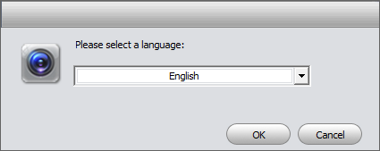
Figure 2-1
- Select installation language from the dropdown list and then click OK button to go to Welcome interface. See Figure 2-2.
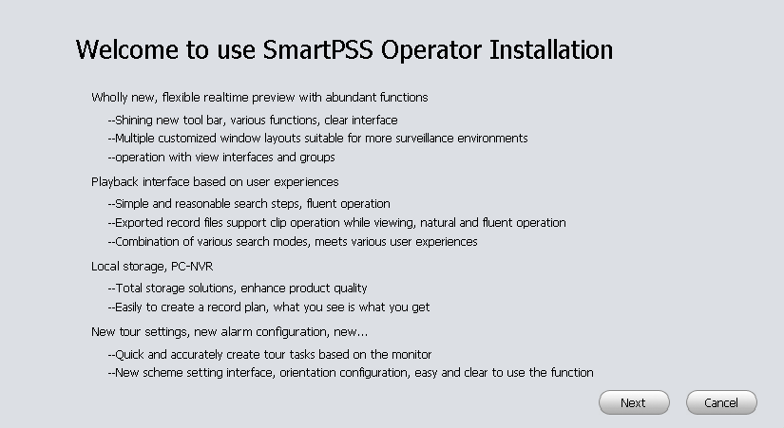
Figure 2-2
- Click next button, you can see an interface is shown as in Figure 2-3. Here you can view End User License Agreement.
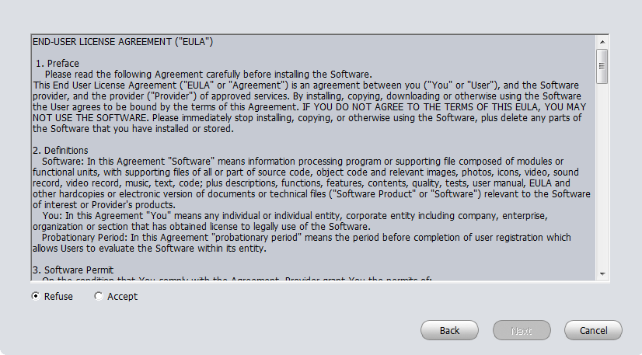
Figure 2-3
- Please check the Accept item and then click Next button to continue. System pops up module installation dialogue box. See Figure 2-4.

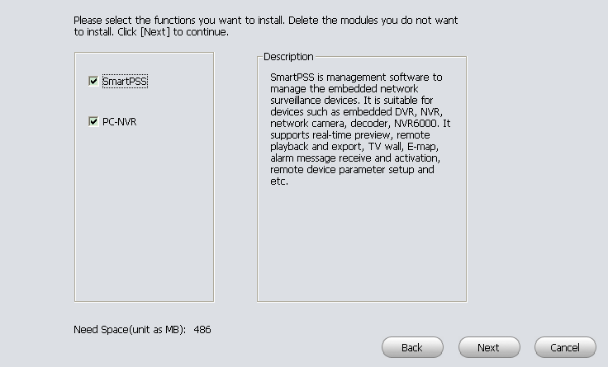
Figure 2-4

- Check SmartPSS item and then click Next button, you can see there is an interface asking you to specify installation path. See Figure 2-5.
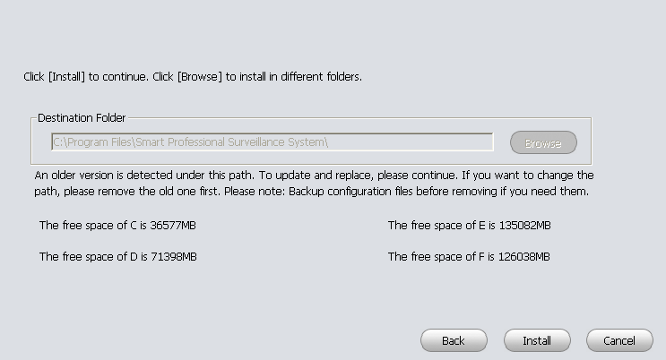
Figure 2-5
- After you select installation path click Next button, system begins installation. The interface is shown as in Figure 2-6.
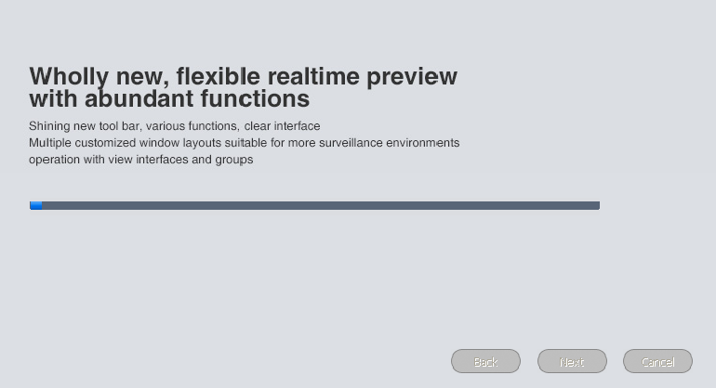
Figure 2-6
- During the installation process, you can click Cancel button to exit. After installation, you can see an interface is shown as below. See Figure 2-7.
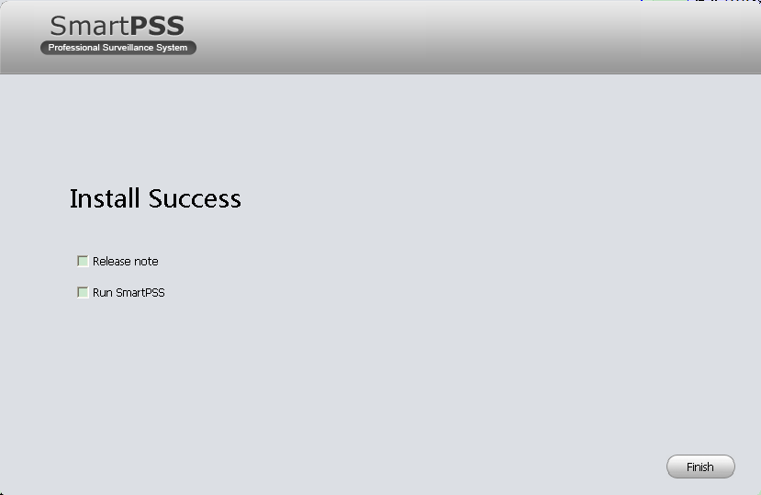
Figure 2-7
- Click Finish button, you can complete the installation.

Un-installation
- From Start -> All programs->SmartPSS, select Uninstall SmartPSS item. System pops up the following dialogue box. See Figure 2-8.
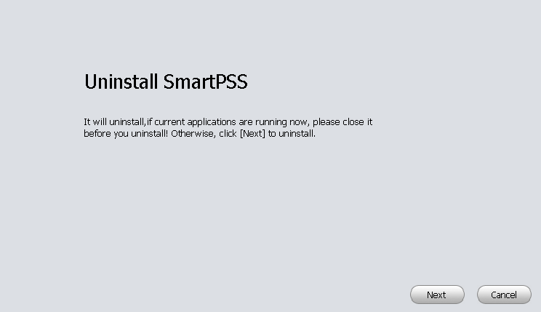
Figure 2-8
- Click Next button, you can see an interface shown as in Figure 2-9.
- Check the box here to remove SmartPSS. You can check the box to remove PC-NVR too. Click Uninstall button to remove.
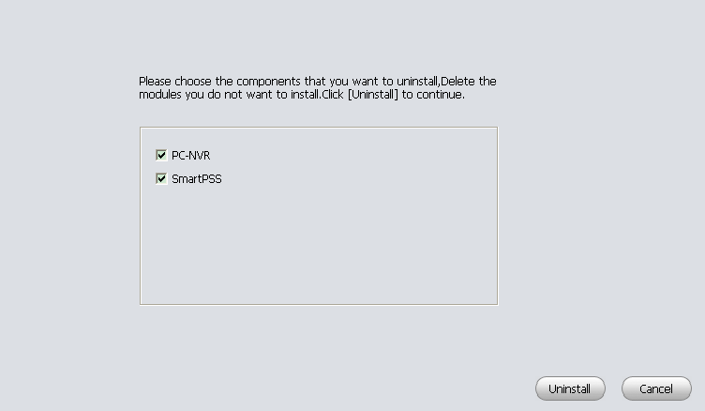
Figure 2-9

Setting
Double click SmartPSS icon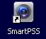, you can go to the login interface.

Login Interface
Login interface is shown as in Figure 3-2.
- User name: Input the user account
- Password: Please input corresponding password to log in.
- OK: Click this button, system can verify the account and then enter the software homepage. (First time login shows device interface.)
- Cancel: Click this button to exit login interface.
Note:
- If it is your first time to run the SmartPSS program, you need to set admin password, see Figure 3-1.
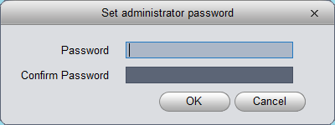
Figure 3-1

- System initial username is “admin”, but initial password is set by user.
- You can memory your password, so that when you can log in the next time, you do not need to input user name and password. Please note this function is for your convenient only. Do not enable this function in public PC.
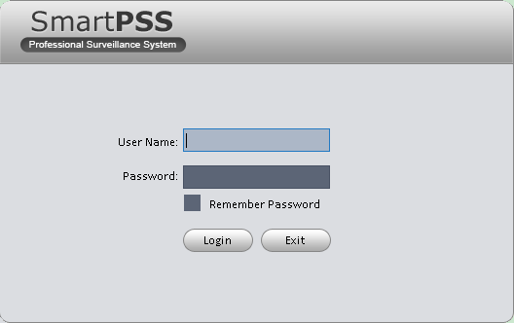
Figure 3-2

Homepage
Click Login button, system begins verifying user name and password and then go to the homepage. See Figure 3-3.

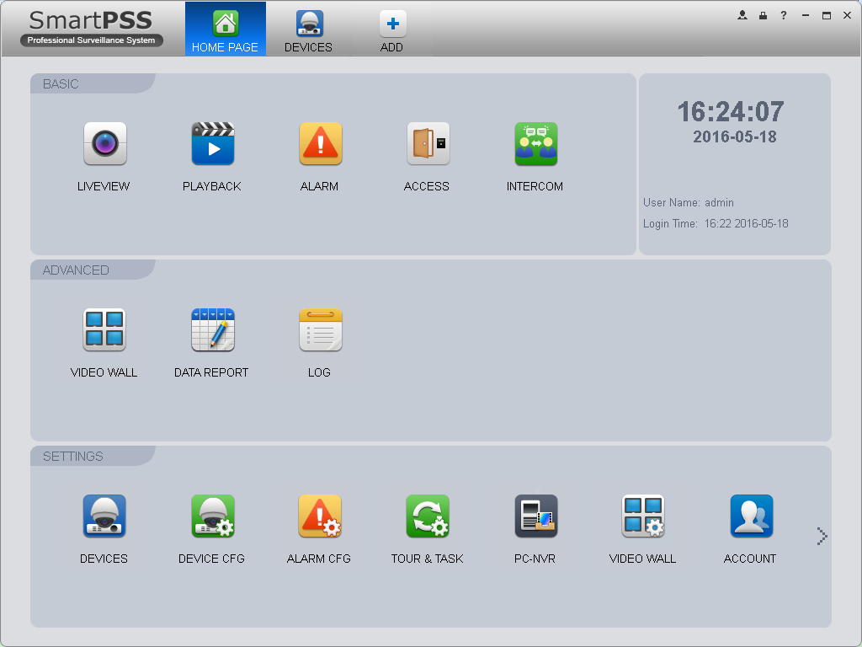
5
4
3
2
1
Figure 3-3
Please refer to the following sheet for detailed information.
SN | Parameter | Function
1 | Menu | Here you can view main page icons and current open function icon.  Click add button to add a function icon on the top pane.
2 | Basic | It includes live view, playback, alarm manager, access control and video intercom.
3 | Extension | It includes video wall, data report, and log search.
4 | Settings | It includes devices manager, signals manager, alarm setup, tour and task, PC-NVR, video wall management, account, general setup and etc.
5 | SmartPSS basic information | It is to display current time, username, login time.

General
If it is your first time to login the SmartPSS, you need to set system parameter. It includes network performance, log save time, login SmartPSS or not, picture and record saved path. Please follow the steps listed below.
Click the  button; you can go to the general interface. See Figure 3-4.
It is to set capability, language, time and etc.
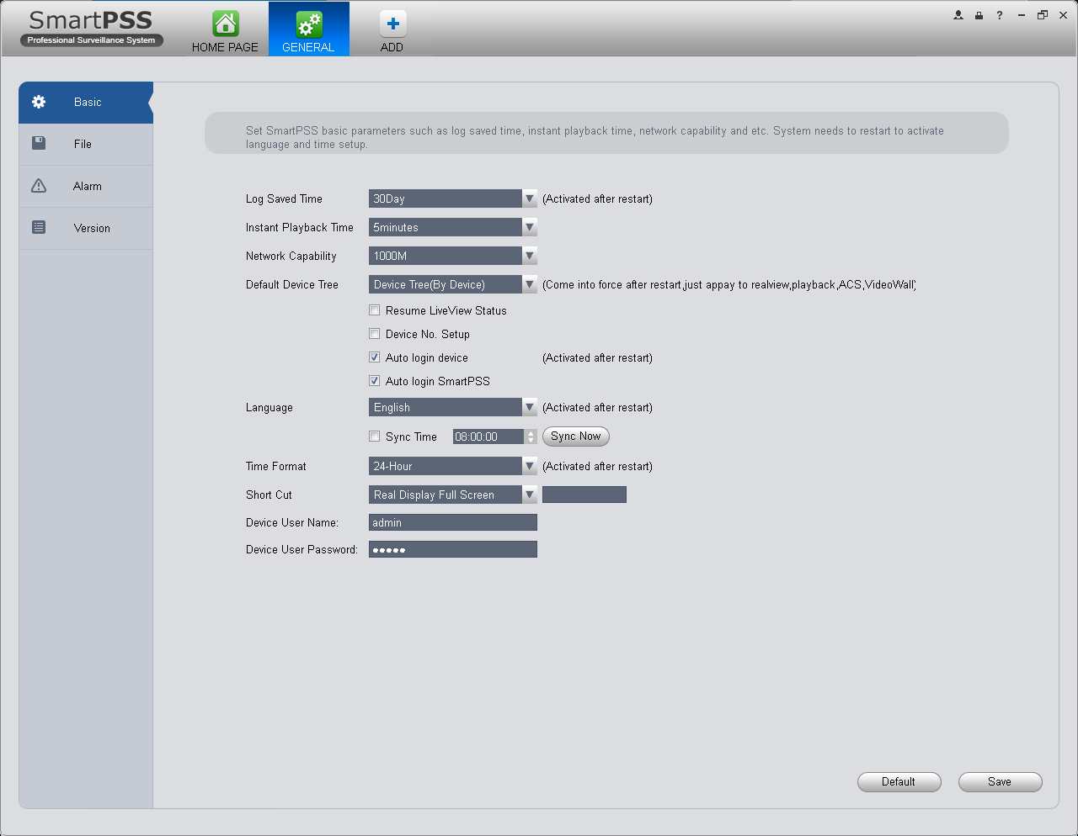
Figure 3-4
Please refer to the following sheet for detailed information.
Item | Function
Log Saved Time | Here you can set log save time. System automatically overwrites old files once it reaches the period you set here.
Instant Playback Time | It is to set instant playback time. If you set 5 minutes, then it plays video starting 5 minutes prior to current time.
Network capability | It is for you to set network function. It includes: “Low”, “10M”, ”100M”, ”1000M”.
Default Device Tree | Set device tree display of preview, playback access control and other modules.  Device tree（by device）as group by device.  Region/Tree （by channel） as group by channel.
Resume Previous State | System restores previous liveview status after it restarts.
Device No. Setup | Customize no. for video channel with device, when NKB is connected, you can open video channel according to your customized channel no.
Auto login device | When program start up, auto login existing device or not. If you select this parameter, then at next login, it auto logs in existing device.
Auto login SmartPSS | Check the box here, you can login SmartPSS directly without inputting user name and password.
Language | Software language.
Sync time | Check the box here to enable time synchronization function and then input synchronization time. SmartPSS can auto synchronize time with the PC at the time you specified.  Click Sync now button to begin synchronization now.
Time Format | System time format. It includes 12H/24H.
Short Cut | Set preview window, record playback, alarm management, e-map and etc.
Device User Name | Set device login username.
Device User Password | Set login password.

File Path
File configuration interface is shown as below. See Figure 3-5.
Here you can set snapshot picture and record file default save path.
Configuration file path: It is to import or export configuration file. If you change path to D disk, you can export current software user information to D disk. If current software has installed at the D disk, you can import user information to current software.

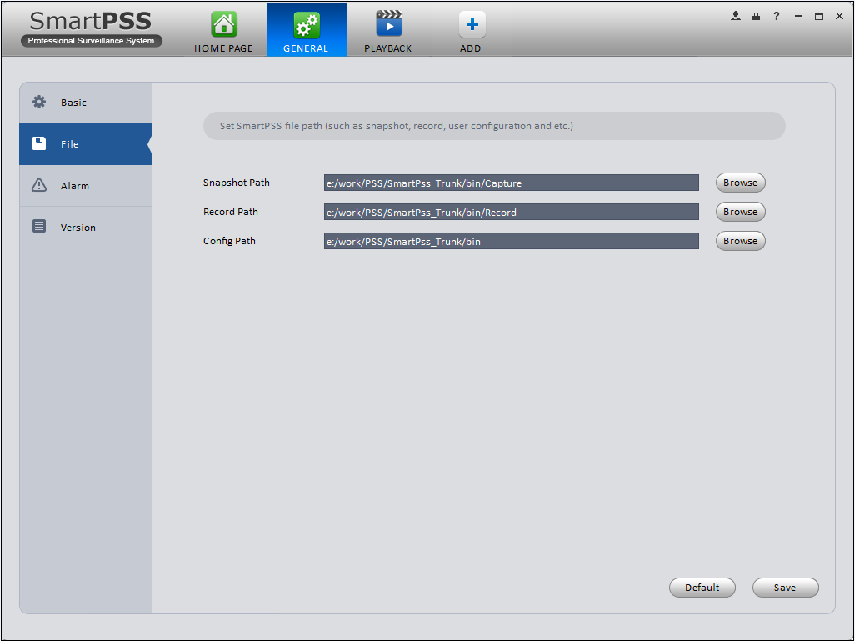
Figure 3-5

Alarm
It is to set alarm prompt audio. The interface is shown as below. See Figure 3-6.
Configure alarm type prompt. Click Save.
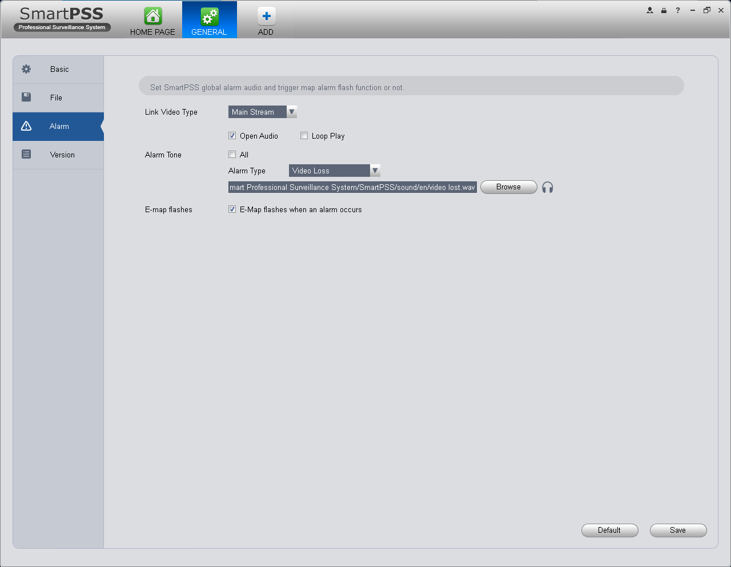
Figure 3-6
Tips
You can click Default button to restore factory default setup.
User config file storage path is used to import and export user config file. If current user config file storage path is modified to other path, then it means all users’ config info are exported. If user re-install, he can export previous all user’s config info to current client.

If he re-install the software and import previously exported user config info, after being saved, original user config info will be successfully imported into current client.

Version
Click the version button; you can go to the following interface.
Here you can view software version information.

Account
Here you can add, modify or delete a user.

Add role
- Click  in the Settings pane, and then click role button, you can go to the following interface. See Figure 3-7.
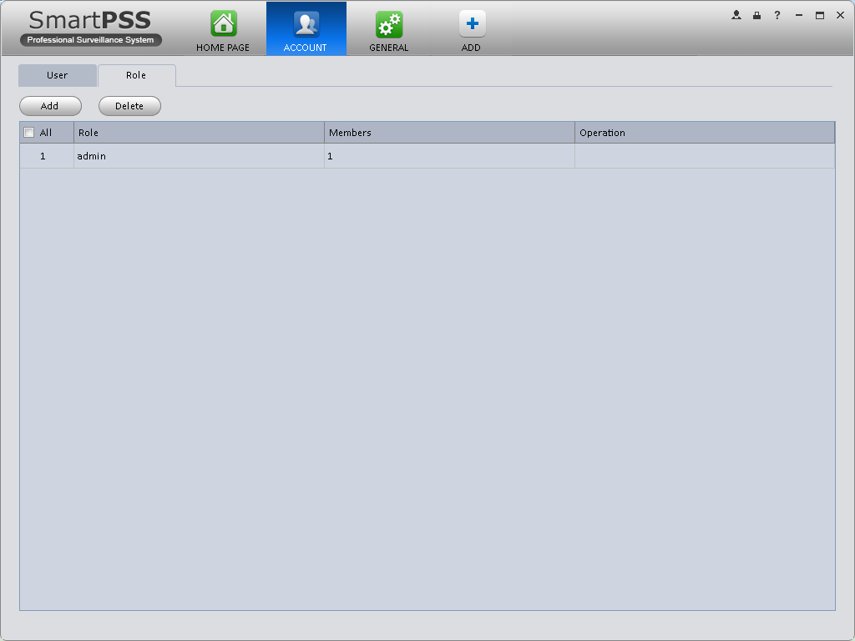
Figure 3-7
- Click Add button, the interface is shown as in Figure 3-8.
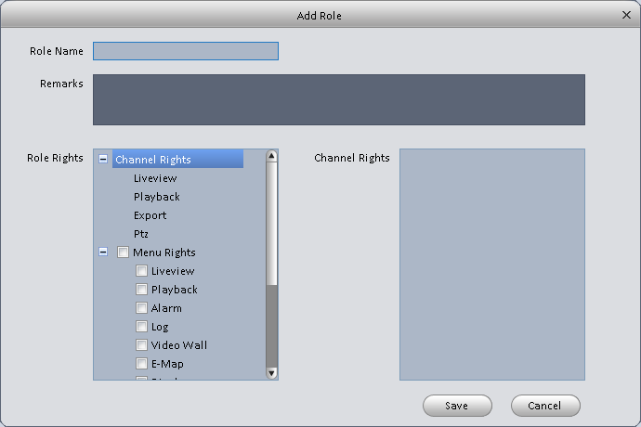
Figure 3-8

- Please input a role name and check the corresponding role rights. You can input some reference information if necessary.
- Click Save button.
Tips
Select a role and then click Modify/Delete button to modify or delete a role.

Add user
- Click in the Settings pane, and then click user button, you can go to the following interface. See Figure 3-9.
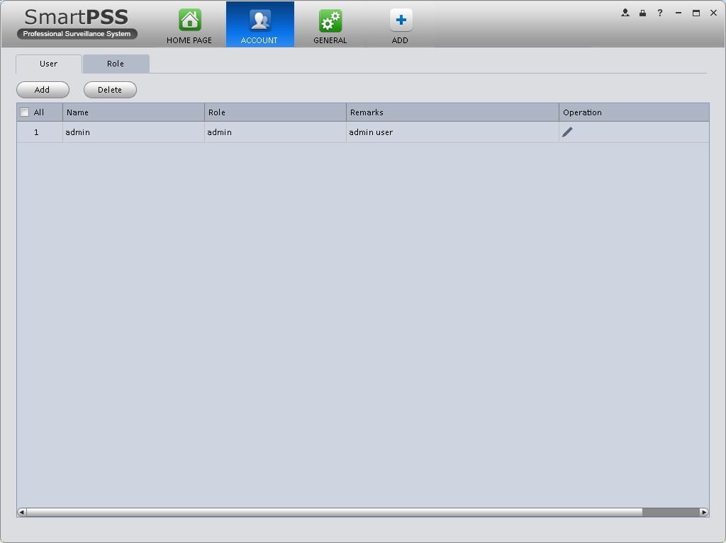
Figure 3-9
- Click Add button, you can see system pops up the following interface. See Figure 3-10.
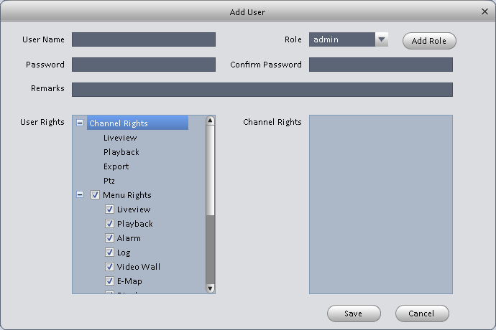
Figure 3-10
- Select a role from the dropdown list, input user name, password and confirm password. Input some description information if necessary. Select rights for the new user.
- Click Save button to add a new user.
Please refer to the following sheet for detailed information.
Item | Function
User name | Please input user name here.
Role | You can select user role from the dropdown list. Or you can click Add role button to add a new role.
Password | Please set user password.
Confirm password | Please input new password again.
User Rights | Here you can check the box to select corresponding rights for current user.  If the new user is a manager, system checks all rights by default.

- Click Save button to add a new user.
Tips
Select a user name and then click Modify/Delete button to modify or delete a user.

Device Manager
Here you can add, modify and delete a device. You can also implement device channel group function.

Auto Add
- Click 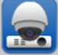 icon. System displays device manager interface.
- Click Refresh, search device within the LAN. You also can enter device segment, and click search to search devices within the same segment.
- Check device, click Add as auto add device. You also can double click the device you want to add. The added device will be shown in list below, where you can view device type, channel and status. You can modify, logout and delete the device.

Manually Add

You can refer to the steps listed below to add, modify or delete a device manually or automatically.
- Click 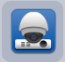 icon in the settings pane, system goes to the device manager interface; you can see an interface is shown as in Figure 3-11.
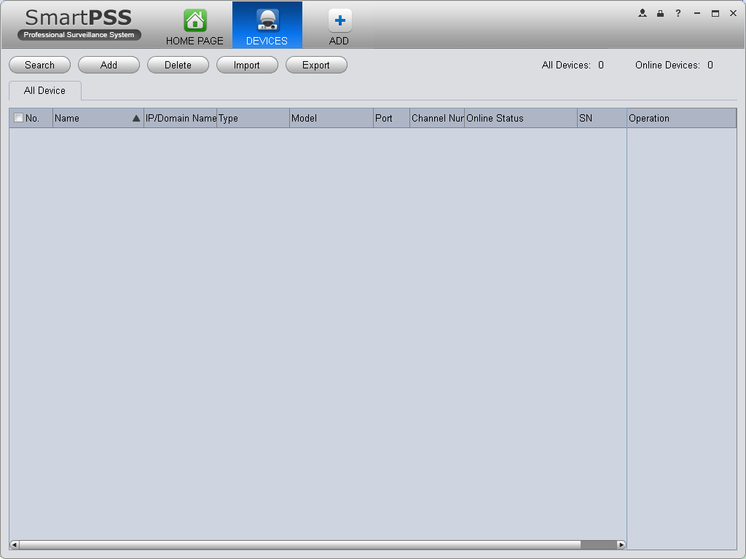
Figure 3-11

- Click Manual Add button, the interface is shown as in Figure 3-12. Please input the corresponding information and then click Add button.
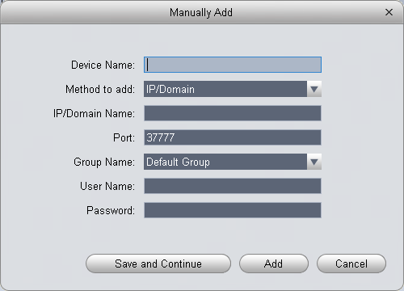
Figure 3-12
Please refer to the following sheet for detailed information.
Item | Function
Device name | Please input a device name here.
Register Mode | By IP/domain and SN.
IP/Domain name | Device IP address or domain name.  Note:  You can add device of IPV6 address.
SN | Device SN.  Note:  For P2P device only.
Port | Device IP port.  It is 37777 by default.
Group Name | You can choose one group.
User name | The user name you login the device.
Password | The password you login the device.
- Click Add. You can click Save and Continue to add next device. Added devices are shown as in Figure 3-14.

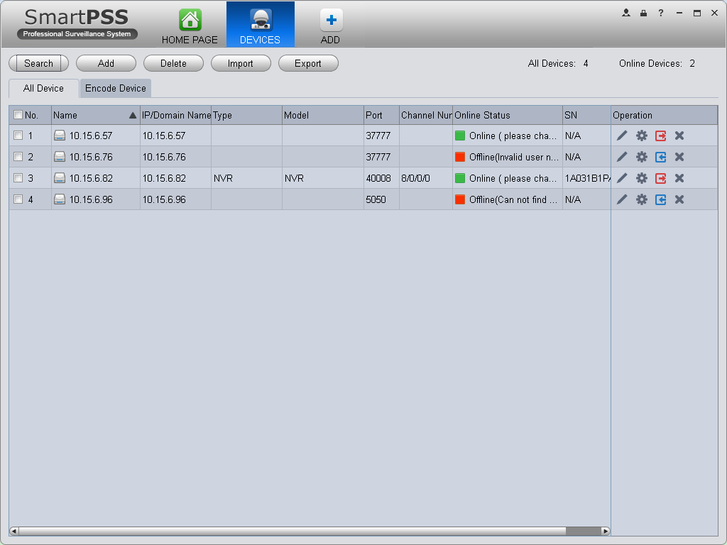
Figure 3-13

Tips

Select a device in the list, and then:
- Click to modify, or click to delete it.
- Click to set device.
- Click to login the device manually.
- Click to logout the device manually.
- Click button and then select save path to save current device list to .xml file.

- Click Import to batch import local config in .xml format. Or you can import with Easy 4IP account. See Figure 3-15.
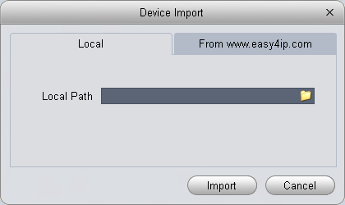
Figure 3-14
If the system config enables device no. setup, then you can see in operation column of device.
- Click , system pops up device no. setup box, see Figure 3-16.
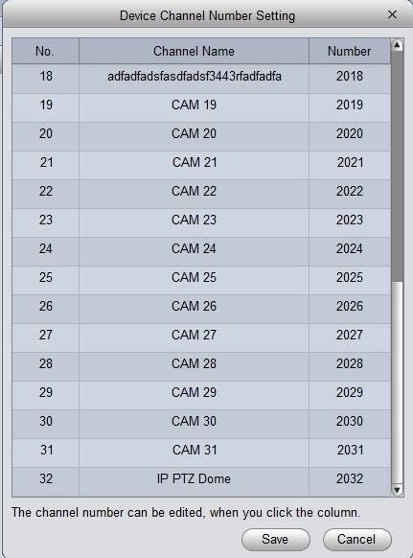
Figure 3-15
- Click list, you may edit/input no., see Figure 3-17.
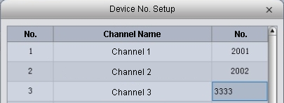
Figure 3-16

NKB keyboard can encode channel and control channel, as it can directly open channel video by encoding. For more information, please refer to NKB user’s manual.

Device CFG
After you added a new device, you can go to the signals manager interface to set parameters. On the homepage, click 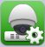 button in the Settings pane, you can go to the following interface. See Figure 3-17.
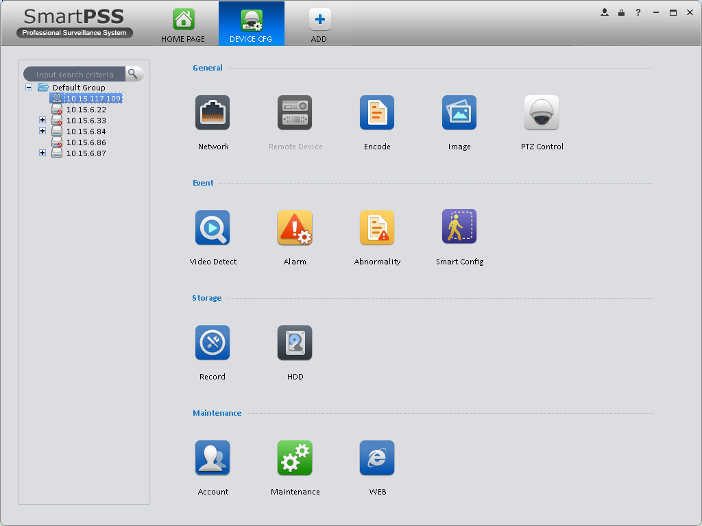
Figure 3-17

General

Network
Here is for you to set network information such as TCP/IP, connection, PPPoE, DDNS, IP filter, SMTP, Multicast, and alarm centre. See Figure 3-18.
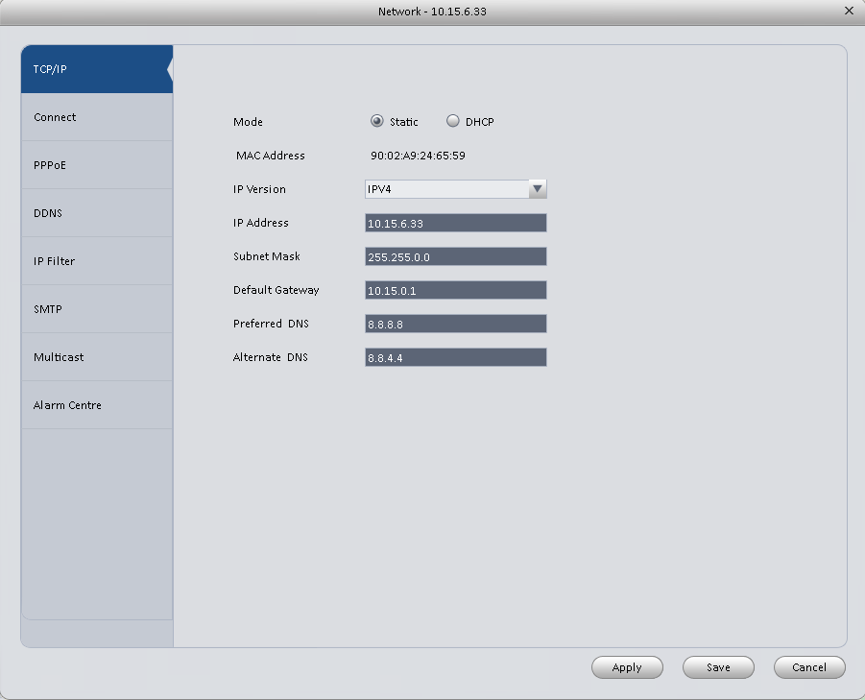
Figure 3-18

Remote
Here you can add remote device manually or automatically. See Figure 3-19.

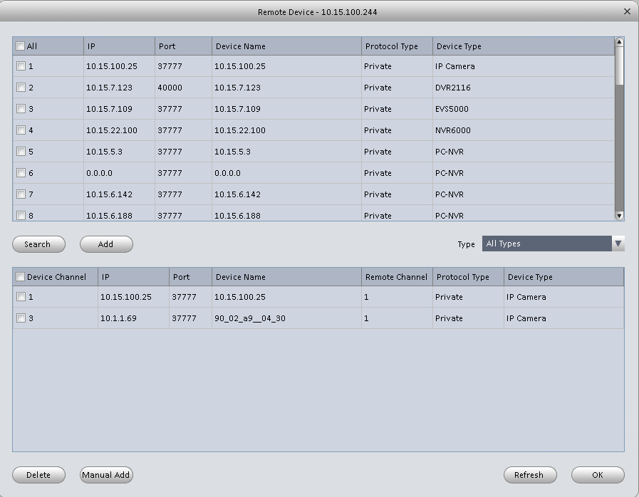
Figure 3-19
Click Search device button, system can list all the devices on the same IP section. Select a device and then click Add button; you can add a remote device.
Click Manual add button, System pops up the following dialogue box. See Figure 3-20. Please input the corresponding information and then click OK button to add a remote device.
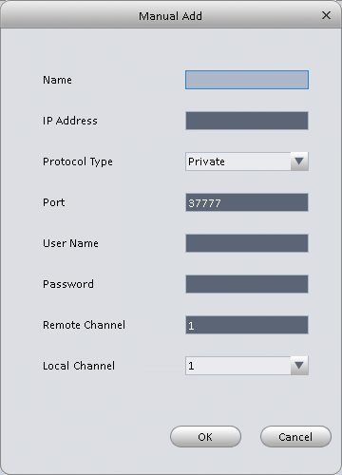
Figure 3-20

Encode

Audio/Video
The interface is shown as below. See Figure 3-21. Here you can set audio/video bit stream.
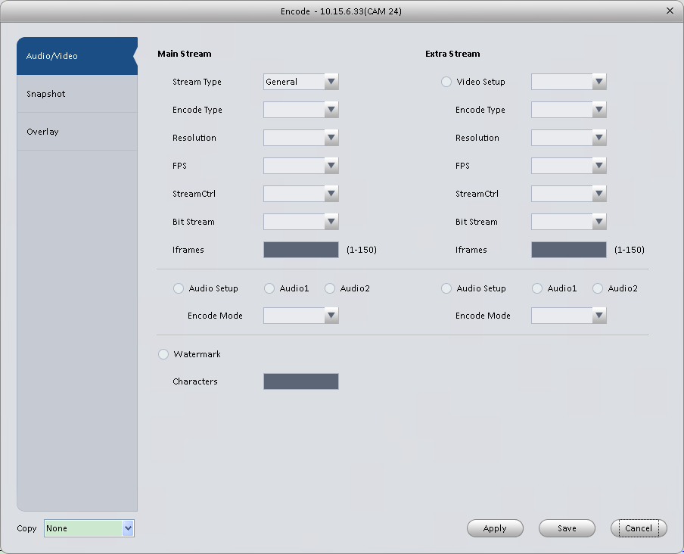
Figure 3-21
Please refer to the following sheet for detailed information.
Parameter | Function
Video setup | Check the box here to enable extra stream video. This item is enabled by default.
Stream type | It includes main stream, motion stream and alarm stream. You can select different encode frame rates form different recorded events.
Encode mode | It is to set audio/video encode mode. Default setup is H.264.
Resolution | System supports various resolutions, you can select from the dropdown list.
FPS | PAL：1～25f/s；NTSC：1～30f/s.
Bit stream | In VBR mode, it is the max value of the bit stream. In the CBR mode, it is a fixed value.
Ref Stream | According to selected encode mode, resolution, display bit stream. (range)
Iframes | Interval between key frames.
Audio encode mode | Check the box here to enable audio function and select encode type from the dropdown list.
Watermark /watermark character | This function allows you to verify the video is tampered or not.  Here you can select watermark bit stream, watermark mode and watermark character.
Copy | Click it to copy current setup to other channel(s).

Snapshot
The snapshot interface is shown as below. See Figure 3-22.
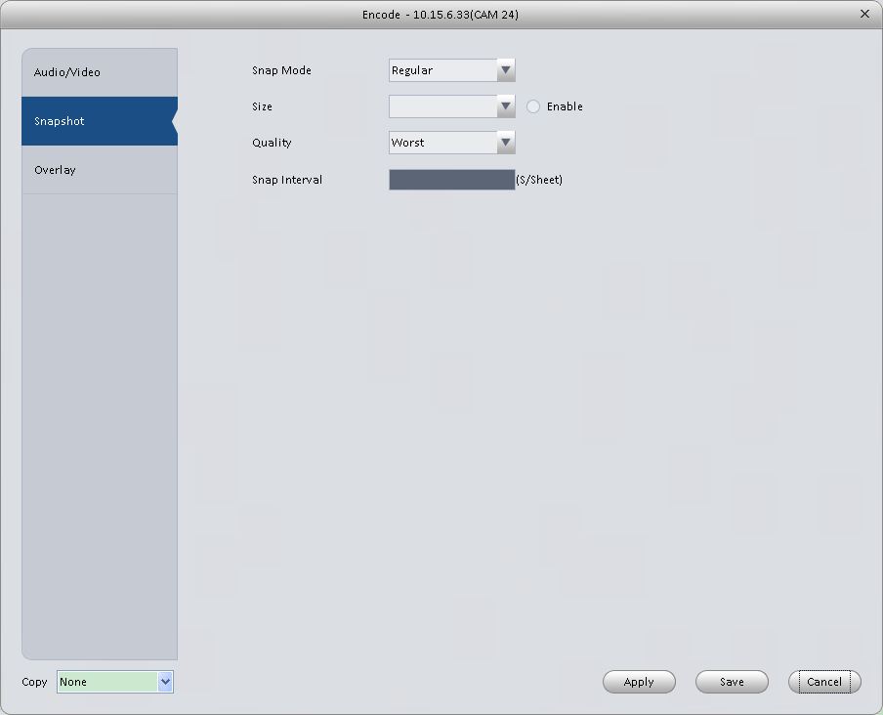
Figure 3-22
Please refer to the following sheet for detailed information.
Parameter | Function
Snapshot type | There are three modes.  - Regular: It enables snapshot function as you set on the snapshot plan.  - Trigger: It enables snapshot function when motion detect occurs.  - ALM: It enables snapshot function when an alarm occurs.
Image size | It is the same with the resolution of the main stream.
Quality | It is to set the image quality.
Interval | It is to set snapshot frequency.
Copy | Click it; you can copy current channel setup to other channel(s).

Overlay
Here is for you to overlay information on the video. See Figure 3-23.
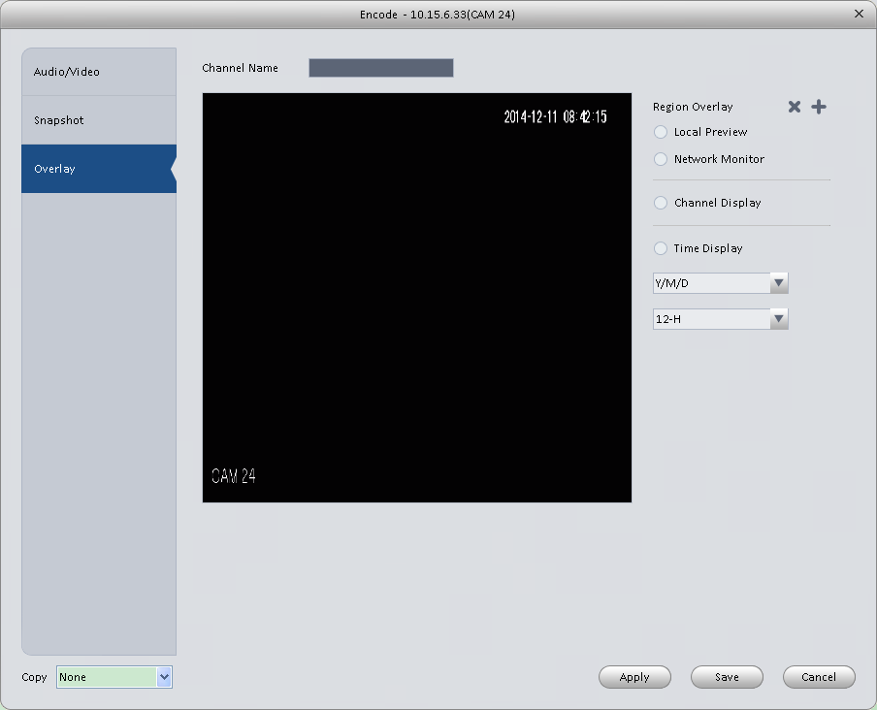
Figure 3-23
Please refer to the following sheet for detailed information.
Parameter | Function
Channel Name | Set channel name.
Region overlay | There are two types: Local liveview/network monitor.  Local liveview: It is to shield the corresponding video under local liveview mode.  Network monitor: It is to shield the corresponding video under network monitor mode.
Channel display | You can enable this function so that system overlays channel information in video window.  Please input channel name here.  You can use the mouse to drag the channel title position.
Time display | You can enable this function so that system overlays time information in video window.  You can use the mouse to drag the time title position.  You can view time title on the live video of the WEB or the playback video.
Date format | Select date format from the dropdown list if you want to overlay date information.
Time format | Select date format from the dropdown list if you want to overlay time information.
Copy | Click it; you can copy current channel setup to other channel(s).

Image
Here you can set camera property. See Figure 3-24.
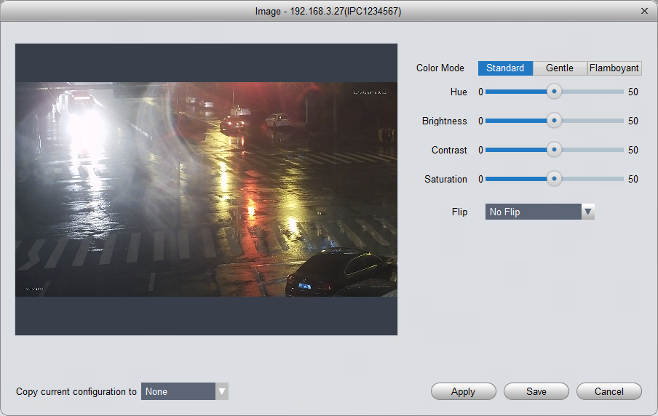
Figure 3-24
Please refer to the following sheet for detailed information.
Parameter | Function
Color mode | It is to set color mode.
Hue | It is to set color hue.
Brightness | It is to adjust color whole brightness. The large the value is, the bright the video is and vice versa.  When you set, the dark pane and the bright pane of the video can be increased or decreased accordingly at the same time.
Contrast | It is to set video contrast. The large the value is, the big the contrast is, vice, versa.
Saturation | It is to set color saturation. The larger the value is, the strong the color is and vice versa.
Viewing Angle | Viewing angle of video. You can select four types of viewing angle. And click Apply to preview on the left.

PTZ Control
It is for you to set PTZ parameters. See Figure 3-25.
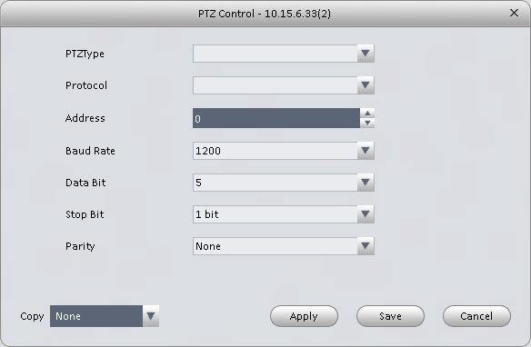
Figure 3-25
Please refer to the following sheet for detailed information.
Parameter | Function
Protocol | Select the corresponding dome protocol such as PELCOD.
Address | Set corresponding dome address. Default value is 1. Please note your setup here shall comply with your dome address; otherwise you can not control the speed dome.
Baud Rate | Select the dome baud rate. Please set according to the speed dome dial switch setup.
Data Bit | Please set according to the speed dome dial switch setup.
Stop bit | Please set according to the speed dome dial switch setup.
Parity | Please set according to the speed dome dial switch setup.

Event

Video Detect
The video detect includes three types:
- Motion detect: Through analyze video, system can enable motion detect alarm when it detects any moving signal that reaches the sensitivity threshold you set here.
- Video loss: This function allows you to be informed when video loss phenomenon occurred. You can enable alarm output channel and then enable show message function.
- Camera masking: When someone viciously masks the lens, or the output video is in one-color due to the environments light change, the system can alert you to guarantee video continuity.
Note:
Enable unfocus: detect defocus image.
Here we use motion detect interface as an example. See Figure 3-26. 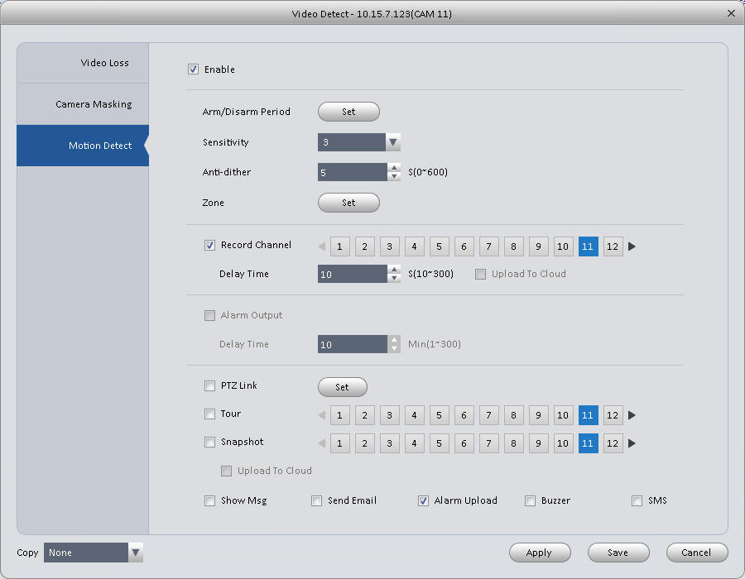
Figure 3-26
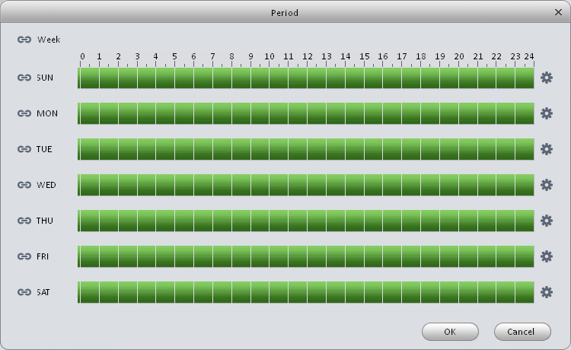
Figure 3-27
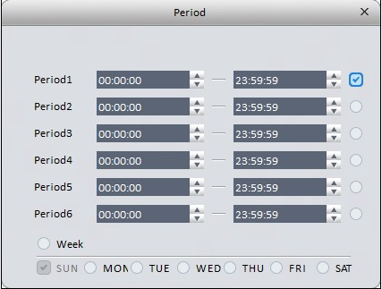
Figure 3-28

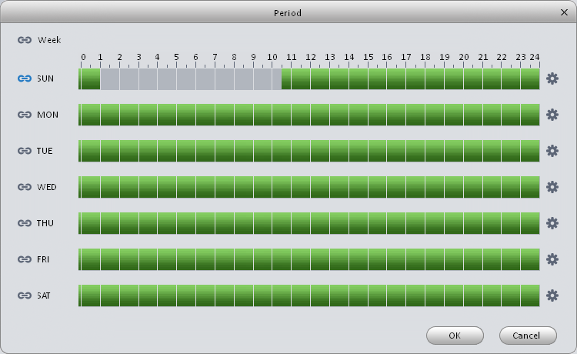
Figure 3-29

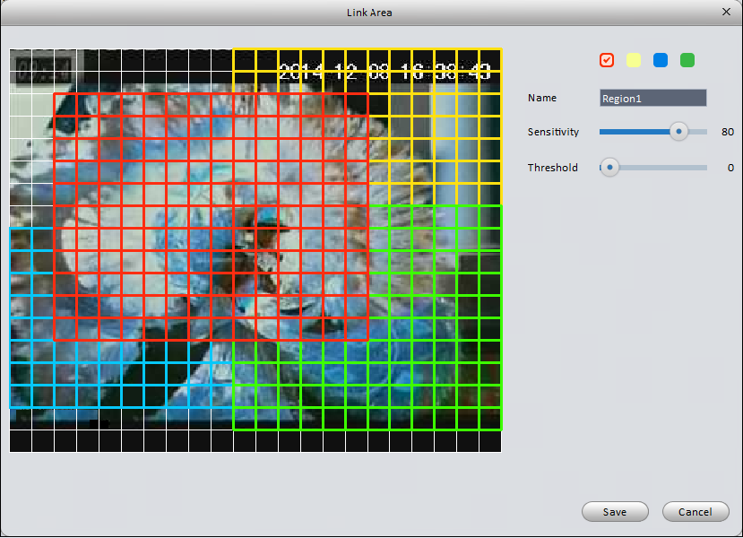
Figure 3-30
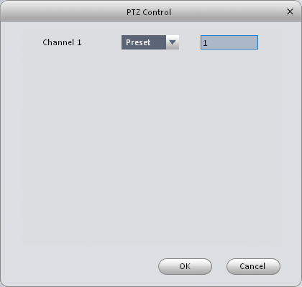
Figure 3-31

Please refer to the following sheet for detailed information.
Parameter | Function
Enable | You need to check the box to enable motion detection function.
Arm/disarm Period | Motion detection function becomes activated in the specified periods. See Figure 3-27.  There are six periods in one day. You can click to set (Figure 3-28) or use mouse to draw the corresponding period on the time bar directly (Figure 3-29).  Click OK button, system goes back to motion detection interface, please click OK button to exit.
Anti-dither | System only memorizes one event during the anti-dither period. The value ranges from 5s to 100s.
Zone | You can click this button to set motion detection zone. The interface is shown as in Figure 3-30. Do remember clicking OK button to save your motion detection zone setup.
Record channel | If you select this parameter, then you perform motion detection alarm recording to this channel.  Please note you need to select auto record in Record-> record control
Record Delay | System can delay the record for specified time after alarm ended.
Upload To Cloud | Check if to upload to Cloud.
Alarm output | Enable alarm activation function. You need to select alarm output port so that system can activate corresponding alarm device when an alarm occurs.
Delay time | System can delay the alarm output for specified time after an alarm ended.
Show msg | System can pop up a message to alarm you in the local host screen if you enabled this function.
Buzzer | Check the box here to enable this function. The buzzer beeps when an alarm occurs.
Alarm upload | System can upload the alarm signal to the centre (Including alarm centre.
Send Email | If you enabled this function, System can send out an email to alert you when an alarm occurs.
SMS | If you enabled this function, System can send out a message to specified phone to alert you when an alarm occurs.
Tour | You need to check the box here to enable this function. System begins 1-wiindow or multiple-window tour display among the channel(s) you set to record when an alarm occurs.
PTZ Activation | Here you can set PTZ movement when alarm occurs. See Figure 3-31.

Alarm
Before operation, please make sure you have properly connected alarm devices such as buzzer. The input mode includes local alarm and network alarm.
The local alarm interface is shown as in Figure 3-32.
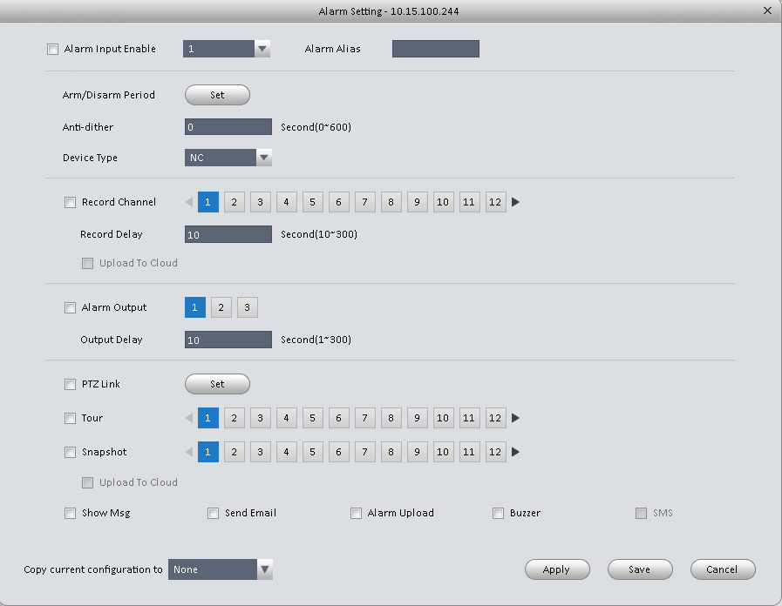
Figure 3-32
Figure 3-33
Figure 3-34

Figure 3-35

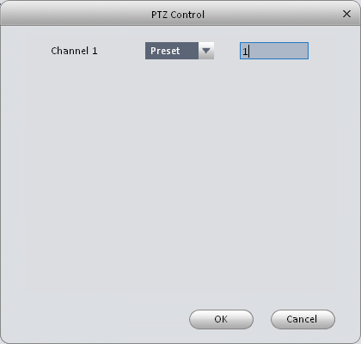
Figure 3-36
Please refer to the following sheet for detailed information.
Parameter | Function
Enable | You need to check the box to enable this function.  Please select a channel from the dropdown list.
Arm/disarm Period | This function becomes activated in the specified periods.  There are six periods in one day. See Figure 3-33.  There are six periods in one day. You can click to set (Figure 3-34) or use mouse to draw the corresponding period on the time bar directly (Figure 3-35).  Click OK button, system goes back to alarm interface, please click OK button to exit.
Anti-dither | System only memorizes one event during the anti-dither period.
Device (Sensor) type | There are two options: NO/NC.
Record Delay | System can delay the record for specified time after alarm ended.
Output delay | System can delay the alarm output for specified time after an alarm ended.
Record channel | If you select this parameter, then you perform local alarm recording to this channel.  Please note you need to select auto record in Record-> record control
Record Delay | Means when alarm link ends, record delay for a certain period of time before stop.
Alarm output | Enable alarm activation function. You need to select alarm output port so that system can activate corresponding alarm device when an alarm occurs.
Show msg | System can pop up a message to alarm you in the local host screen if you enabled this function.
Buzzer | Check the box here to enable this function. The buzzer beeps when an alarm occurs.
Alarm upload | System can upload the alarm signal to the centre (Including alarm centre.
Send Email | If you enabled this function, System can send out an email to alert you when an alarm occurs.
SMS | If you enabled this function, System can send out a message to specified phone to alert you when an alarm occurs.
Tour | You need to check the box here to enable this function.
Snapshot | If you select this parameter, then the channel is config with alarm snapshot function.

Abnormality
It includes six statuses: No device, no space, device error, net offline, IP conflict and MAC conflict. See Figure 3-37 through Figure 3-42.
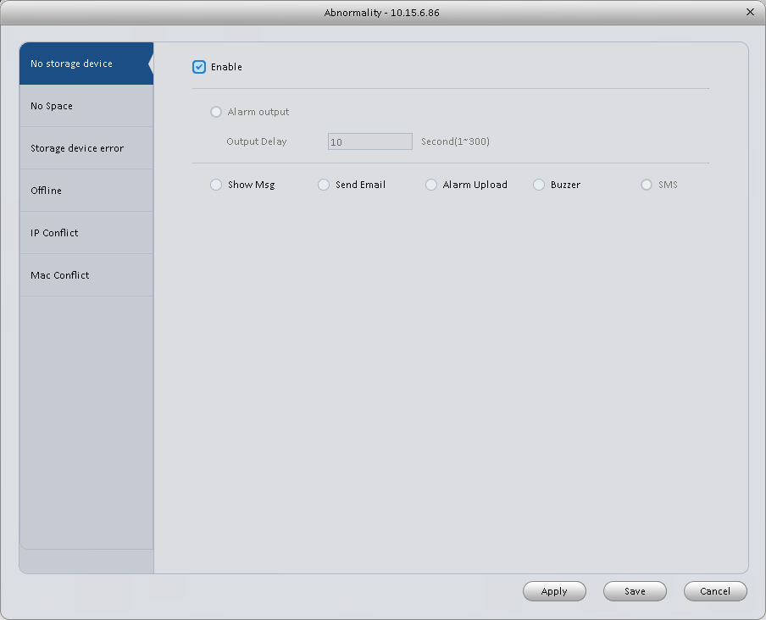
Figure 3-37
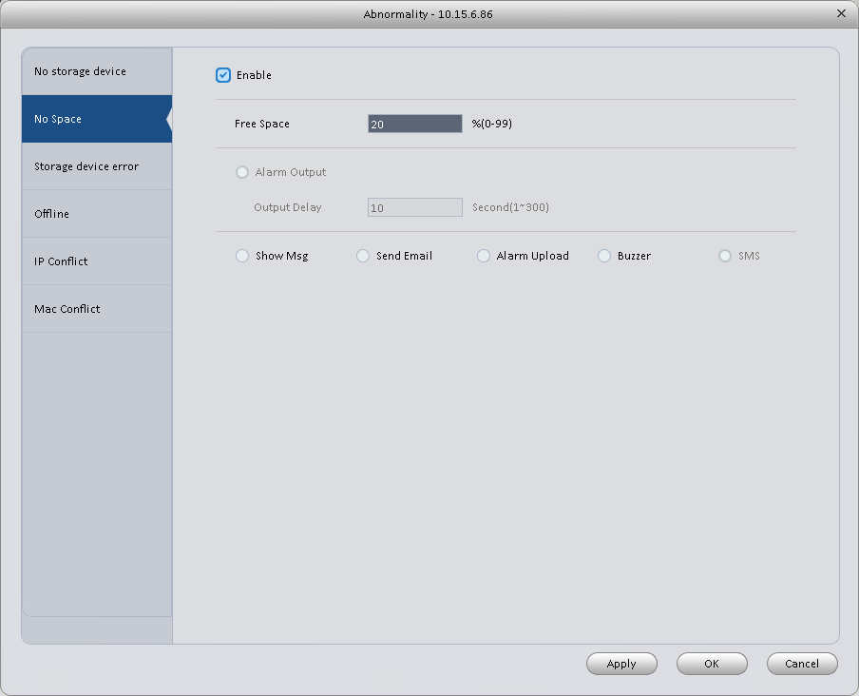
Figure 3-38
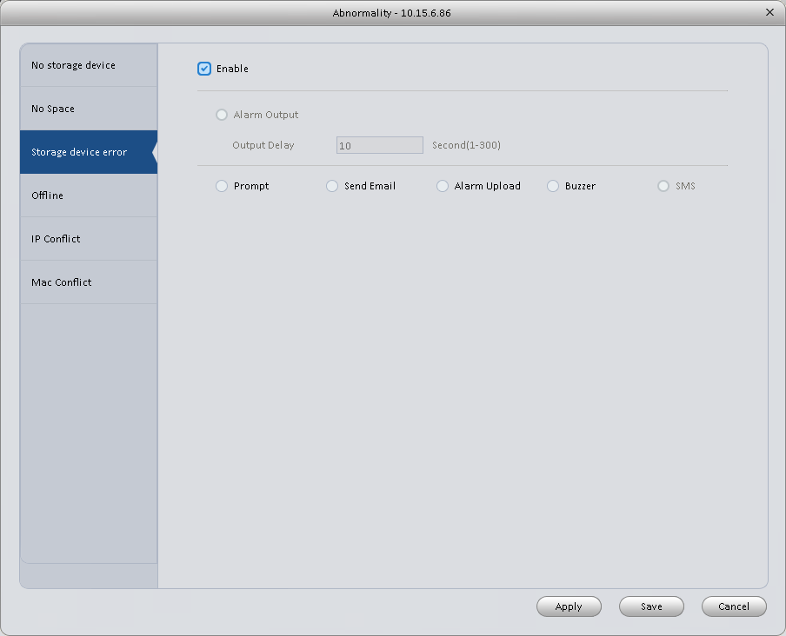
Figure 3-39
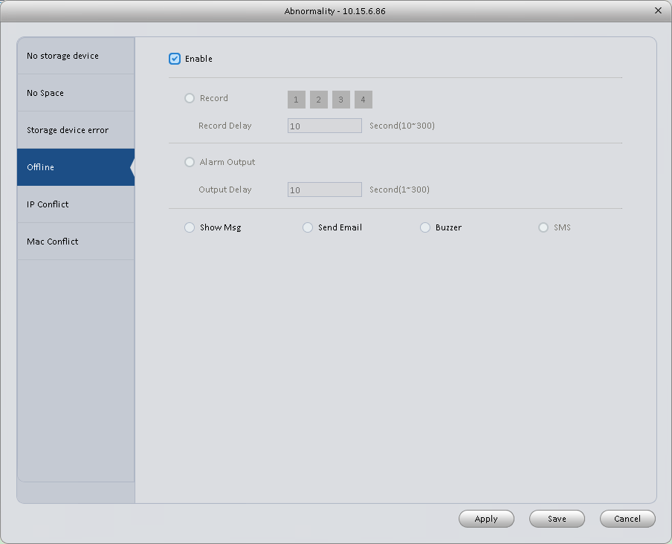
Figure 3-40
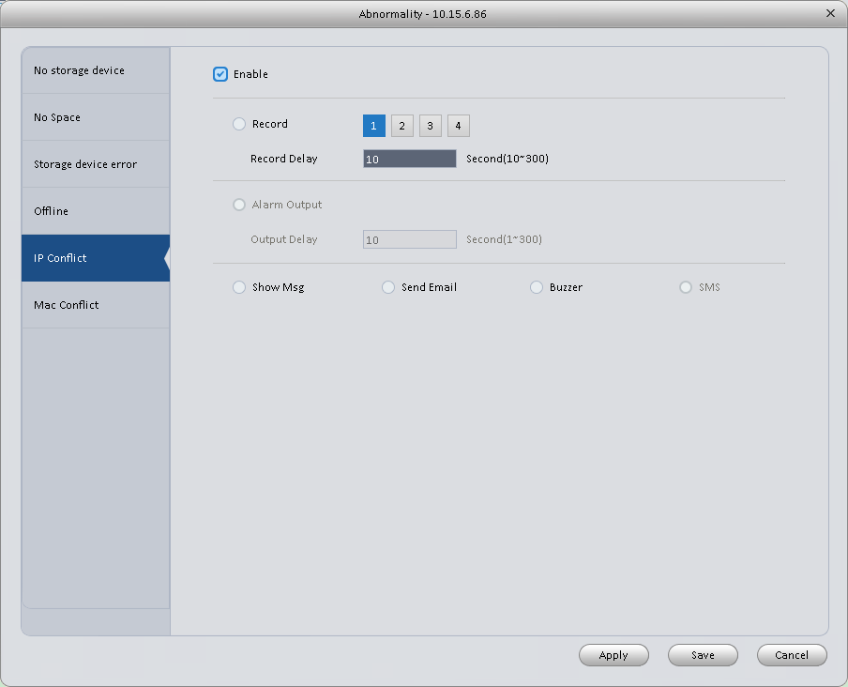
Figure 3-41
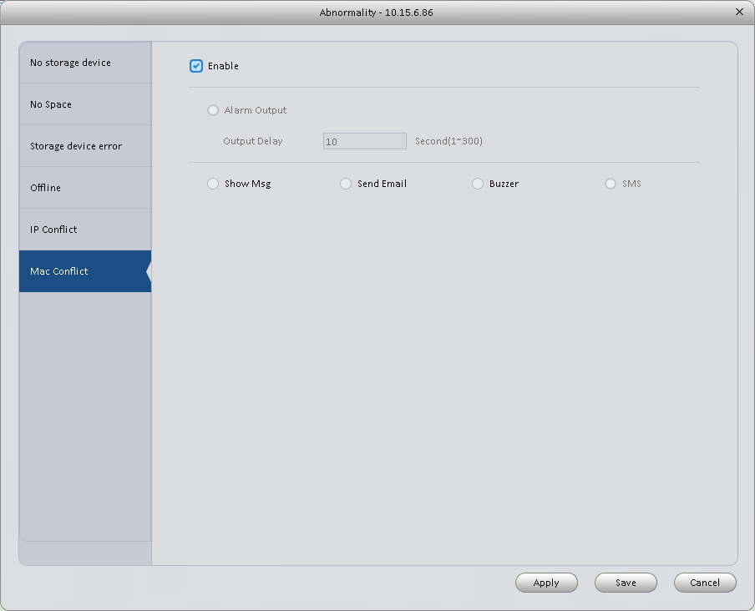
Figure 3-42
Please refer to the following sheet for detailed information.
Parameter | Function
Enable | Check the box here to enable selected function.
Alarm Output | Please select corresponding alarm output channel when an alarm occurs. You need to check the box to enable this function.
Output delay | The alarm output can delay for the specified time after an alarm stops.
Show message | System can pop up a message to alarm you in the local host screen if you enabled this function.
Alarm upload | System can upload the alarm signal to the centre (Including alarm centre.
Send Email | If you enabled this function, System can send out an email to alert you when an alarm occurs.
Buzzer | Check the box here to enable this function. The buzzer beeps when an alarm occurs.
SMS | If you enabled this function, System can send out a message to specified phone to alert you when an alarm occurs.

Smart Config
SmartPSS supports to add SmartIPC and config added intelligent device, including audio detection config and face recognition. After config is complete, you can go to live interface for preview. Please refer to Ch 4.1.1.
See Figure 3-51.

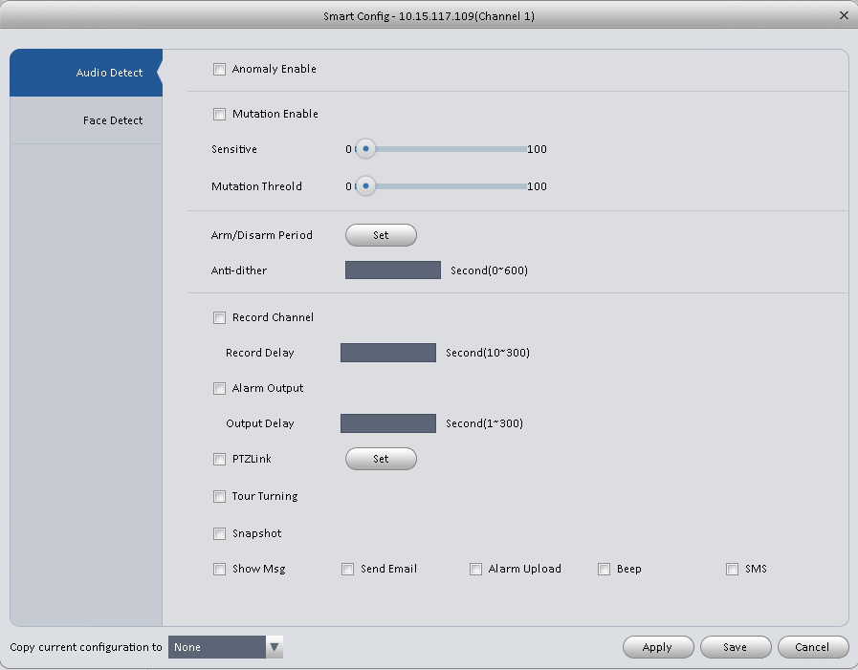
Figure 3-43

Parameter | Note
Abnormal Enable | If enable this parameter, then audio detection alarm is enabled.
Mutation Enable | May config sensitivity and mutation threshold.  If select this parameter, then mutation detect is enabled.  Sensitivity： 1-100 level adjustable. The smaller the value is, the more input sound volume change exceeds constant environmental sound and is judged as abnormal audio. User shall adjust according to actual environment.  Mutation threshold：1-100 level adjustable. It is used to set filter of environmental sound intensity. If environmental noise is high, then you shall set this value high. Please set and adjust according to actual environment.
Arm/Disarm Period | Set alarm arm/disarm period.  Click set pop up Arm/Disarm Period box for setup.
Anti-dither | Means only record one motion detection event within the period. Value range 0s～100s.
Record Channel | If select the parameter, then alarm record the channel.  Go to “Record >Record Control” and select auto record.
Record Delay | Means when alarm link is end, motion detection record will remain for a period of time before stop.
Alarm Output | If select the parameter, then enable alarm link output port, so when alarm occurs, it can link corresponding alarm output device.
Output Delay | Means when alarm link ends, alarm will remain for a period of time before stop.
Snapshot | If select this parameter, then select this parameter, then this channel config motion detection snapshot function.
Send EMAIL | If select this parameter, then when alarm occurs, it sends Email to user.
Alarm Upload | If select this parameter, then when alarms occurs, alarm will be sent to center.
Beep | If select this parameter, then when alarm occurs, it beeps.
SMS | If select this parameter, then when alarm occurs, user will receive SMS.

Face Detect is shown in Figure 3-52.

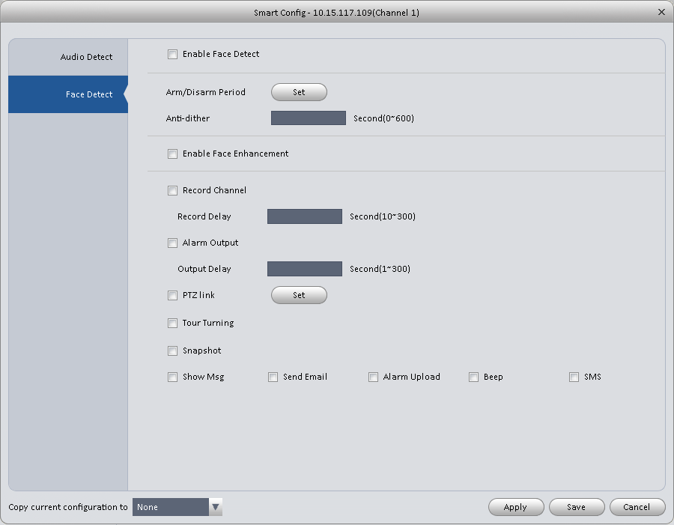
Figure 3-44

Parameter | Note
Enable | If select this parameter, it will link alarm.
Arm/Disarm Period | Set alarm arm/disarm period.  Click setup to pop up arm/disarm period box.
Enable Face Enhancement | If select this parameter, then it enable dynamic trick.
Record Channel | If select this parameter, then the channel has record of alarm.  Go to “Record > Record Control” and select “auto” record.
Record Delay | Means when alarm link ends, motion detection delays for a period of time.
Alarm Output | If select this parameter, then enable alarm link output port, when alarm occurs, may link alarm output device.
Output Delay | Means when alarm link ends, alarm delays for a period of time.
Snapshot | If select this parameter, then it configures dynamic snapshot function for this channel.
Send EMAIL | If select this parameter, then when alarm occurs, it send Email to user.
Alarm Upload | If select this parameter, then when alarms occurs, alarm will be sent to center.
Beep | If select this parameter, then when alarm occurs, it beeps.
SMS | If select this parameter, then when alarm occurs, user will receive SMS.

Record/Storage

Schedule
Record setup has record plan and record control.
- Record plan (schedule): Record during set period.
- Record control: Select mode of record.
You can set the corresponding period to enable schedule record function. You can follow the steps listed below to set schedule record function.
- Click Schedule button, you can go to the following interface. See Figure 3-45.
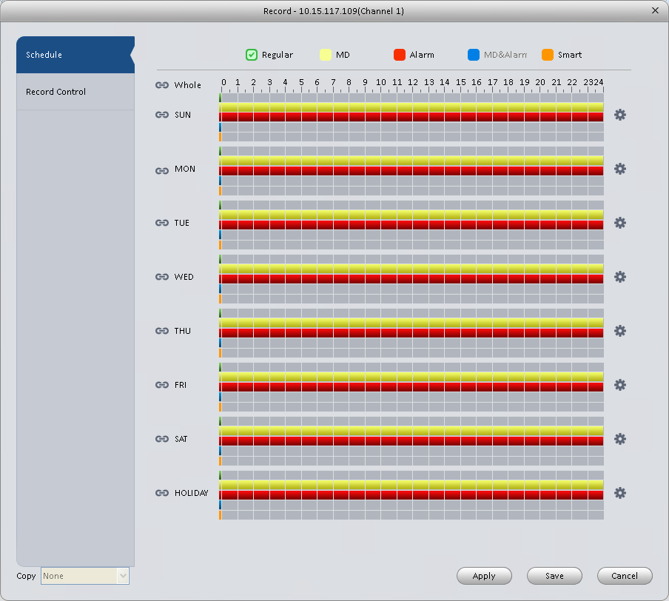
Figure 3-45
- Click button after corresponding date, you can see an interface shown as below. See Figure 3-46.
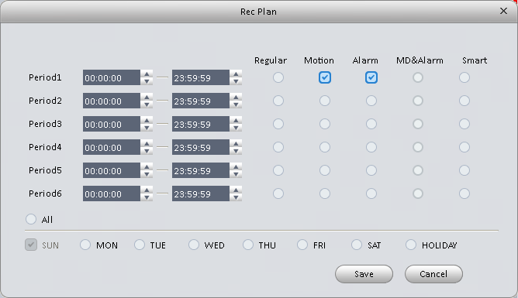
Figure 3-46
- Set record period and check the box to select record type. Click OK button, now you can see an interface shown as in Figure 3-47.
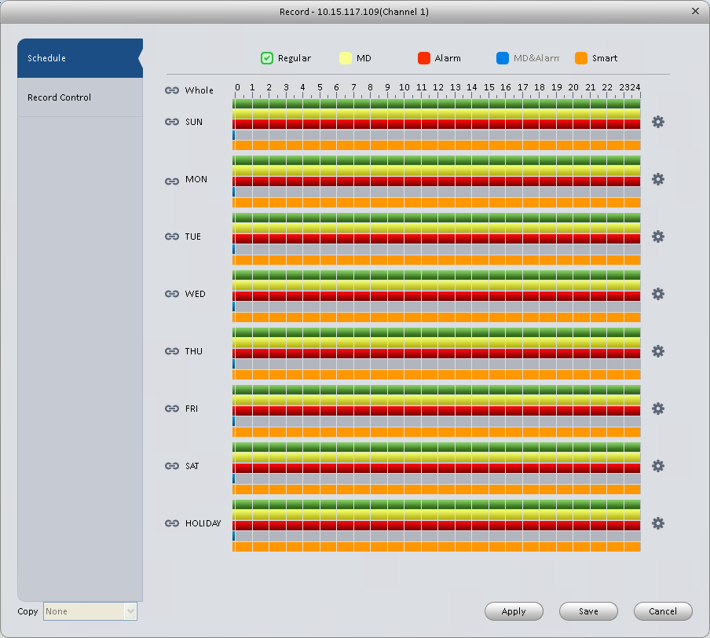
Figure 3-47
You can view the current time period setup from the color bar.
- Green color stands for the general record.
- Yellow color stands for the motion detect record.
- Red color stands for the alarm record.
- Blue color stands for MD and alarm record.
- Orange color stands for smart alarm record.
Tips
Choose the channel you want, then click save button to copy current setup

Record Control
It is for you to set record control mode. See Figure 3-48.
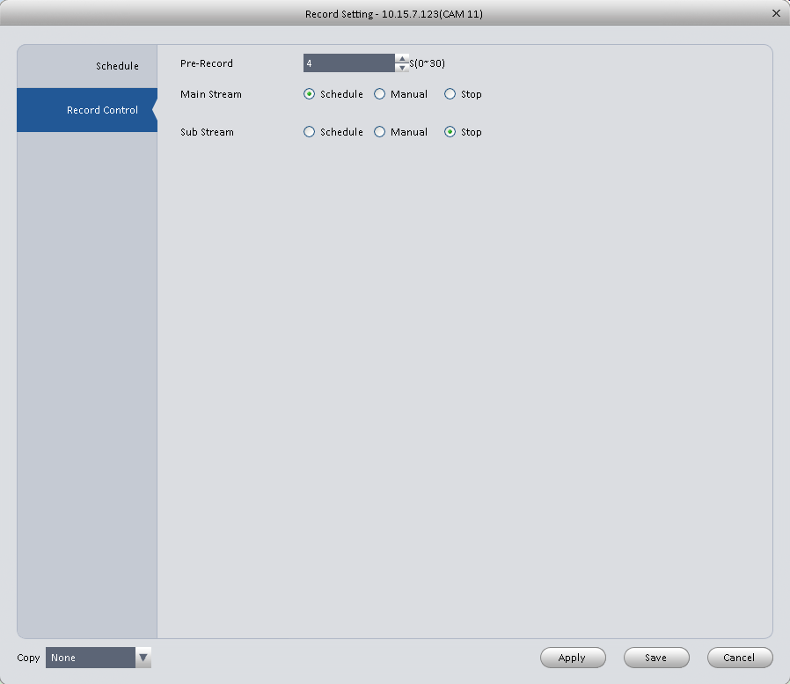
Figure 3-48
Please refer to the following sheet for detailed information.
Parameter | Function
Pre-record | Please input pre-record time here.
Main stream | It is to set main stream record mode. It includes: Schedule/manual/stop.
Sub stream | It is to set sub stream record mode. It includes: Schedule/manual/stop.

Disk

Local Store
The local interface is shown as in Figure 3-49. Here you can save data to local SD card or HDD and meanwhile view health status of HDD.
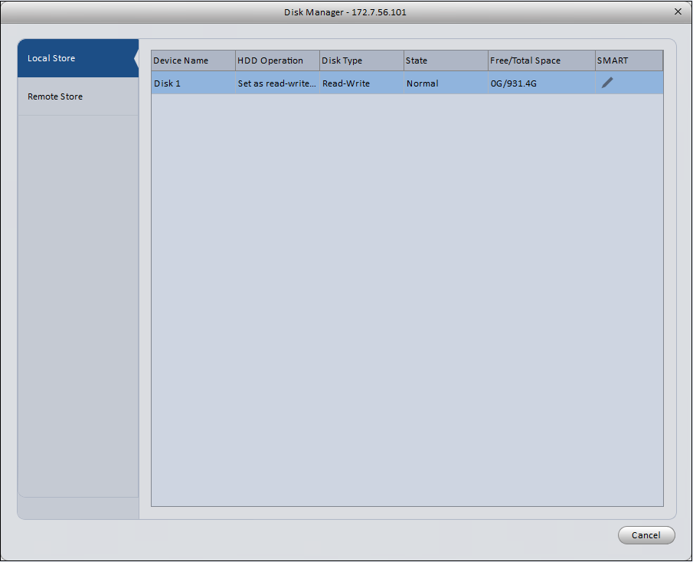
Figure 3-49

Remote store
It is for you to upload data to a PC via FTP. See Figure 3-50.

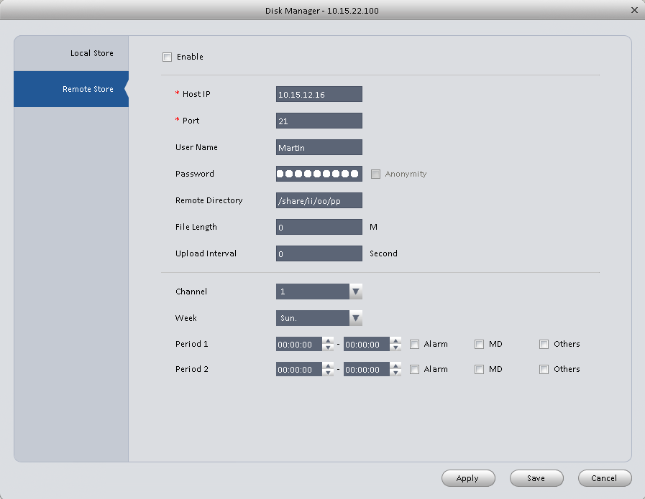
Figure 3-50

Maintenance

Account
Here you can add/modify/delete a group or add/modify/delete a user. System default user group is admin/user. System default user is admin/888888/666666.
Click Account button in Signals interface and then click Role button. See Figure 3-51.

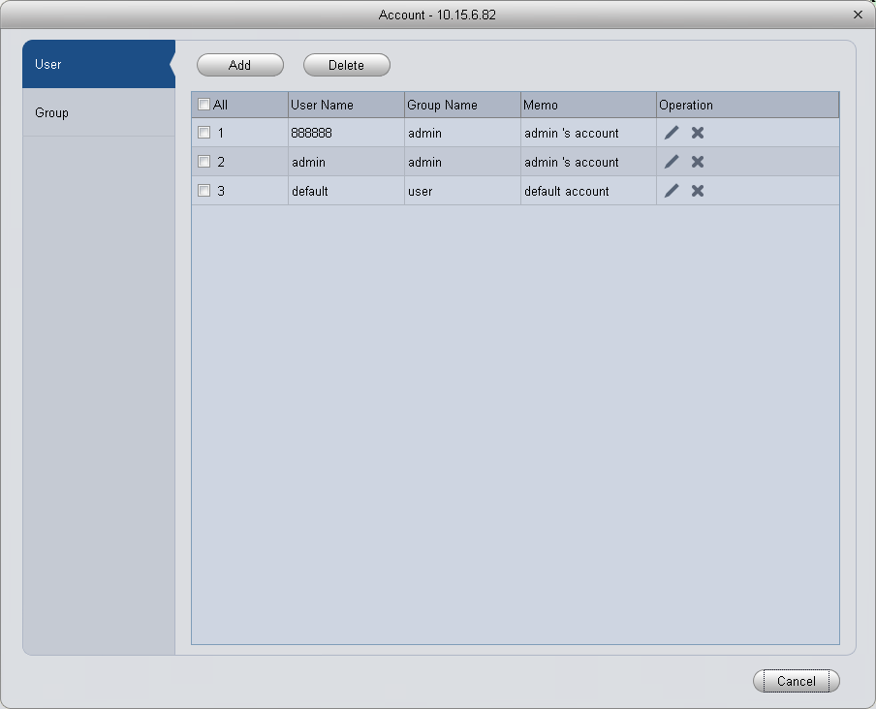
Figure 3-51
Click Add button, you can see system pops up the following interface. See Figure 3-52. Please input a group name and then select corresponding rights, input some note information for your reference if necessary. Click OK button to exit.
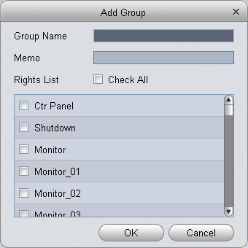
Figure 3-52
Go to the User interface, here you can add/remove user and modify user name. See Figure 3-53.
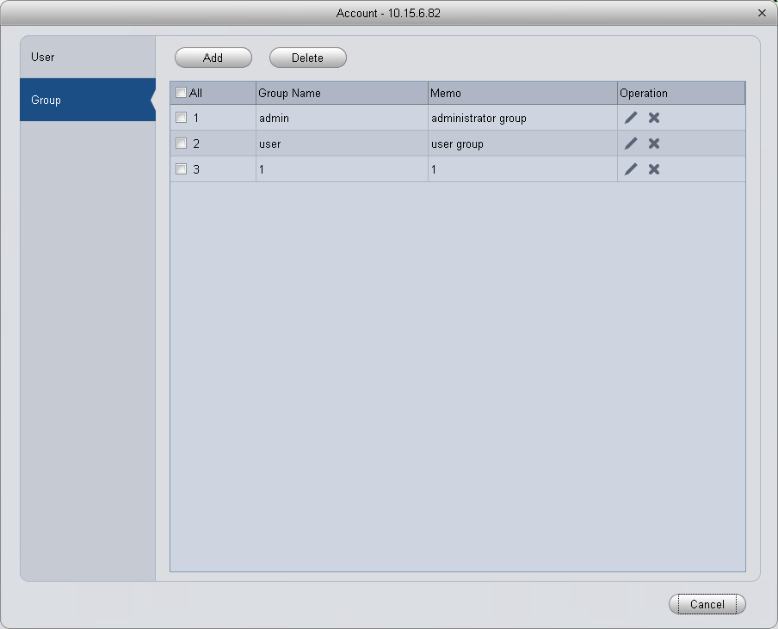
Figure 3-53
Click Add button, you can see the following interface. See Figure 3-54. Please input user name, password, and select a group from the dropdown list. Select corresponding rights and then click OK button.
Tips
If you want to multiple users to use this account login at the same time, you need to check the box to select reusable function.
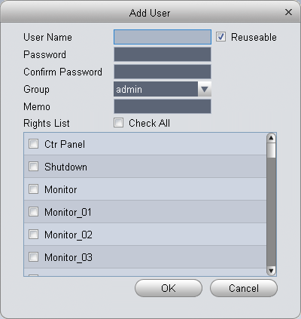
Figure 3-54
Note:
Access controller username and password are fixed, and password is 123456.

Maintenance

Local Setup
Here you can set system time, date format, record period and etc. See Figure 3-55.
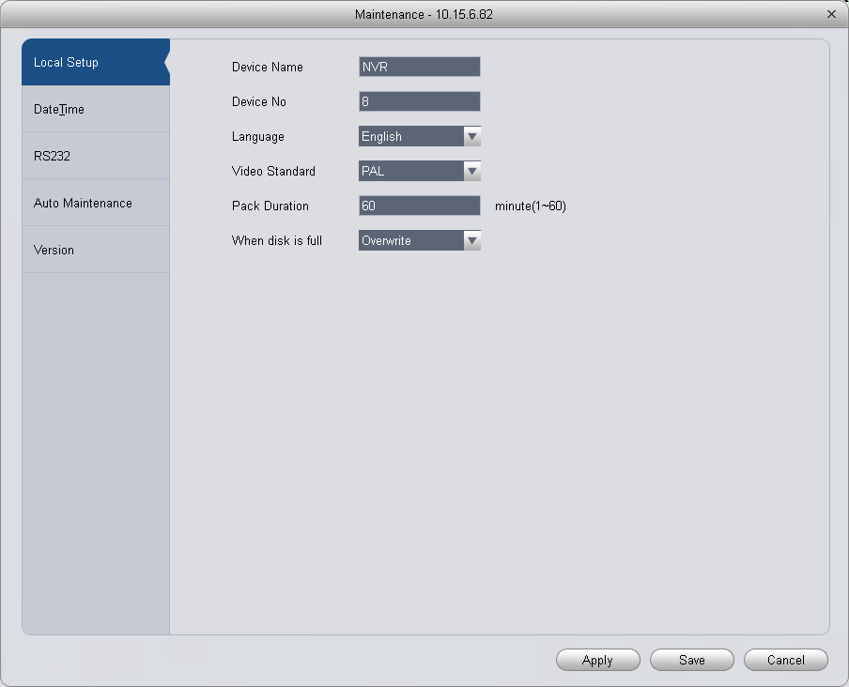
Figure 3-55
Please refer to the following sheet for detailed information.
Parameter | Function
Device name | It is to set device name.
Device No. | When you are using one remote control to manage multiple devices, you can give a serial numbers to the device.  Before the operation, please make sure you have clicked address button on the remote control and input a number for current device.
Language | You can select the language from the dropdown list.  Please note the device needs to reboot to get the modification activated.
Video Standard | This is to display video standard such as PAL.
HDD full | Here is for you to select working mode when hard disk is full. There are two options: stop recording or rewrite.  - If current working HDD is overwritten or the current HDD is full while the next HDD is no empty, then system stops recording,  - If the current HDD is full and then next HDD is not empty, then system overwrites the previous files.
Pack duration | Here is for you to specify record duration.

Date&Time
The date and time interface is shown as in Figure 3-56.
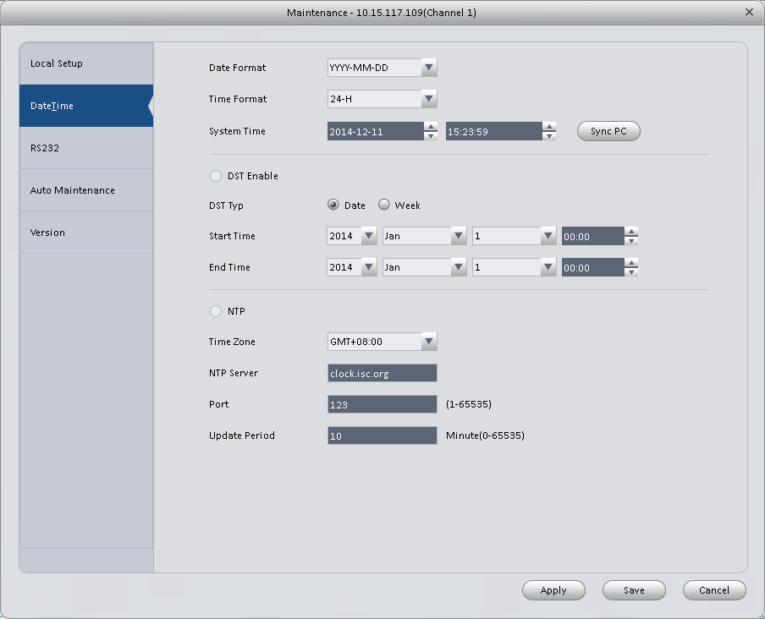
Figure 3-56
Please refer to the following sheet for detailed information.
Parameter | Function
Date format | Here you can select date format from the dropdown list.
Time Format | There are two options: 24-H and 12-H.
Time zone | The time zone of the device.
System time | It is to set system time. It becomes valid after you set.
Sync PC | You can click this button to save the system time as your PC current time.
DST enable | Here you can set day night save time begin time and end time. You can set according to the date format or according to the week format.
NTP | You can check the box to enable NTP function.
NTP server | You can set the time server address.
Port | It is to set the time server port.
Update period | It is to set the sync periods between the device and the time server.

RS232
The RS232 interface is shown as in Figure 3-57.
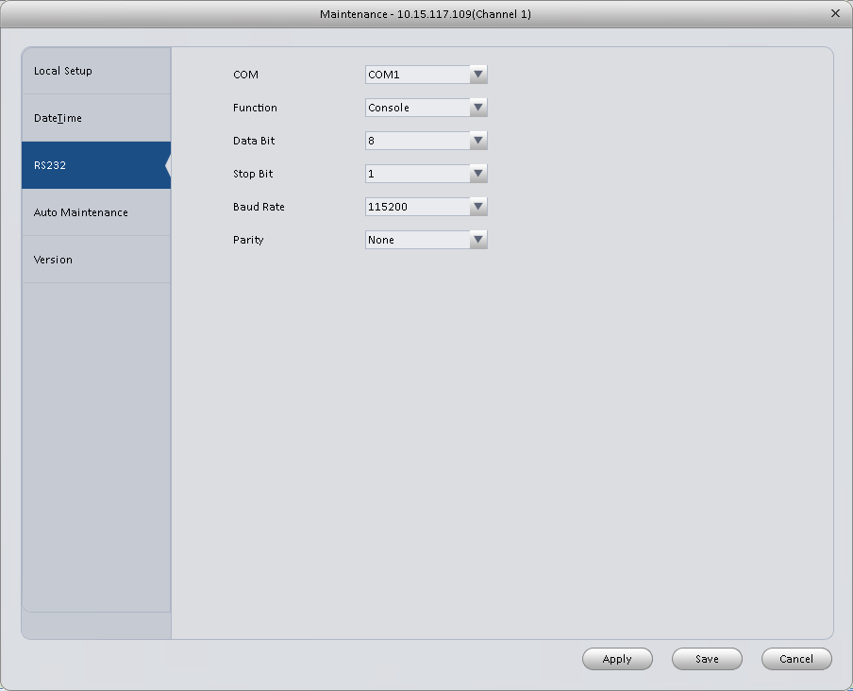
Figure 3-57
Please refer to the following sheet for detailed information.
Parameter | Function
COM | You can select from the dropdown list.
Function | There are various devices for you to select.  - Console is for you to use the COM or mini-end software to upgrade or debug the program.  - The control keyboard is for you to control the device via the special keyboard.  - Transparent COM (adapter) is to connect to the PC to transfer data directly.  - Protocol COM is for card overlay function.  - Network keyboard is for you to use the special keyboard to control the device.
Baud Rate | Default setup is 115200.
Data Bit | Default setup is 8.
Stop bit | Default setup is 1.
Parity | Default setup is none.

Auto Maintenance
Here you can set auto-reboot time and auto-delete old files setup. You can set to delete the files for the specified days. See Figure 3-58.
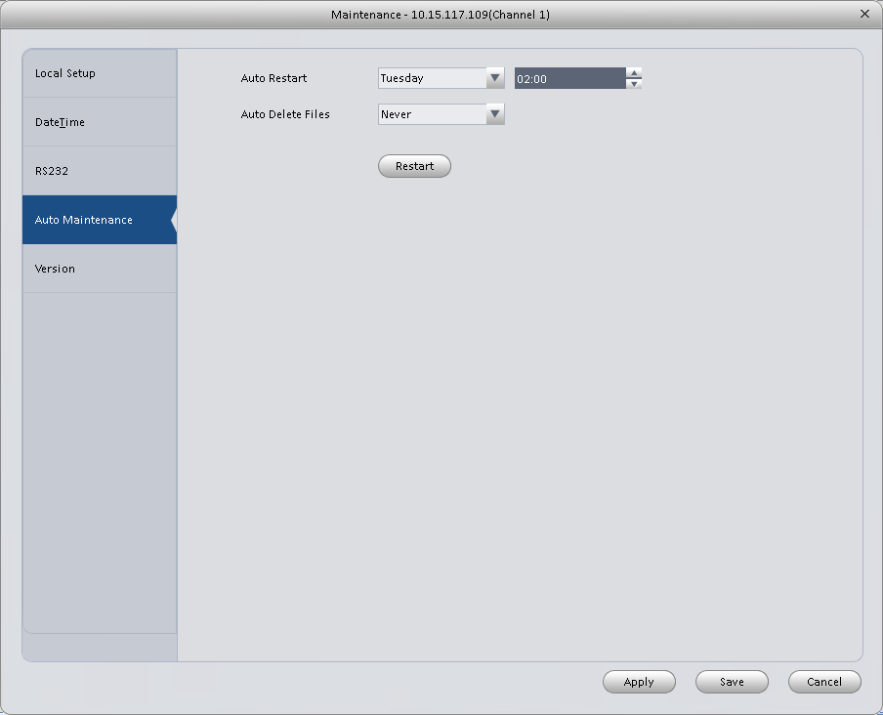
Figure 3-58

Version
Version interface is shown as below.

Upgrade
Upgrade program.

WEB
Click it to go to the WEB of the device. See Figure 3-59. The following figure is for reference only.
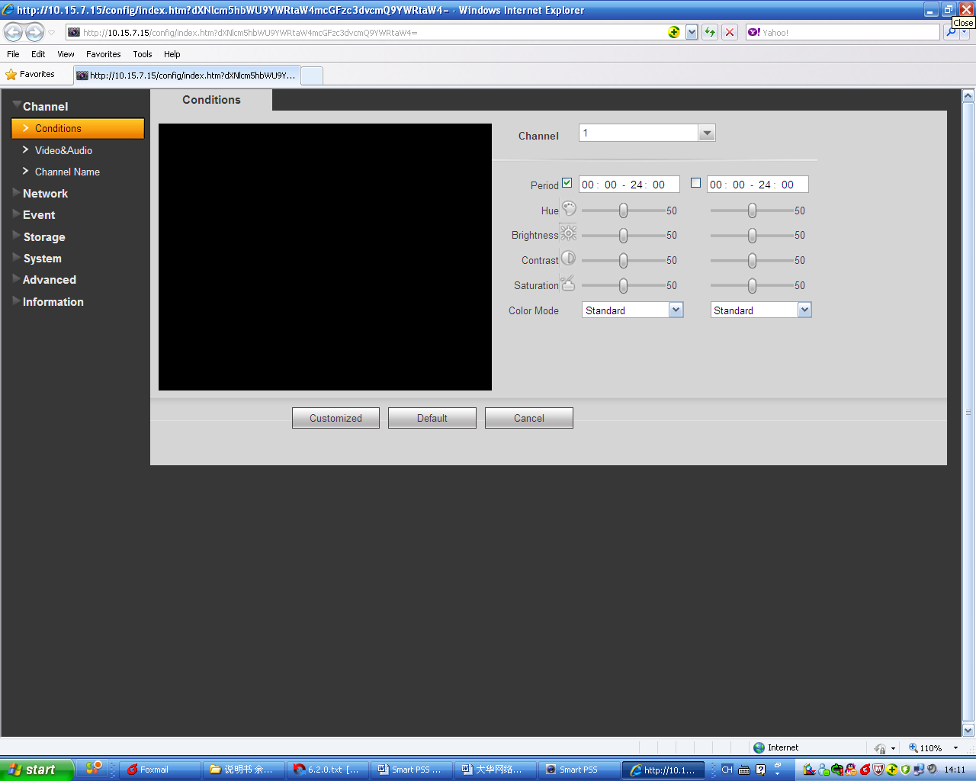
Figure 3-59

Alarm Setup

Set Alarm Scheme

You can follow the steps listed below to set an alarm scheme.
- Click the icon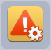 in the Settings pane, you can go to alarm configuration interface. See Figure 3-60.
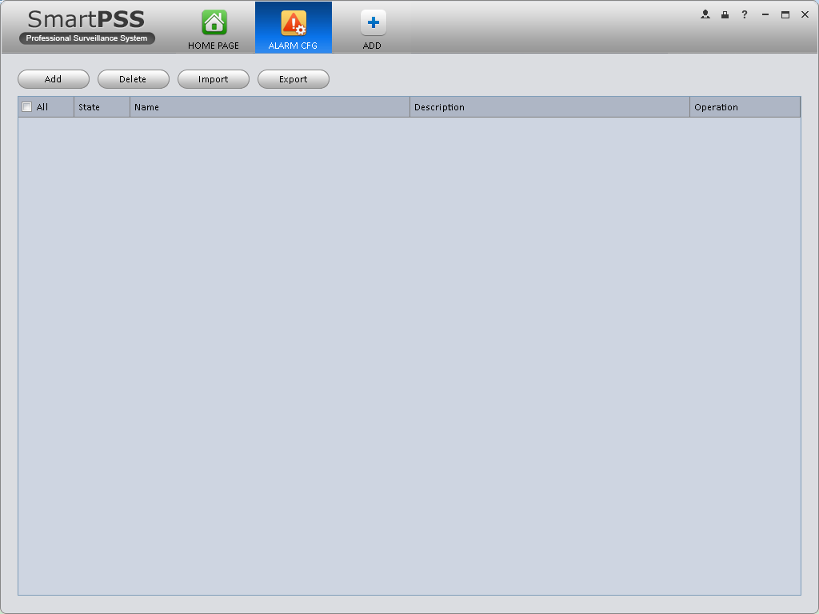
Figure 3-60
- Set alarm sources.
  - Click button in Figure 3-60 , system goes to alarm sources setup interface. See Figure 3-61.
- Here you can input a scheme name and some reference information. Select the alarm type from the dropdown list.
“Alarm Type” includes video loss, camera masking, motion detection, audio abnormal and etc.

- Check the box to select a channel you want to set alarm scheme on the left pane; you can add it to the list on the right pane. 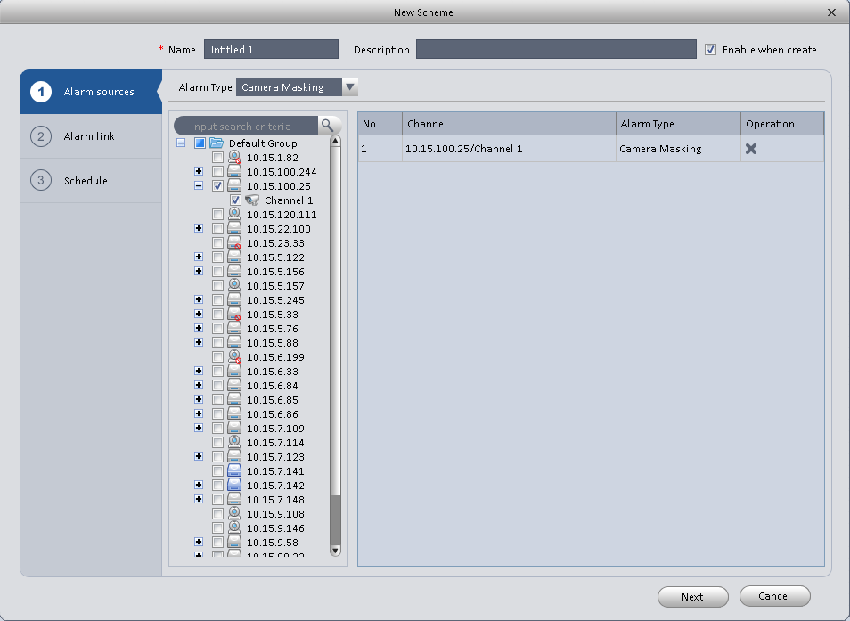
Figure 3-61
- Click Alarm Link on the left pane or click next button in Figure 3-61 , you can go to the following interface. Please check the trigger channel in Figure 3-62 and alarm output channel in Figure 3-63.

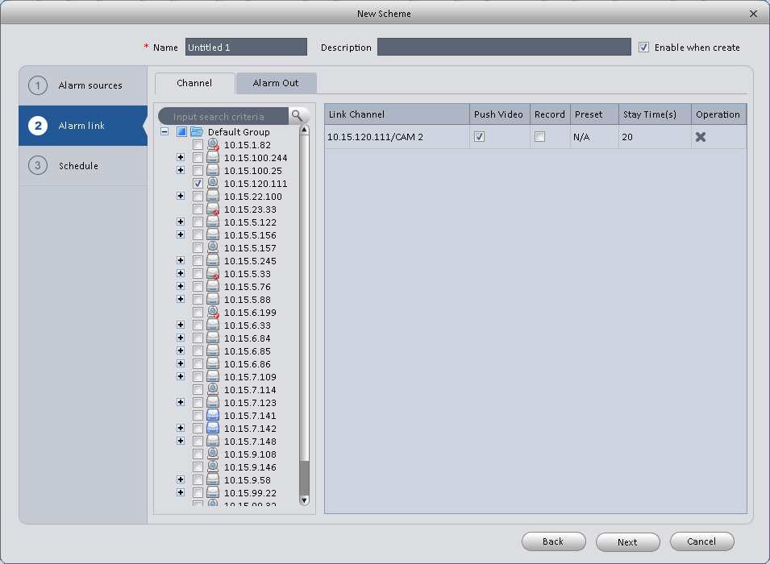
Figure 3-62
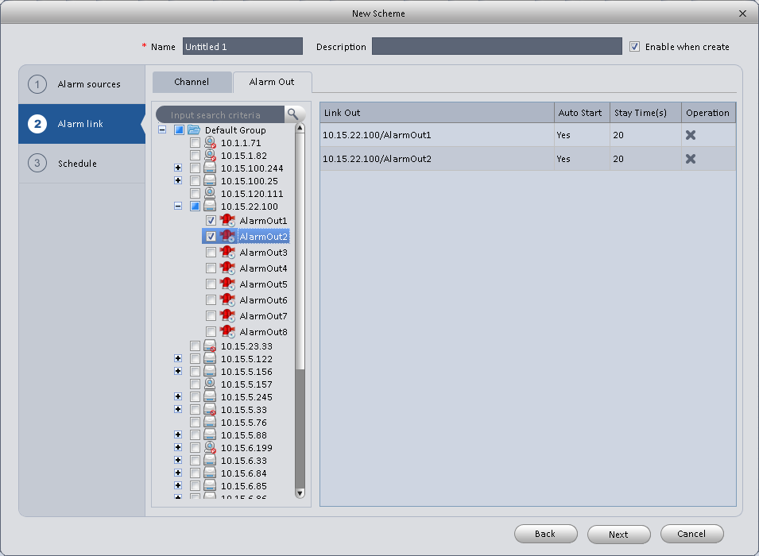
Figure 3-63
- Click Period button on the left pane or click next button in Figure 3-62, you can go to the following interface. See Figure 3-64.

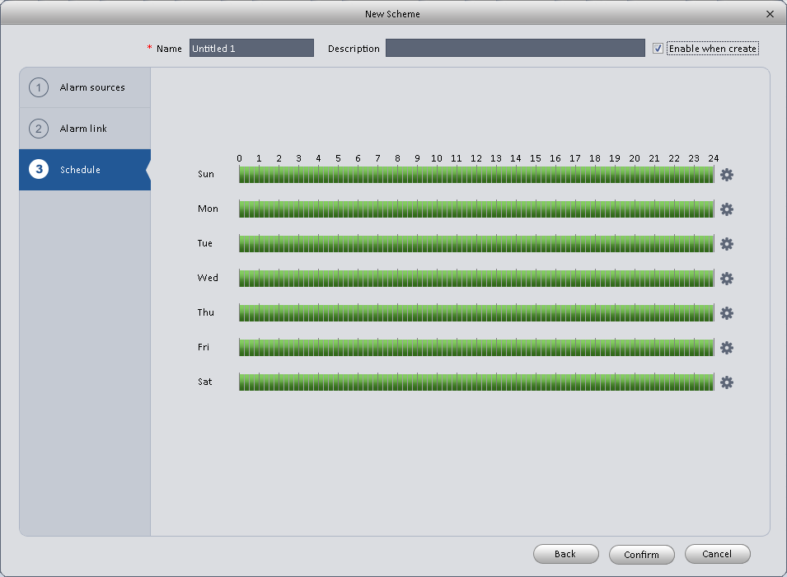
Figure 3-64
Click after a date to set alarm activation period. There are six periods in one day. See Figure 3-65. Click OK button to exit.
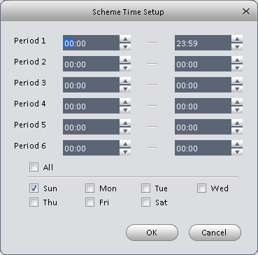
Figure 3-65
  - Click OK button, you can view the scheme information on the alarm setup interface. See Figure 3-66.
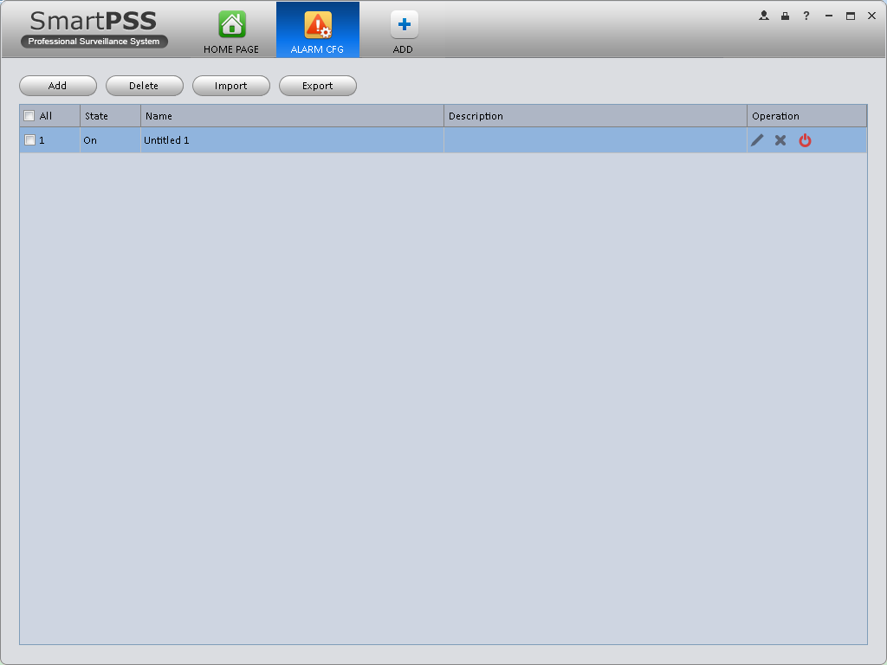
Figure 3-66

Enable/Disable/Export Scheme
After you added a scheme, you can view the following contents for operation information.
- : Delete current scheme.
- : Disable current scheme.
- : Enable current scheme.
- : Add scheme.
- : Select one or more scheme(s) and then click this button to delete.
- : Import scheme information.
- : Export scheme informaiton.

Tour &Task
It is to realize monitor tour among each window. Please follow the steps listed below to set.
- Click icon in the Settings pane, you can go to monitor tour interface.
- Click Add. System pops up add box.
- Input plan name, see Figure 3-67.
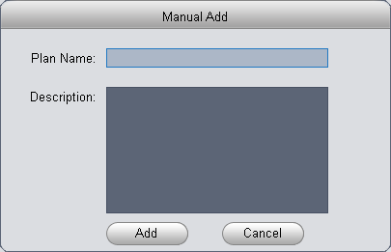
Figure 3-67
- Click Add.
- Click  button. System shows tour setup interface.
- Input task name, stay time.
- Click at the bottom of the interface to select window amount.
- Drag channel(s) on the right pane to the windows on the left pane. See Figure 3-68.

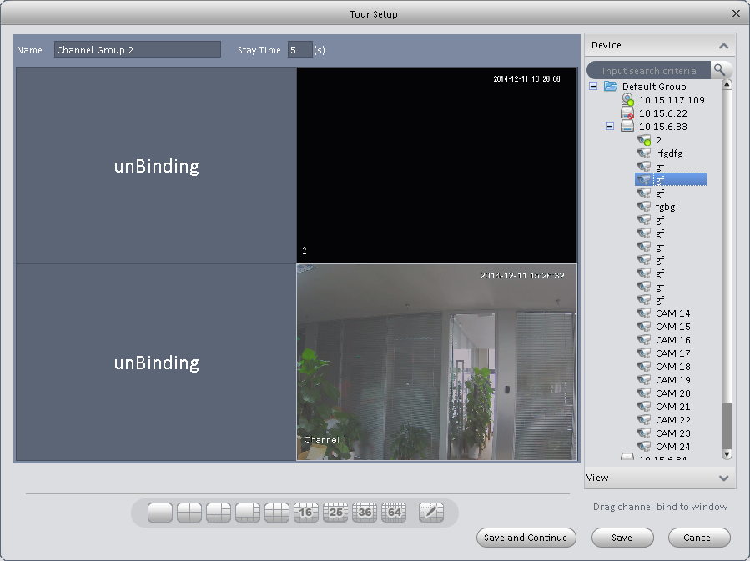
Figure 3-68
- Click button to save current setup. You also can click to save current setup and continue to set another. When you complete task setup, see Figure 3-69.
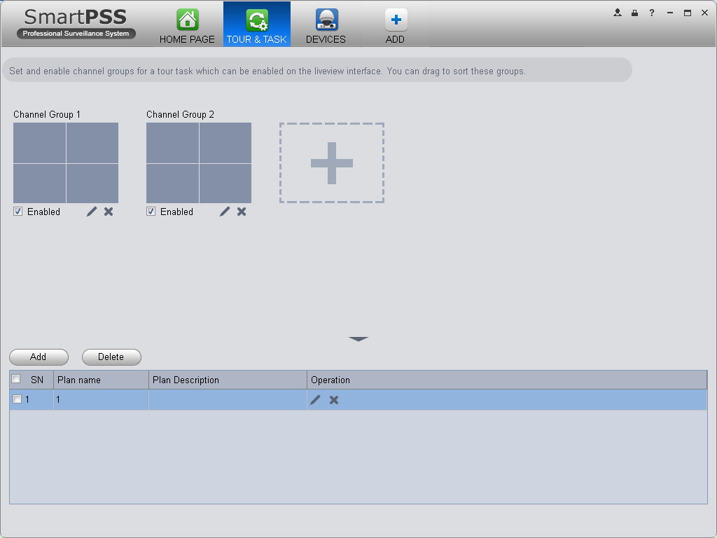
Figure 3-69

In Figure 3-69, you can check the enable button to open current scheme. You can modify and delete current task scheme.
After tour plan is created, click Liveview in Basic area, select tour plan in Liveview interface. Click at the bottom of the interface to enable the plan.

PC-NVR
Important
Before you use this function, please make sure you have installed PC-NVR and after you run PC-NVR, you must add it into device management.

This function allows you to storage record file on the PC to effectively use wideband. You can add, modify or delete PC-NVR and set PC-NVR parameter. Please follow the steps listed below.
- Click icon in the Settings pane, you can go the PC-NVR interface. See Figure 3-70.
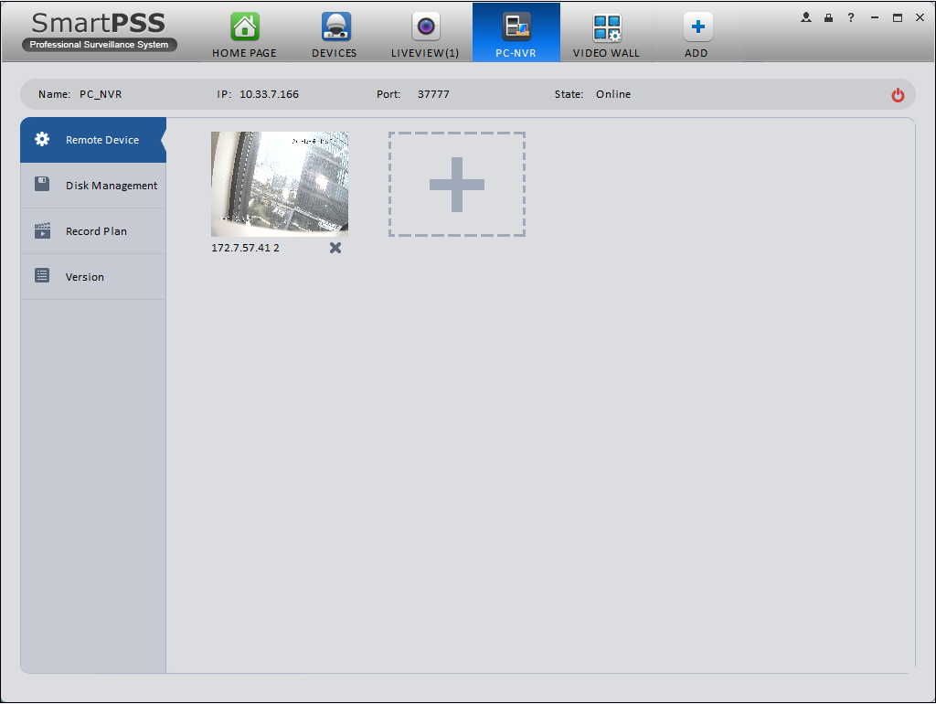
Figure 3-70
- Remote device
  - Click button, you can see an interface.
  - Please select a device. SeeFigure 3-80
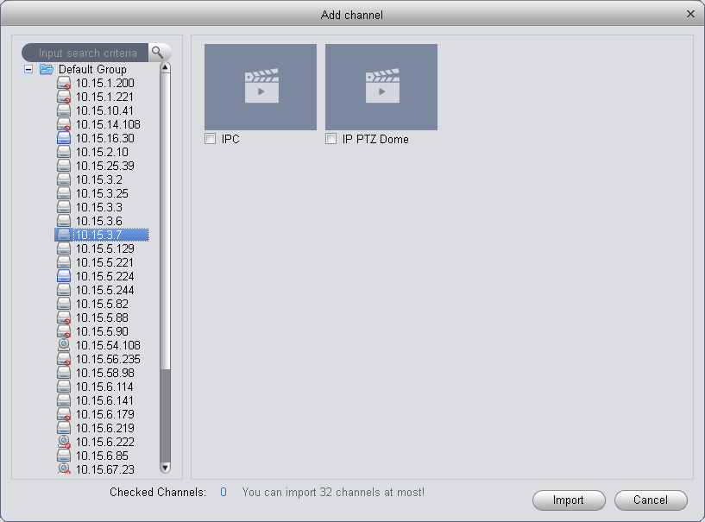
Figure 3-71

  - check the record channels
  - Click Import button.
- Disk manager
SmartPSS support disk allocation management of PC-NVR.
Note: Before allocation, make sure the disk has at least 7G in free space.
  - In Figure 3-70, click disk manager button on the left pane, you can go to the setup interface.
  - You can select saved disk and input the space then click. See Figure 3-72.
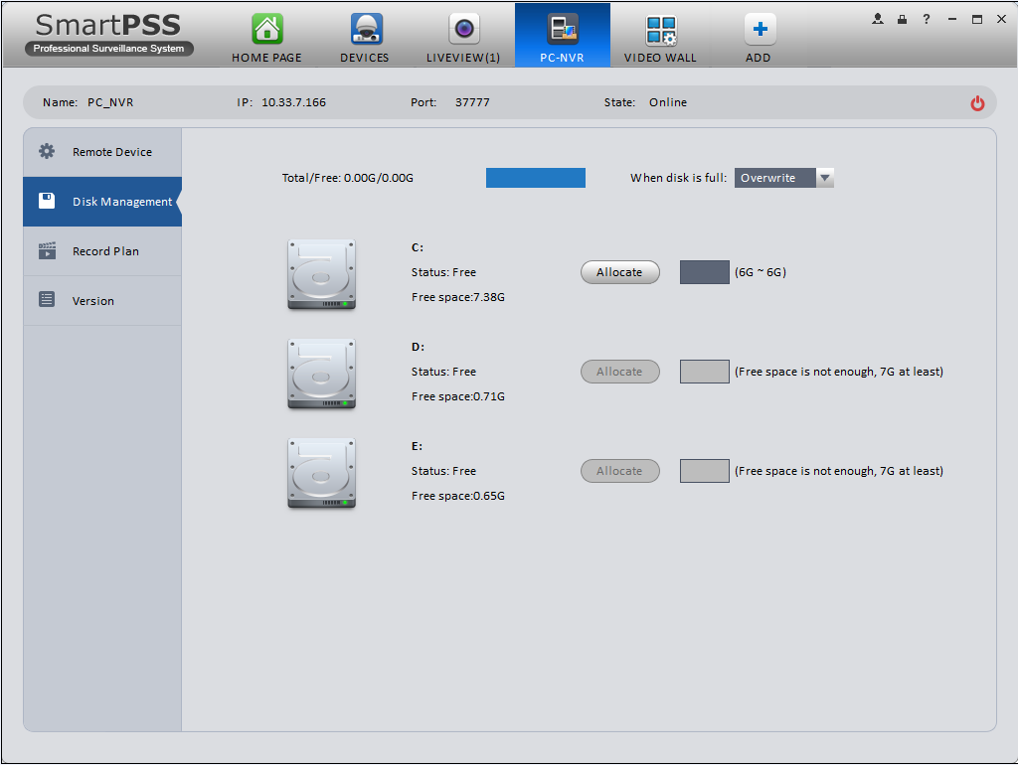
Figure 3-72
- Add record plan
  - In Figure 3-70, click Record Plan button on the left pane. And then select a channel from the dropdown list and then click button. You can go to the following interface. See Figure 3-73.
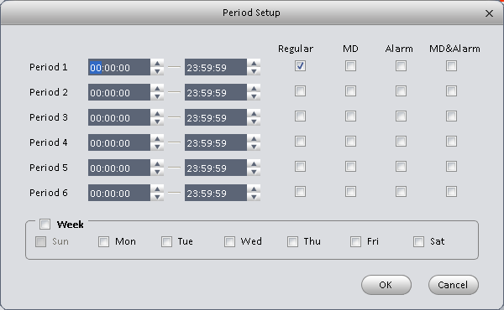
Figure 3-73
  - Please set period information and type.
  - Please set the corresponding time.
  - Click OK button. You can see an interface shown as in Figure 3-74.
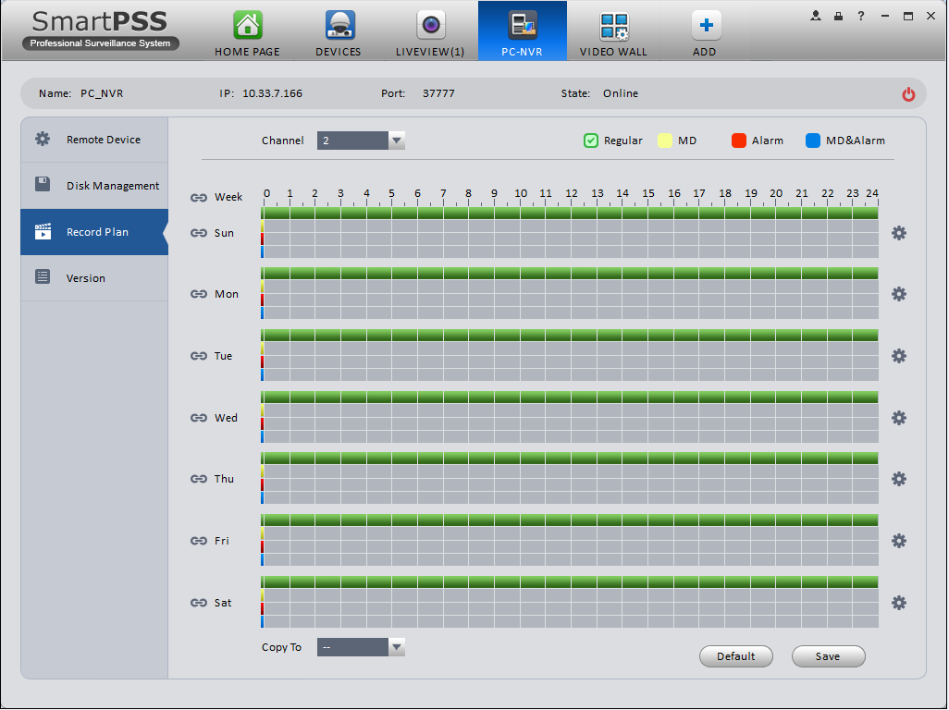
Figure 3-74
  - Click Save.
Tips
After you complete setup for one channel, you can click Dropdown in Figure 3-74 to copy current setup to other channel(s).
- View version.

Video Wall Configuration
This function allows you to output video to the video wall. Please follow the steps listed below.
- Click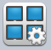, system goes to video wall setup interface. See Figure 3-75.
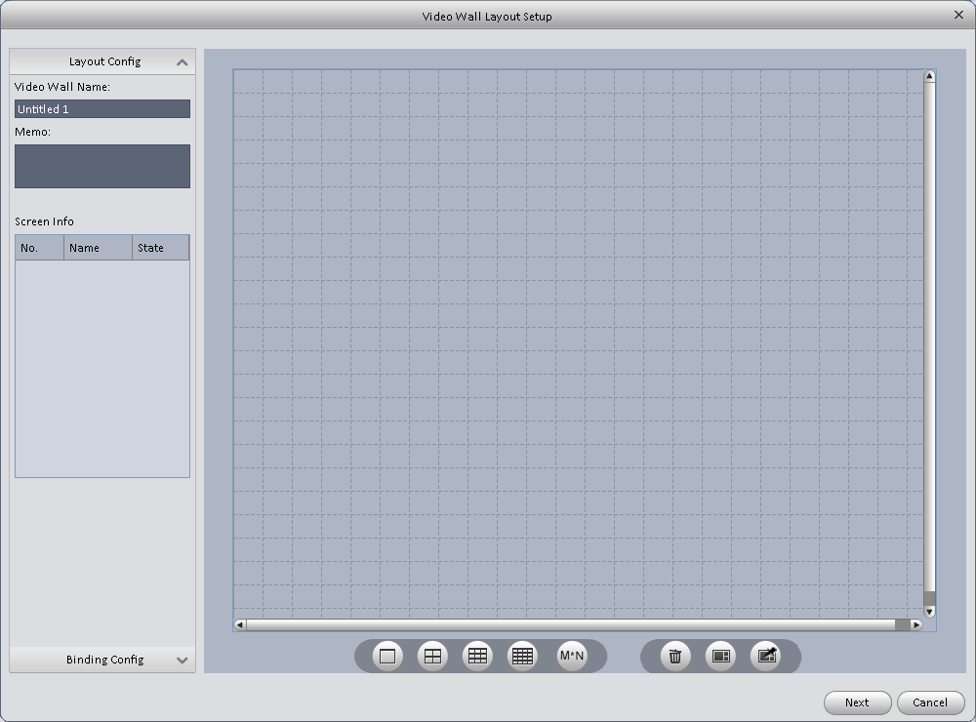
Figure 3-75

- Config video wall.
  - Enter video wall name and description.
  - Click 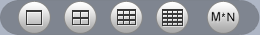 below, select layout as 1*1, 2*2, 3*3, 4*4 or M*M. Click screen to draw video wall physical layout, see Figure 3-85.

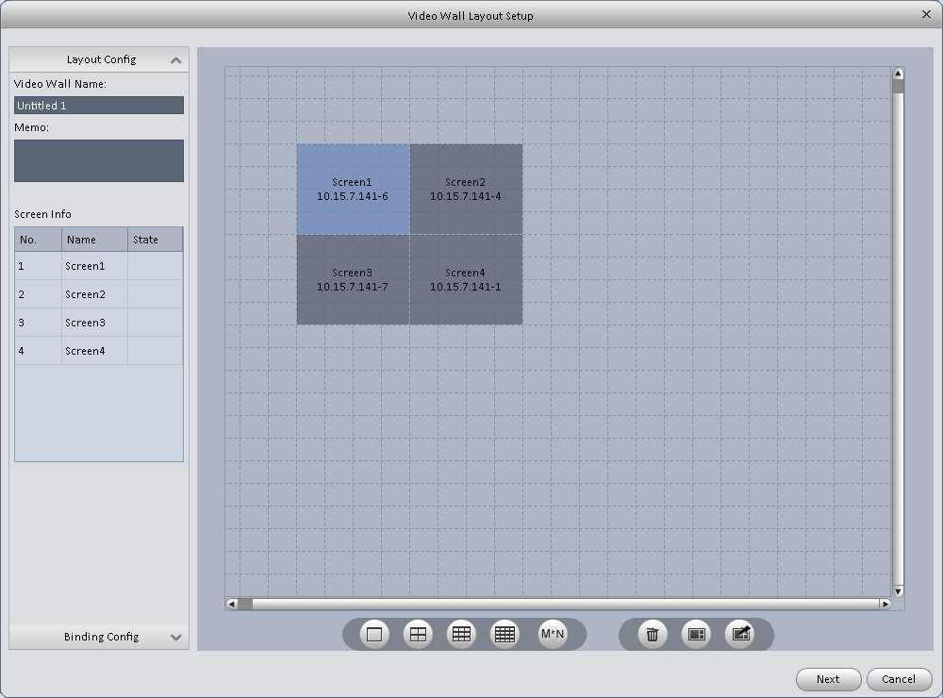
Figure 3-76

Note
- Use Ctrl+left click mouse to select several screens, right click mouse to select splicing or click , you can combine several screens to a splicing screen. Right click mouse, select unbind splicing or click , you can cancel splicing.
- Select a screen and right click to select rename or delete, you can rename screen name or delete a screen. Click, you can delete all screens.

  - Click Next button, you can go to video wall input binding interface.

- Binding decoder channel
Select a decoder channel and then drag it to the corresponding screen of the video wall. See Figure 3-86.
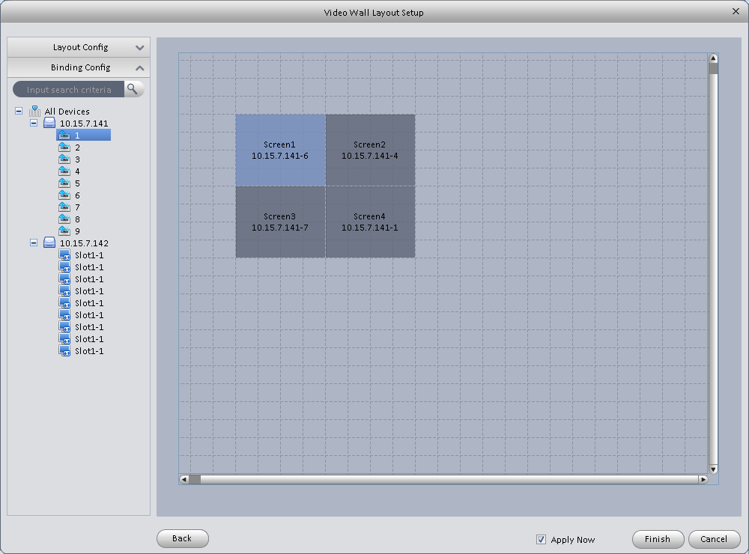
Figure 3-77
Note:
When a screen binds M30, you need to splice physical layout, otherwise you cannot bind.

- Check the box to enable setup immediately and then click Finish button, you can see an interface shown as in Figure 3-78.

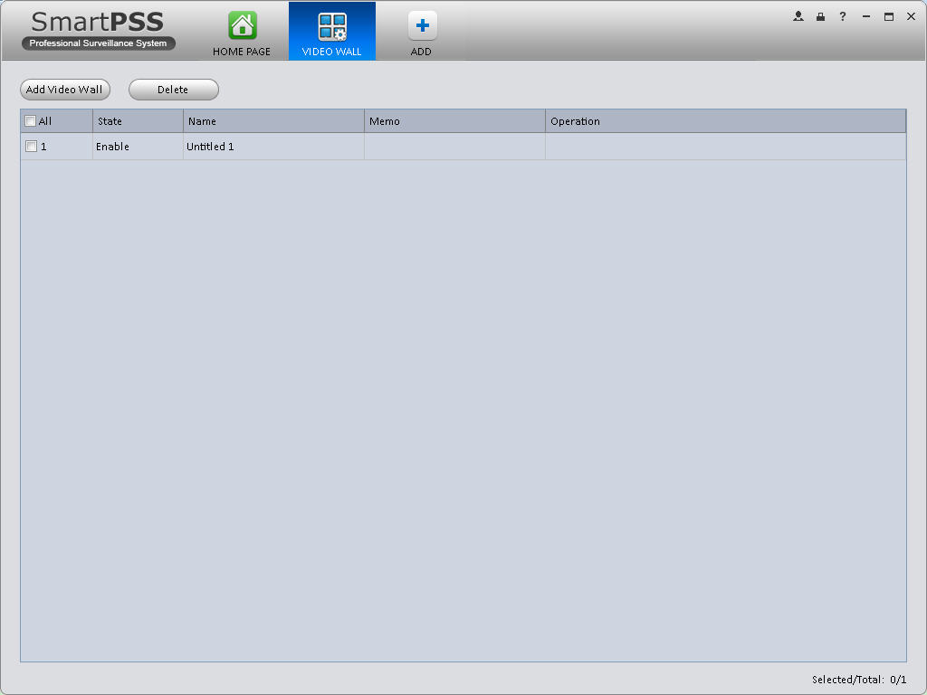
Figure 3-78
In Figure 3-78, double click a video wall, or select a video wall and then click Modify button, you can change its setup. You can also click Delete button or to remove. Click, you can change video wall on/off setup.

Basic Operation

Liveview

Real-time Liveview
In Liveview opqge, you can group device or channel and view real-time liveview.
On the homepage, click in the Basic pane, you can go to the liveview interface. See Figure 4-1.
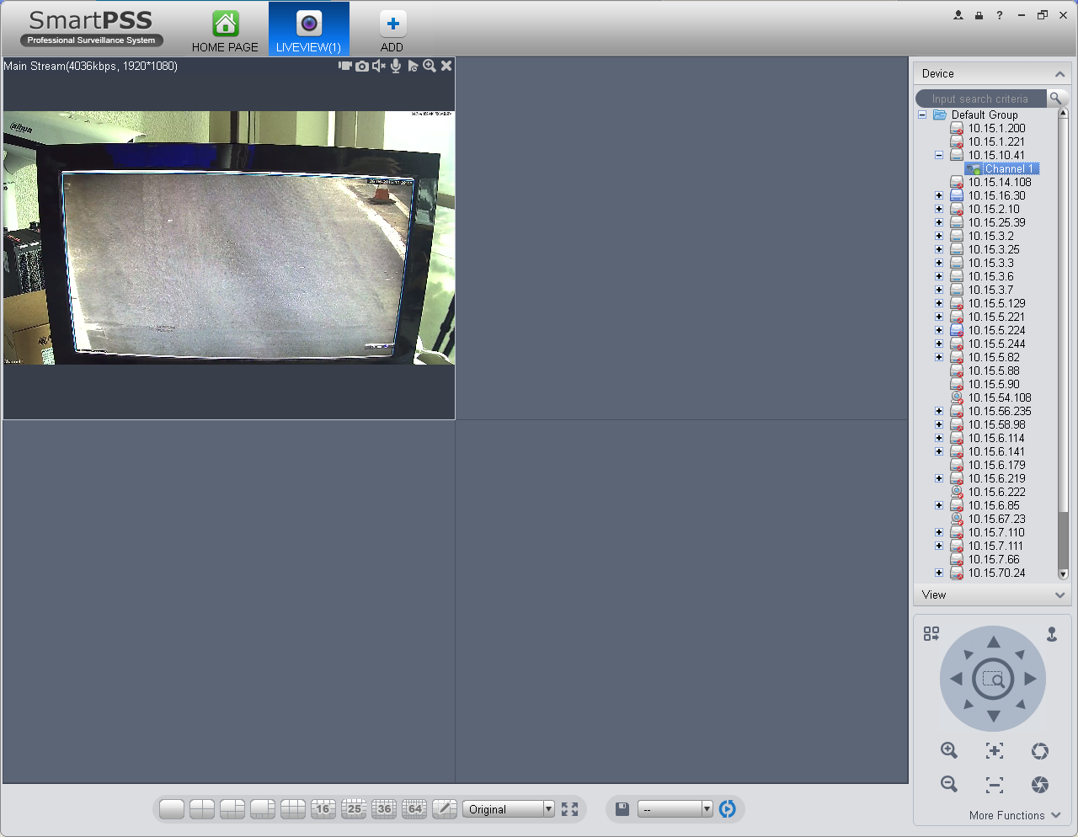
2
1
6
5
3
4
Figure 4-1
Please refer to the following sheet for detailed information.
SN | Item | Function
1 | Bit stream information and shortcut operation menu | Please refer to the following contents for detailed information.  - : Enable/disable local record.  - : Snapshot.  - : Enable/disable audio.  - : Enable/disable bidirectional talk.  - : Instant playback.  - : Digital zoom  - : Close current window.
2 | Video window | Real-time video
3 | Window split mode | - : It is to set 1-wind to 64-window mode.  - 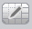: Select a window and then click this button to custmoze its setup.  - : Adjust video scale.  - : Full screen.
4 | Tour button | ：Save current view as a viewing profile. You can use it under View, Playback, and in tour interface.  Note:  When add view, check add to tour task before you can view it in tour&task.  ：Enable tour plan. Refer to Ch 3.9.  ：Close tour plan.
5 | PTZ | It is for PTZ dome camera series product only.  Here you can set camera direction, zoom in, zoom out, iris and etc.  Click advanced button to set preset, tour, aux function and so on.
6 | Device list | When default device tree is set to: device tree (by device), device tree shows device group and channel.  When default device tree is set to: region/tree (by channel), device tree shows channel.  Here you can create a new group and drag a device or channel to it.  Right click a channel, you can select main stream/sub stream or quickly go to the device setup interface.
Select a liveview window, double click a device channel on the right pane to open the video. Double click a group name; you can open all channels under current group. Right click device channel, you can switch between main stream/extra stream.
Right click liveview window, you can see an interface shown as in Figure 4-2.
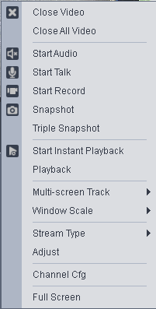
Figure 4-2
Please refer to the following sheet for detailed information.
Item | Function
Close video | Click it to close current window.
Close all video | Click it to close all windows.
Start audio | Click it to enable audio function.
Start talk | Click it to enable bidirectional talk function.
Start record | Save audio/video of current window to a record file.
Snapshot | Snapshot current window. Click it once to save one picture.
Triple Snapshot | Snapshot current window. Click it once to save three pictures by default.
Start instant playback | It is to enable instant playback in current window.
Playback | Click it to go to the playback interface to playback record of current window.
Multi-screen Track | It can split screen to 1+3, 1+5 mode for 4K camera main stream.  You can drag small box in video window.
Fisheye installation mode | It is to adjust fisheye installation mode. It includes: ceiling mount, wall mount and ground mount.
Fisheye view | It is to adjust fisheye view mode.
Window scale | It is to adjust window scale.
Stream type | Switch between main stream/sub stream
Adjust | Set video brightness, contrast, hue and saturation.
Intelligent Overlay | Overlay intelligent rule, intelligent pattern and intelligent object box in video window.
Channel setup | Click it to go to the channel setup interface.
Full-screen | Click it to switch to full screen mode. You can double click video window or right click mouse and then select exit full screen/press Esc to exit.

Record
During the liveview process, you can follow the steps listed below to record.
On the liveview interface, right click mouse and then select record button.
Or you can click the button at the top of the video window to record.
The icon becomes when device is recording.
You can right click mouse to select stop record or click the at the top of the video window to stop record.
The default record save path is SmartPSS/Record. Here you can go to chapter 3.3 General
and then select file setup icon to modify record save path.

Snapshot
During the liveview process, you can follow the steps listed below to snapshot.
- On the liveview window, right click mouse and then select snapshot. You can see system pops up snapshot dialogue box. See Figure 4-3.
Tips
You can also click at the top of the video window to snapshot.
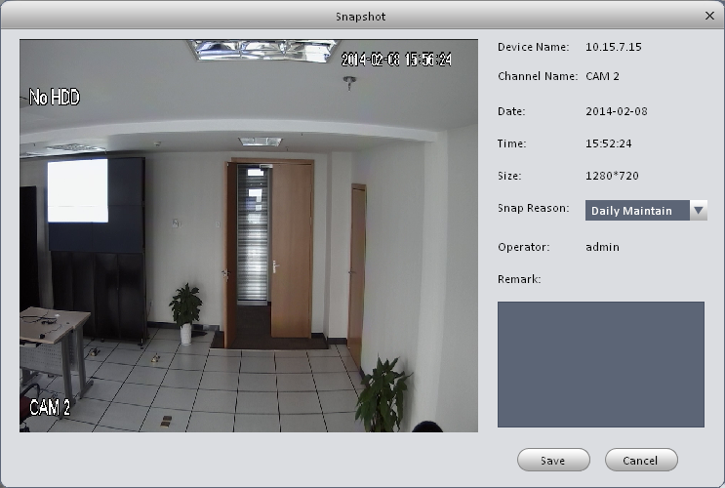
Figure 4-3
- Please select corresponding parameter from the snapshot reason dropdown list and then input the information in the Remarks column.
- Click save button, you can see system prompts “Successfully saved snapshot!”.

On the Liveview window, right click mouse and then click Triple snapshot, you can snap three pictures at one time. You can see the corresponding dialogue box if the snapshot succeeds.
The default picture save path is SmartPSS/capture. Here you can go to chapter 3.3 General and then select file setup icon to modify picture save path.

E-Map
E-map is shown in device list not. You can directly drag map into preview window for preview, as well as save map into image for next time use. Via e-map, you can better visualize position of video channel or alarm channel and see live preview of the channel or alarm status.

Edit E-Map
- You can go to device list on the right of Preview window, right click the default group or any group, select New Map, see Figure 4-4.
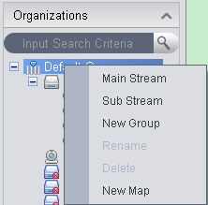
Figure 4-4
- In map name field enter name of map, select picture and save it to enter edit page.
- In map edit interface, drag video channel or alarm input you want to be displayed on map to designated position, see Figure 4-5.
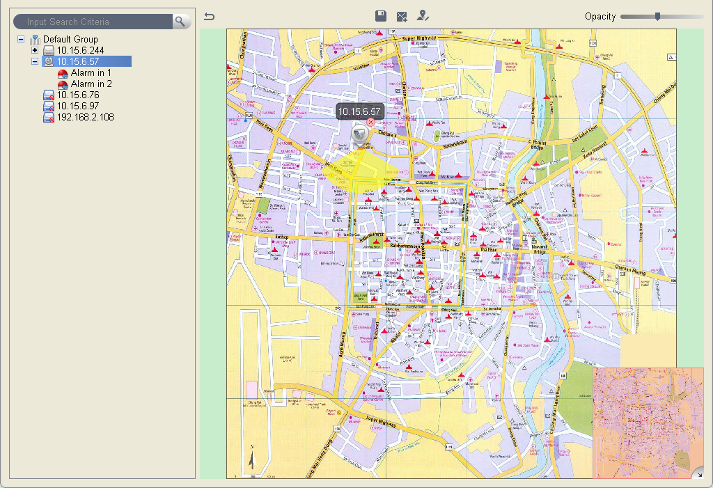
Figure 4-5

- On map set monitoring range of video channel, see Figure 4-6. You can slide the bar at the upper right corner to set opacity, see Figure 4-7.
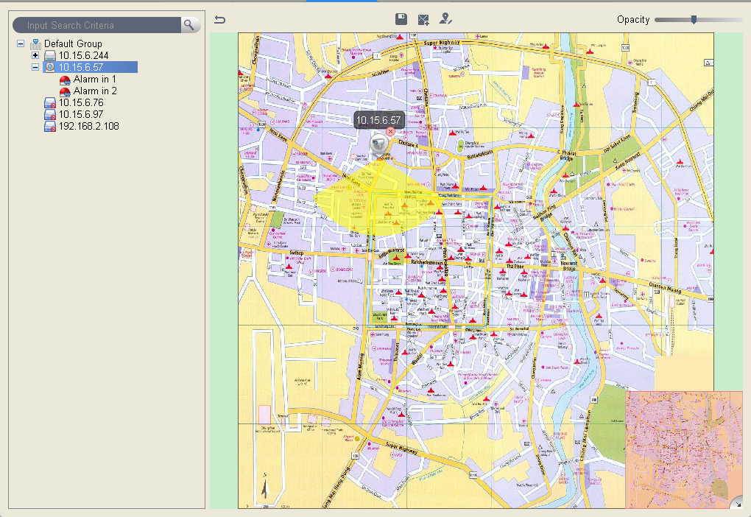
Figure 4-6

Figure 4-7

- After you finish edit, click to save map.
- Click to return to preview.
Parameter | Note
Save | Save current map you are editing.
New Area | Create new area on map.
Edit Map | Modify map name and picture.
Opacity | Set opacity of monitoring range.

Preview E-Map
You can directly drag map you want to preview from device list into idle window, or select one idle window, in device list double click map. Map can be zoomed in/out and you can move mouse to see every detailed position info, see Figure 4-8.
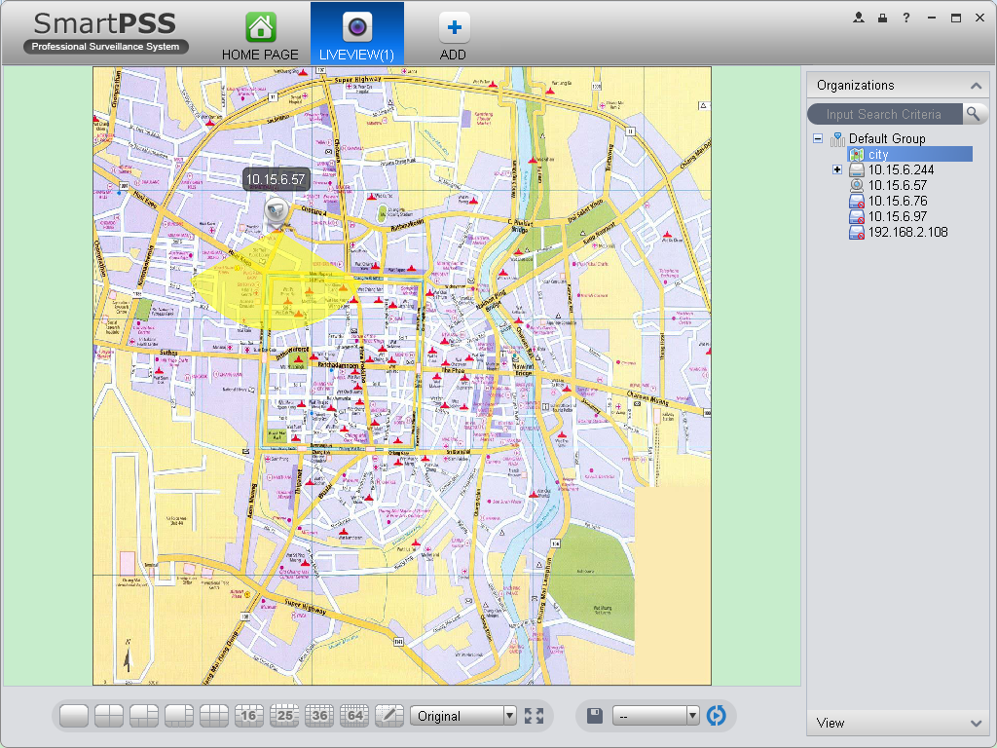Figure 4-8
After you open map, you can move your mouse to a video channel to see short preview.
You can click a video channel, then the video channel will be opened next to your mouse, see Figure 4-9. Click again to close video.

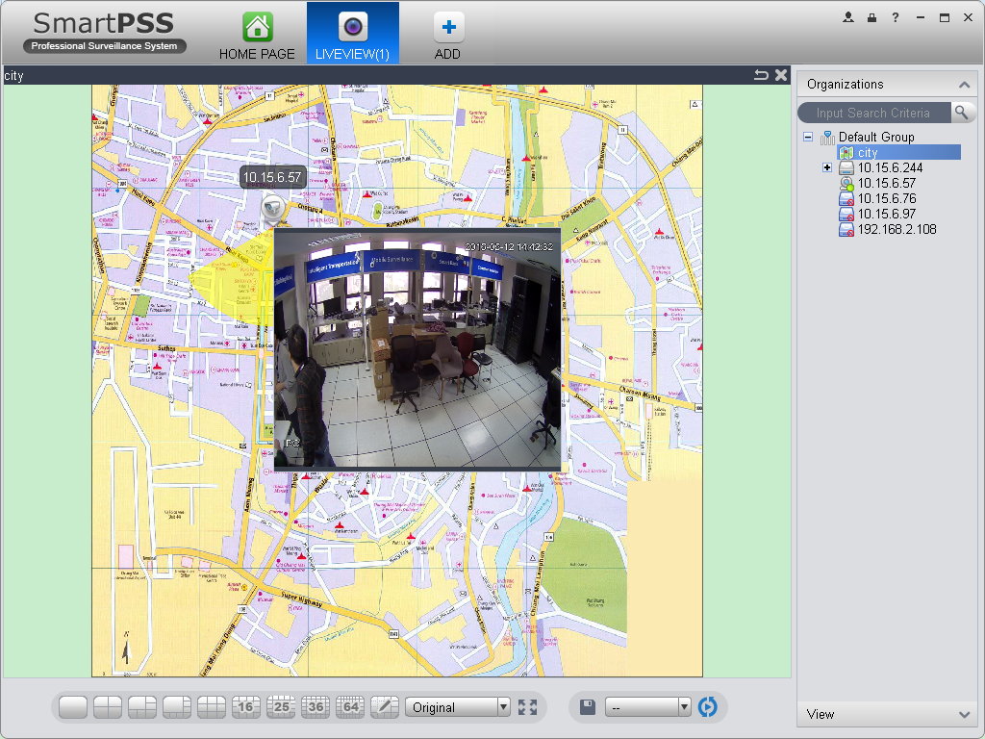
Figure 4-9
You also can right click in blank area, select open all channels or video wall to preview all channels on the map, see Figure 4-10 and 4-11.

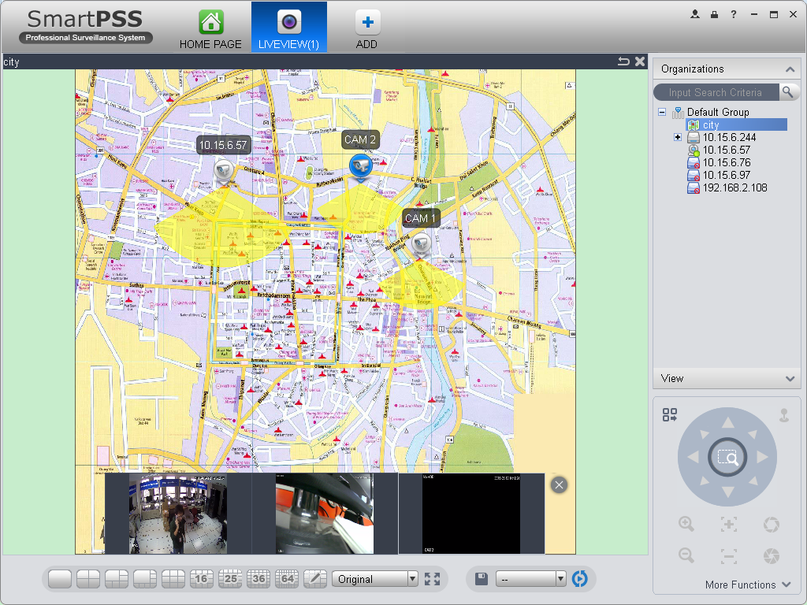
Figure 4-10

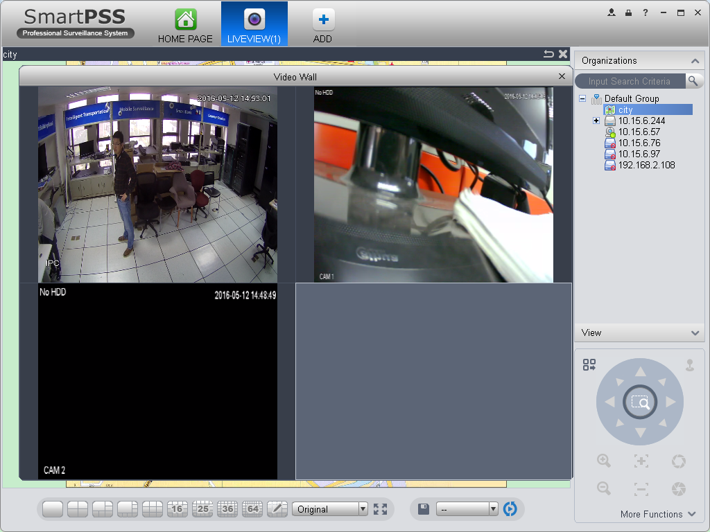
Figure 4-11

When alarm occurs, corresponding channels on map will flash.

Fisheye
Installation of fisheye includes in-ceiling, wall mount and ground.
In-ceiling supports 8 views, the ground mounted 1+4 mode is illustrated by Figure 4-4.
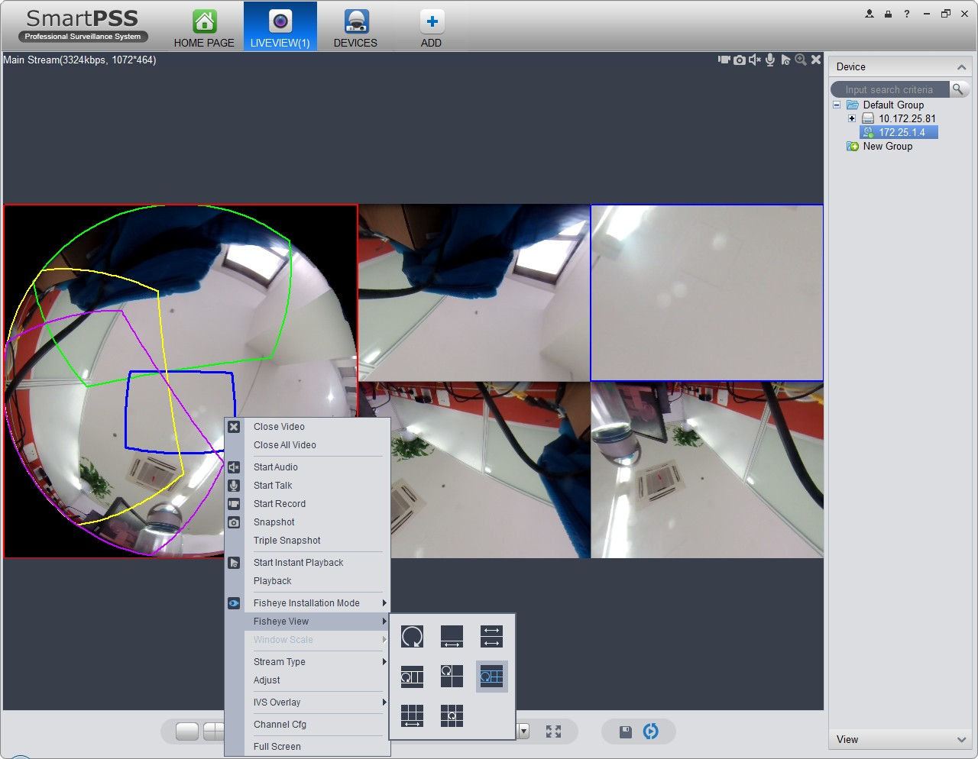
Figure 4-12

In the left, fish eye splits into 4 scene boxes, if you drag one box with mouse, as : , the corresponding above scene box will rotate.
Wall mount supports 5 views, and ground supports 7 views.

Smart Alarm
If the system configures SmartIPC device, then you can configure rule for smart channel of the device in Liveview interface.
- In Liveview interface, device list on the right, right click intelligent device, select IVS Channel Cfg. See Figure 4-4.
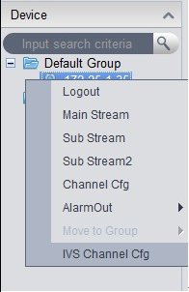
Figure 4-13
- In channel list dropdown list, select channel, see Figure 4-6.
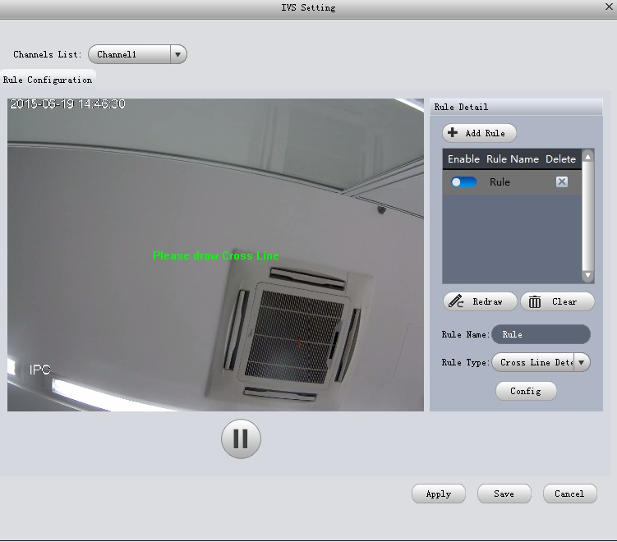
Figure 4-14

- Click . See Figure 4-6.
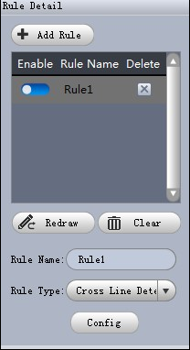
Figure 4-15

- Configure rule name, and select rule type.
- In video window, draw detection region, and right click to complete drawing.
- Click Redraw to draw detection region again.
- Click Clear to clear drawn detection region.
See Figure 4-10.
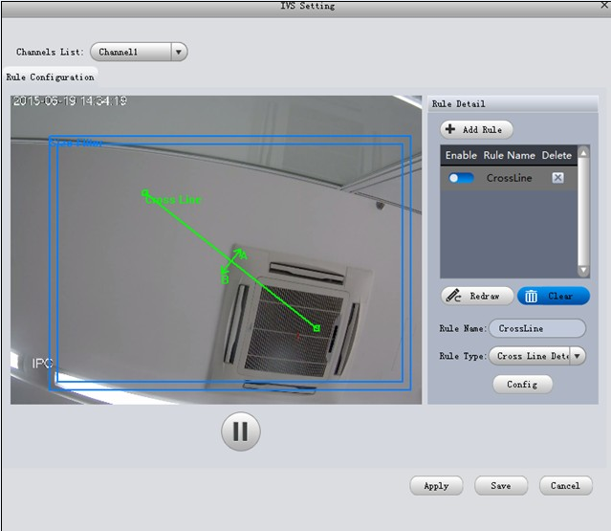
Figure 4-16

- Click Config.
- Set parameters, select “A<- ->B”, “A-->B” or “A<--B”, see Figure 4-11.
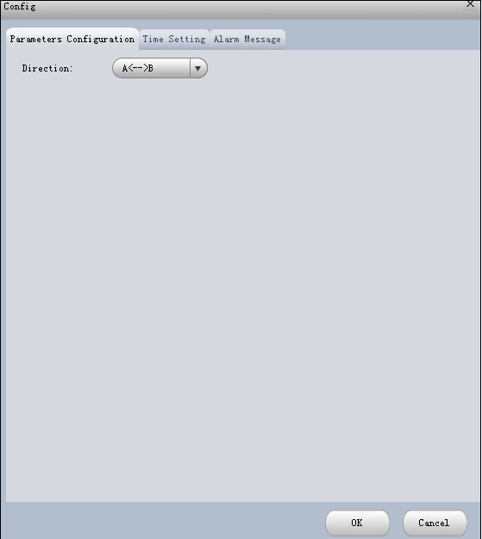
Figure 4-17

- Click Time Setting, set time, see Figure 4-12.
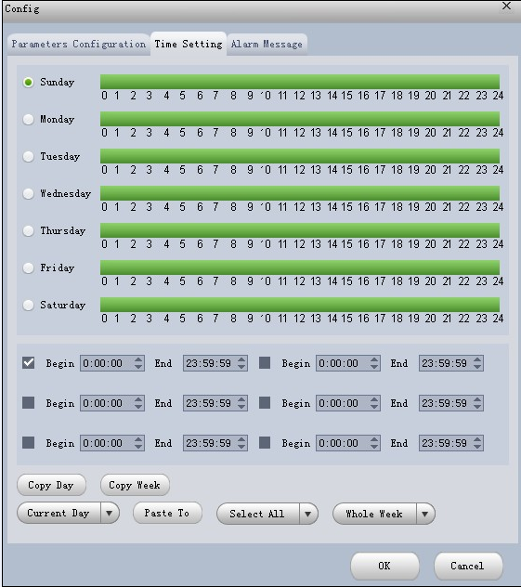
Figure 4-18

- Click Alarm Message.
- Check alarm output, record, snapshot and click OK.
- Click Apply.
When alarm occurs, in LOG interface, you can select alarm log for type, and IVS device for device name to search alarm info. See Figure 4-13.
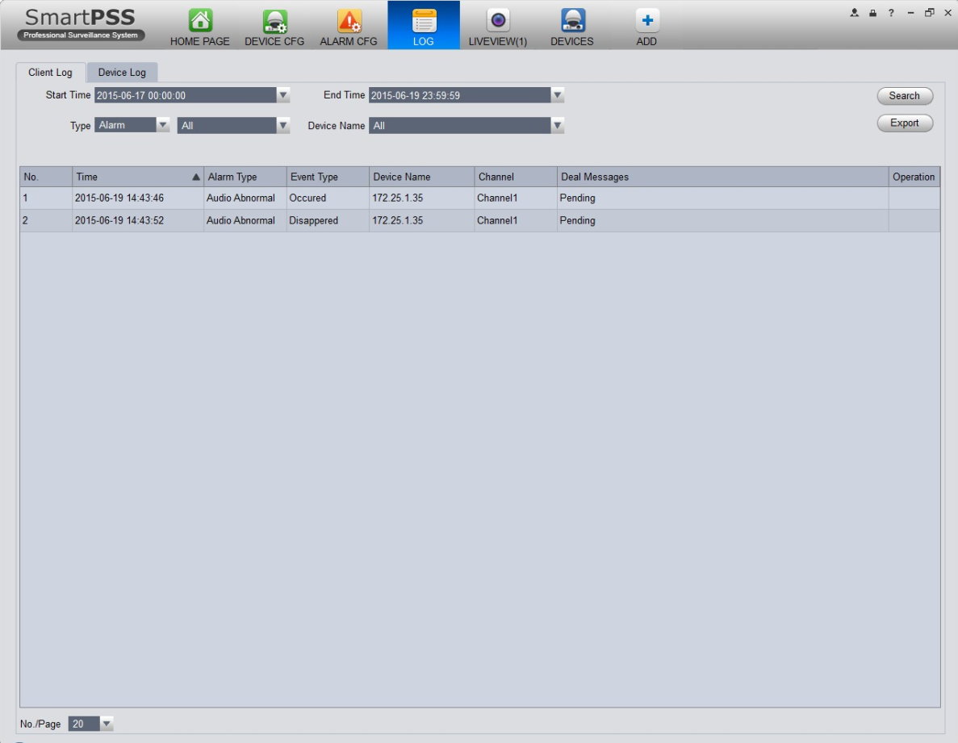
Figure 4-19

Smart Track
The system supports smart track in Liveview interface.
- In device list on the right of Liveview window, right-click smart track device, select “Smart Track Config”. System pops up Smart Track Config box, see Figure 4-14.
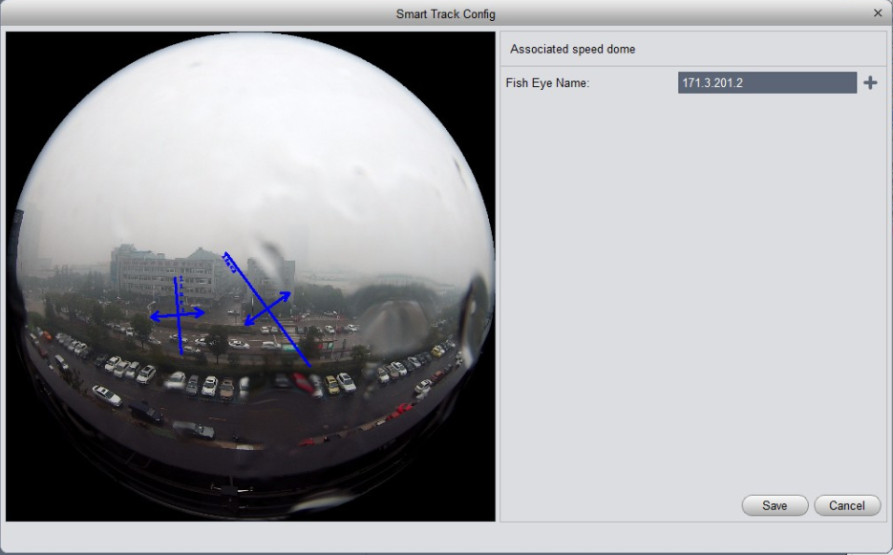
Figure 4-20

- Click , select PTZ dome device.
Note:
Do not link more than 3 PTZ cameras at the same time.
- Click Save. See Figure 4-15.
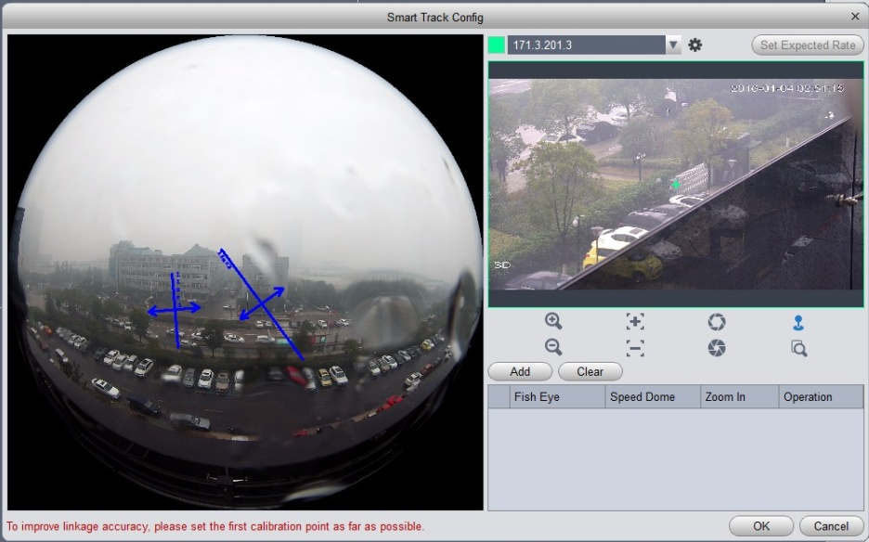
Figure 4-21
- Click Add.
- In fish-eye device list on the left,, select one point. Then image shown on the right will turn to the this selected point, click .
Note:
To improve accuracy of track, mark of first group shall be a far fixed reference object.
- Repeat step 4 and 5, add at least three points. See Figure 4-16.
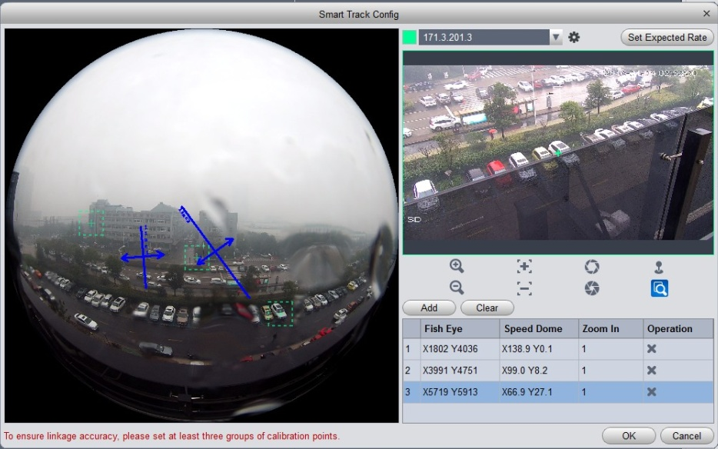
Figure 4-22

- Click OK.
- Right click device on the right in fish-eye device list, select Smart Track.
System pops up smart track box, see Figure 4-17.
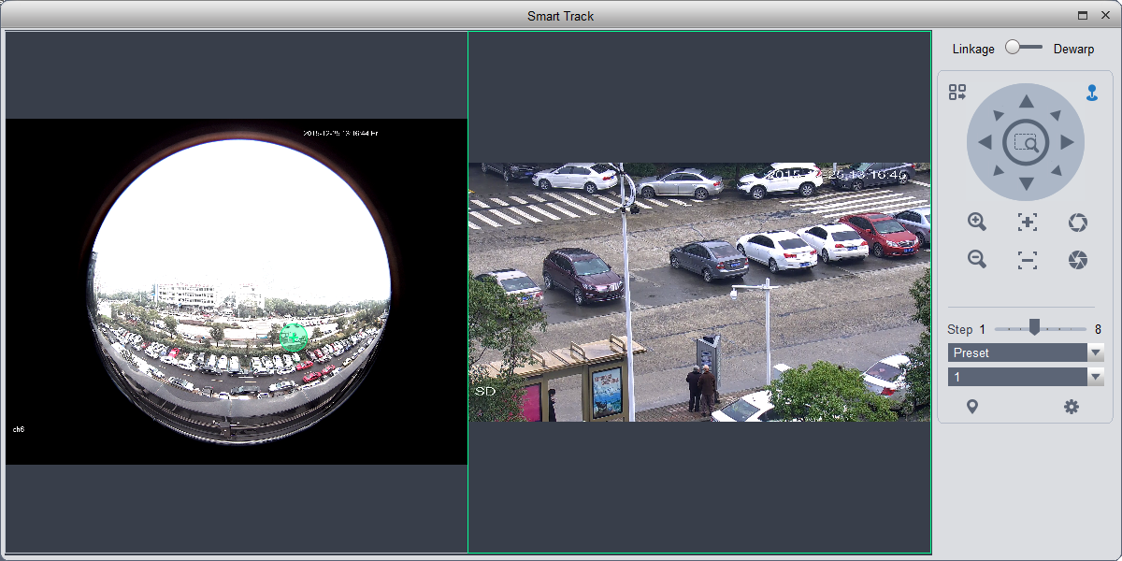
Figure 4-23
- Click a random point on device on the left, PTZ camera on the right will auto turn to the related position.
In this interface, you can correct smart track by clicking on dewarp at the upper-right corner, please refer to Ch 4.1.4.

PTZ
If the device type is PTZ dome camera, you can click the PTZ button to set. See Figure 4-24.

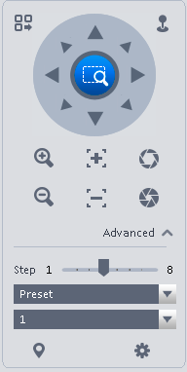
Figure 4-24
Please refer to the following sheet for detailed information.
Item | Function
PTZ menu | Click to go to the PTZ menu. See Figure 4-25.  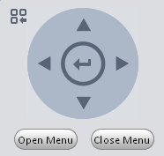  Figure 4-25
Mouse simulator | Click, you can use your mouse to set camera movement direction.
Direction buttons | It is to set camera movement direction. There are total 8 directions.  Top/bottom/left/right/top left/top right/bottom left/bottom right.
Zoom | It is to control speed dome to realize zoom function.
Focus | It is to adjust video definition.
Iris | It is to adjust brightness.
Step | It is to control PTZ movement speed. It supports value 1 to value 8.
Preset | There are 128 presets by default.  You can set camera to a specified preset.  Use direction keys to move the camera to your desired location and then input preset value. Click Set button, you have set one preset.
Tour | This function allows the camera to move between several presets.
Horizontal rotate | It is to enable horizontal rotate function.
Scan | It is to set two limits so that the camera can move back and forth.
Pattern | The camera can memorize dome operation such as pan, tilt, and zoom to repeat.
Aux | It is to set aux positioning.

Preset
This function allows you to set camera to a specified position.
Preset setup
Please note system supports a max of 128 presets by default.
- In Figure 4-24, use direction keys to move the camera to your desired location.
- Click dropdown list, select preset; click and click dropdown list. Select number within 1~128.
- Click to set corresponding preset. .

Tour
This function allows camera to go between several presets.
Important
Before you use this function, please set at least two presets.
Tour setup
- In Figure 4-24, select Tour from the dropdown list and then click button. See Figure 4-26.
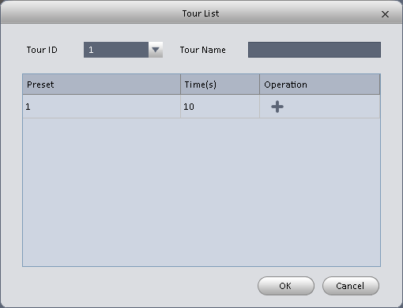
Figure 4-26
- Input tour number/tour name.
- Select preset number from the dropdown list and input stay time.
- Click button to add one preset to the tour. Select another preset number from the dropdown list and then click Add button again to add more preset to the tour.
- Click OK button to complete the tour setup.
- Click button to tour.

Pan
- Click dropdown list, select Pan.
- Click to enable Pan.

Scan
- Click dropdown list, select Scan.
- Click PTZ button, to rotate left, click , set left border.
- Rotate PTZ to right, click m set right border.
- Click to enable Scan. PTZ will rotates within the range of two borders.

Pattern
Pattern is the process of recording.
- Click dropdown list click Pattern.
- In dropdown list select number of pattern, you can set up to 5 patterns.
- Click , after button is red, operate on 8 buttons of PTZ to start setup of pattern.
- Click , complete pattern setup.
- Click , deivce will rotate accoridng to set pattern.

Aux
- Click dropdown list, select Aux.
- In Aux order box, input any number between 1~255. Each number has a corresponding function.
- Click , display function of Aux order.

Playback
After you recorded a file, you can go to this interface to playback.
On the homepage, click in the Basic pane, you can go to the playback interface. See Figure 4-27.
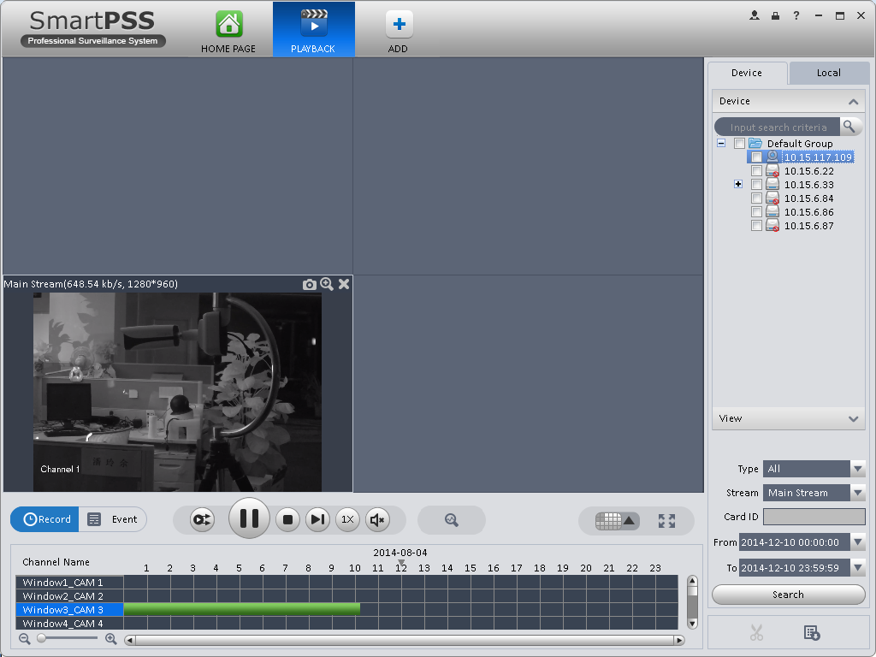
6
5
4
3
2
1
Figure 4-27
9
8
7

SN | Item | Function
1 | Shortcut operation column | There are shortcut operations to download record file and snapshot.  - : Snapshot.  - : Zoom in window  - : Close current window.
2 | Playback window | Playback record
3 | Mode | There are two playback mode: by time/by event.
4 | Playback tool bar | It is to control the playback process, audio and etc：  - ：Window sync operation button. When this function is enabled, the operation of the playback bar is for all windows. When it is in status, it is for current selected window only.  - ：It is to switch playback and pause.  - ：Stop playback.  - ：Forward by one frame.  - ：It is to control the playback speed.  - ：It is to adjust volume.  - : Motion detect the zone.
5 | Window display mode setup | It is to set window split mode. The value ranges from 1-window to 36-window.  - : Select a window and then click this button to realize customized setup.  - : Full screen.
6 | Time bar control | It is to zoom in /zoom out time line.
7 | Time bar | Playback time process.
8 | Time clip | It is to edit the time line to download the specified records.
9 | Export process | It is to export the records of the specified period.

Playback Device Record
Please follow the steps listed below to search the record you want and then playback.
- In Figure 4-27, click Device button on the upper right intergface.
- Check a channel (or some channels) on the device list on the top right pane.
- Select record type, stream type and record start time and end time.
- Click Search. See Figure 4-22. By default, system search record by “time”.
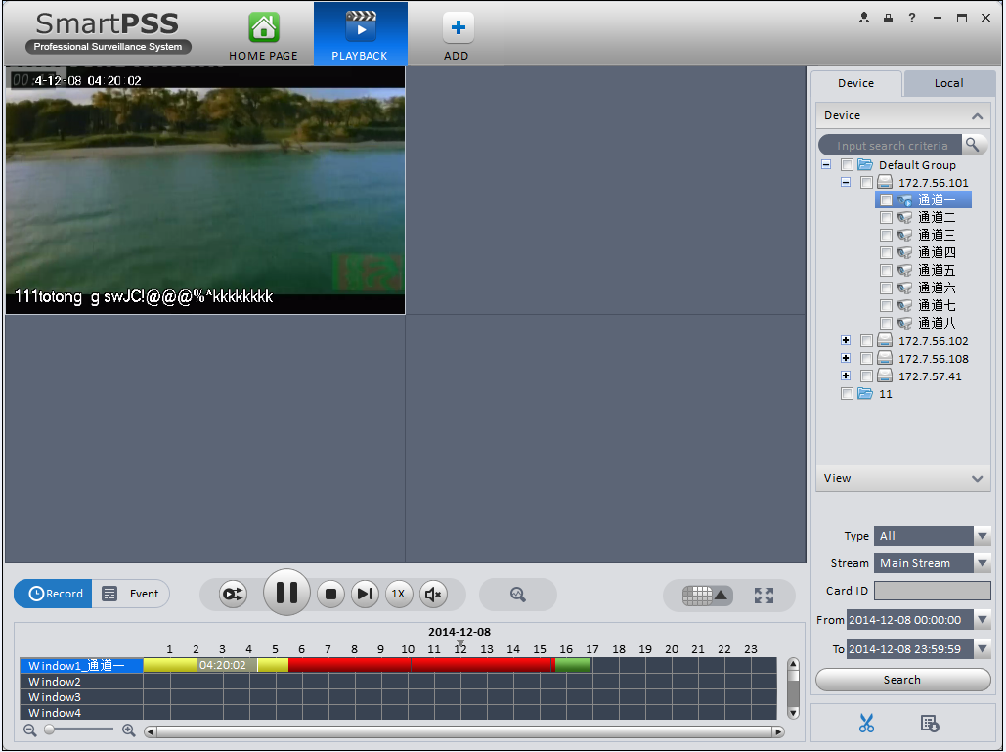
Figure 4-28
- Green color stands for the general record.
- Yellow color stands for the motion detect record.
- Red color stands for the alarm record.
- Blue color stands for card no. record.

- Click  to play record.
- Click to intelligently search motion detection. System shows motion detection window.
- Left click to select motion detection area with the box.
- Click to search motion detection. The purple time bar represents found motion detection in Figure 4-23.
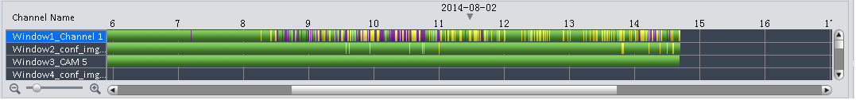
Figure 4-29
- Click to play motion detection in video window.
: Re-select motion detection area.
: Exit intelligent search.
- Click event below video window. System search record file by event.
- Click , to playback record. See Figure 4-24.
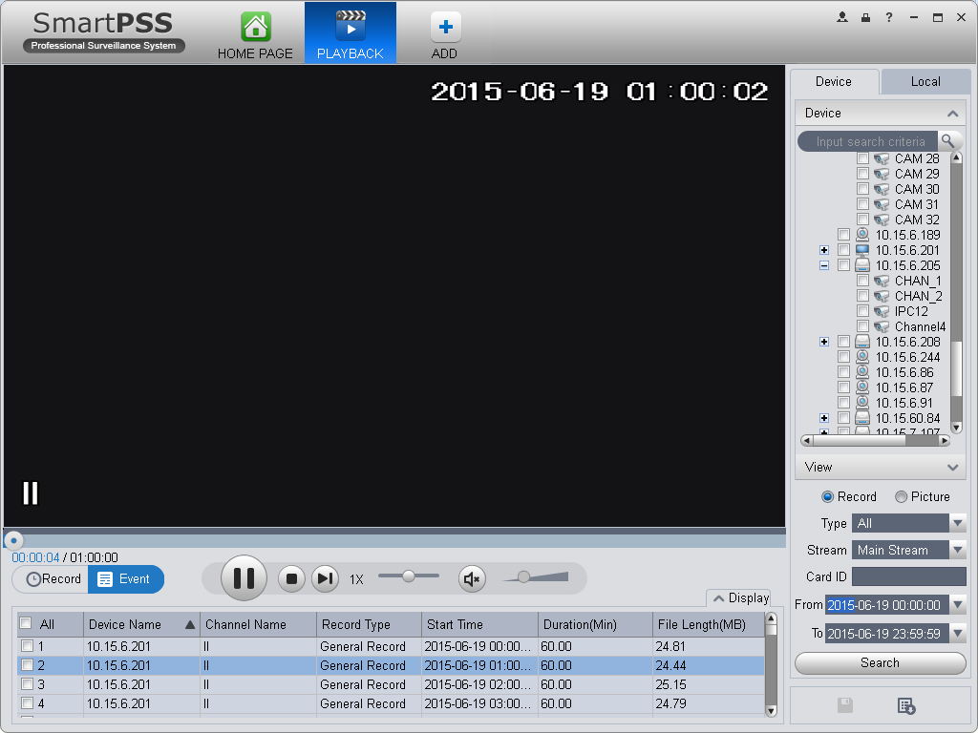
Figure 4-30
- Select Picture on the right.
- Configure search time, click Search. System shows snapshot, see Figure 4-25.
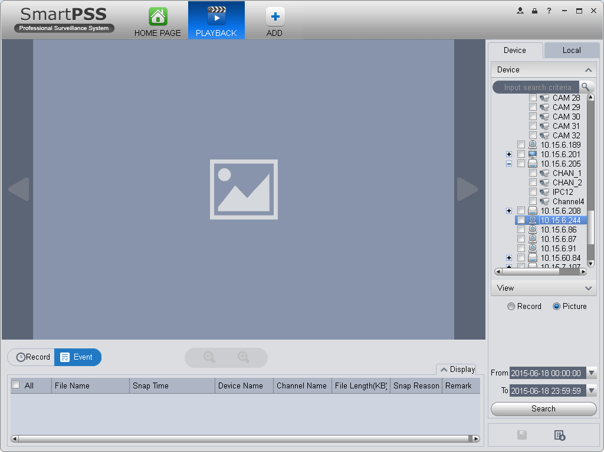
Figure 4-31
You can click to view snapshot.
- (optional) You also can playback record under View.
  - In Liveview interface, click at bottom.
System pops up Figure 4-26.
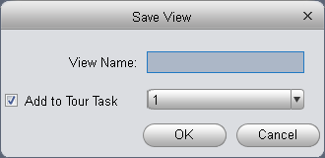
Figure 4-32
  - Input video name, click OK.
  - On the right, click View tab, right click newly added view, select Playback.
  - System auto jumps to playback window, and shows process bar at the bottom.
  - Click to play record, see Figure 4-27.
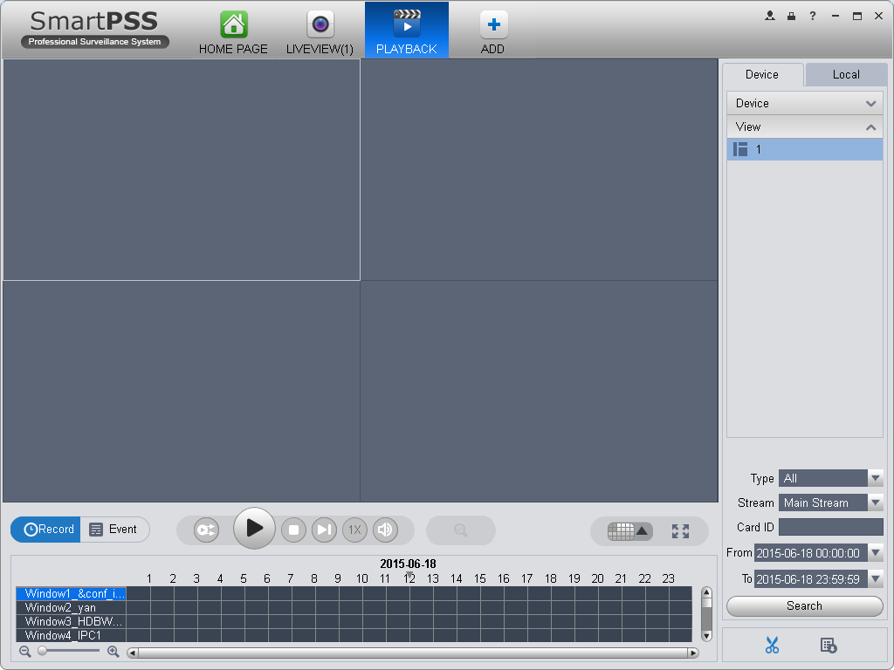
Figure 4-33

Playback Local Record
Please follow the steps listed below to search the record you want and then playback.
- In Figure 4-27, click Local button on the right pane.
- Check a channel (or some channels) on the device list on the top right pane.
- Set search for record or picture, and select local record or picture time to search.
- Click to search record or snapshot of the device at Liveview (see Ch 4.1.2 or 4.1.3).
- Now you click to playback window. And click to rewind. Click to view picture.

Export
There are three ways for you to select export records.
- In Device record interface, select periods on the time line and then click to export records.
- In Record event interface, select record type and then click to export records.
- In Local record interface, check the records first and then click to expoer records.
You can see the export interface is shown as in Figure 4-34. Select the corresponding export path and then click OK button to export.
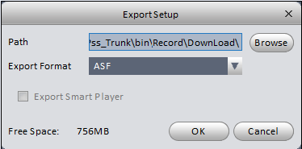
Figure 4-34
You can click to view exporting and exported conditions.

Fisheye Playback
You can use fish eye to playback device record and local record.
For example to play local record.
In playback window, click local record tab.
After you search out record, you can select fisheye view to playback the record. See Figure 4-29.
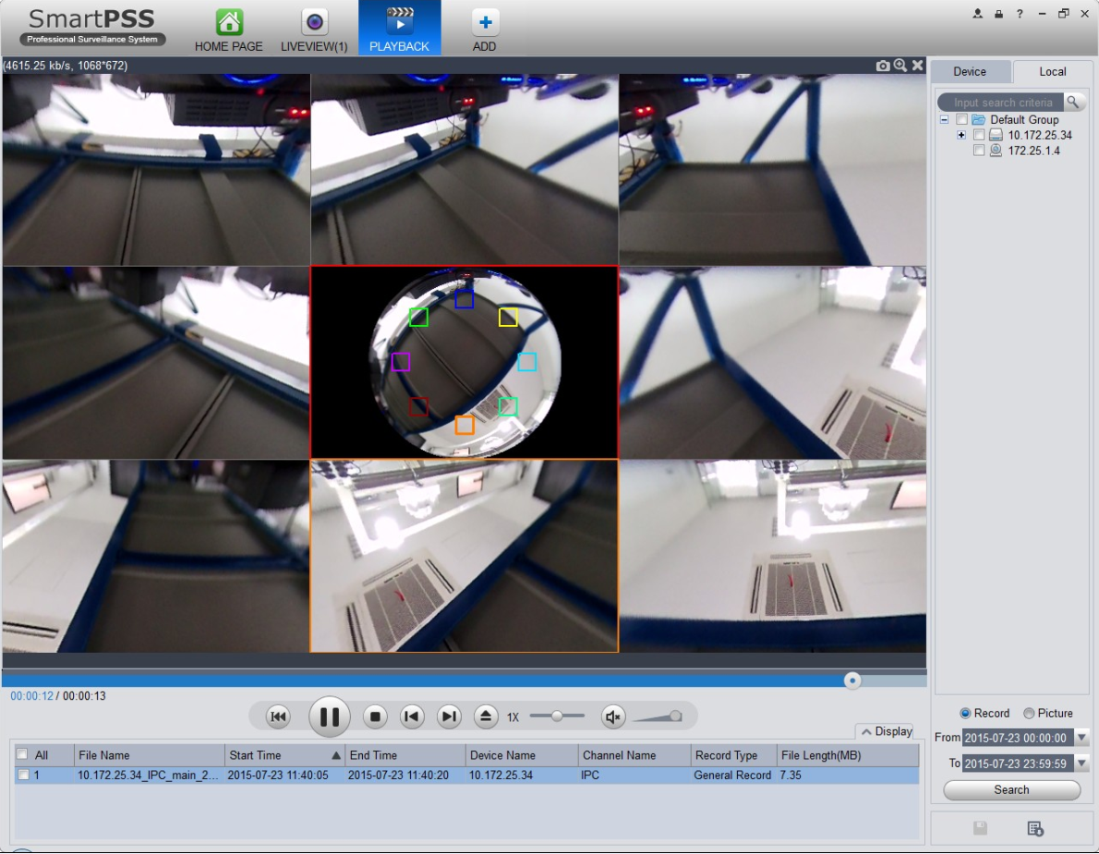
Figure 4-35

Alarm Manager
If you have set an alarm scheme, you can see the corresponding alarm in the Alarm manager interface. You can refer to chapter 3.7.1 to set an alarm scheme first.
Click icon  in the basic pane, you can go to Alarm manager interface. See Figure 4-36.
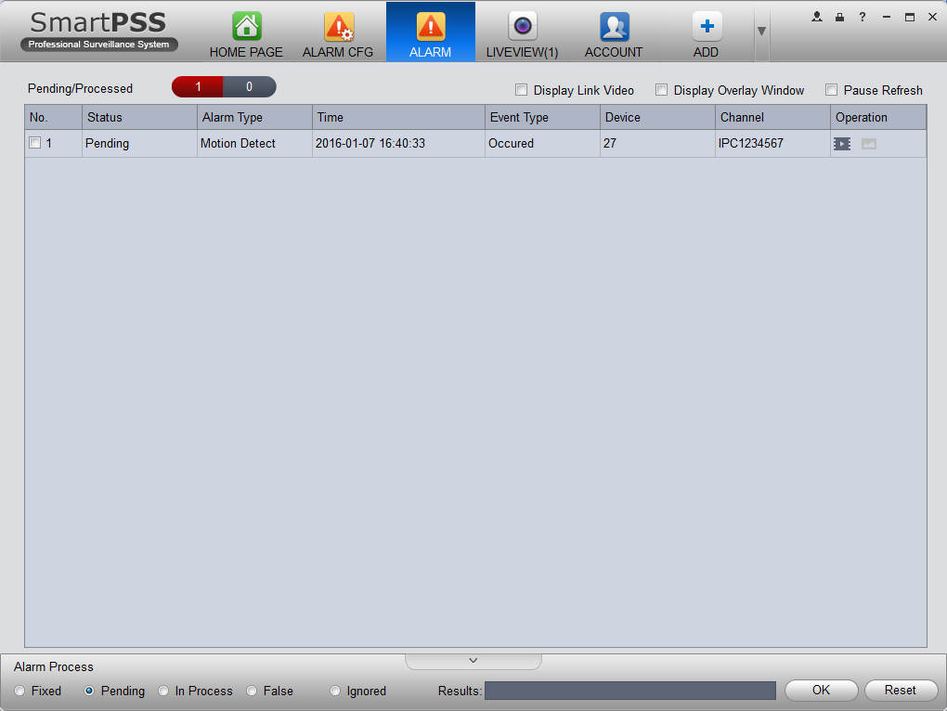
Figure 4-36
You can click next to operation column in alarm interface to view linked record, and click to view linked snapshot.
If you have set alarm activation video function in your alarm scheme setup (chapter 3.7), you can see system instantly shows video window. See Figure 4-37.
If you check the box at the bottom of the interface to pause refresh, the new alarm info will not be shown in alarm list instantly. Click Alarm Manager at the right bottom of the interface, system goes to the alarm manager interface for you to view the corresponding alarm record.
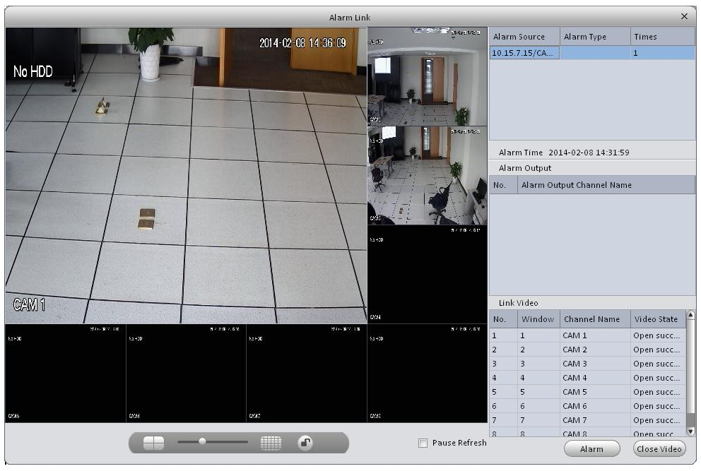
Figure 4-37

Video Talk
It supports call, live preview, remote unlock, message sending, right config and info search.
For fence station, you shall select device type as fence station on WEB. Go to System Settings>Local Config>Device Type, select device type as fence station. In System Settings>LAN Config set building no., unit no. both to 0, set MGT center IP to the installation IP address of SmartPSS.VTO select its building no. and unit no. according to actual condition on WEB. On VTO web, you can create room no., and VTH config self room no. and VTO on device local GUI while room no. must exsit on corresponding VTO.
For example, Unit 1, Building 1. VTO WEB can create room no., VTH config its room no. and corresponding VTO on device local GUI.

Note:
After fence station and VTO web interface are configured, you need to add to SmartPSS Client, please refer to Ch 3.5 for steps to add device.

After device is added, in SmartPSS Client video talk interface, in the device tree on the right, building no., unit no. reported by each device will create device tree. Fence station shoes its own name.

VTS Center
In homepage Basic function area, click .
System pops up “video talk” VTSinterface, see Figure 4-38.
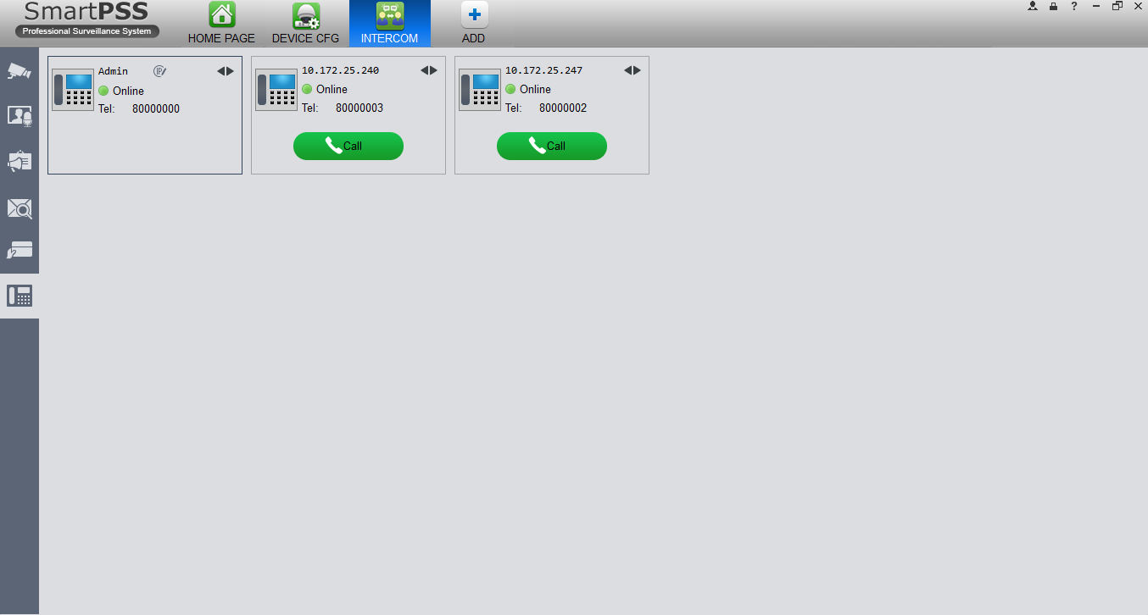
Figure 4-38
VTS address is the address required by talk with device tree, system will auto get local address. If local IP address is not set, the gotten address will be 127.0.0.1. User fill in and confirm, as well as click to set again.
A user can select online or offline and in offline status, all incoming calls will auto be transferred to other idle VTS.
Currently only support VTH transfer, cannot transfer VTO. If VTO is connected to VTS directly, then VTS has the priority to answer call.
A user can click sequence button or click and drag VTH to sort, then incoming call be answer according to this sorted sequence.
A user can answer call or transfer call, see Figure 4-39.
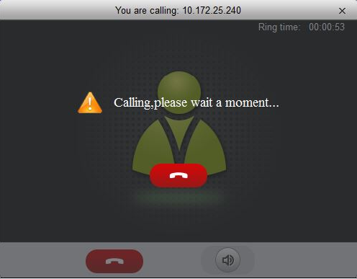
Figure 4-39

Monitor
Click Monitor tab.
In Monitor interface, you can unlock, one-way call fence station or VTO and other operations, see Figure 4-40.

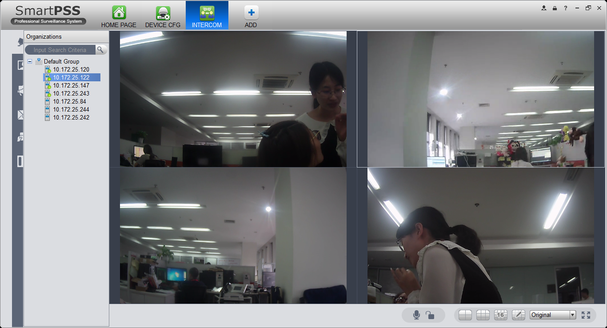
Figure 4-40

Click in the window, or at lower bottom, or right click to select start call.
All of these allow client to one-way call VTO or fence station, so the VTO or fence station can hear call from client.
Click in the window, or at lower buttom, or right click to select unlock.
Click , in the window, or right click to select snapshot, start record.
You can snapshot or record the live preview.
In video window, right click menu includes snapshot, record, switch string type, adjust window scale and etc. Please refer to Ch 4.1.

Talk
Click talk tab.
Below contact there is info of fence station or VTO in format of unit, and on the right there is VTH under this unit.
See Figure 4-41.
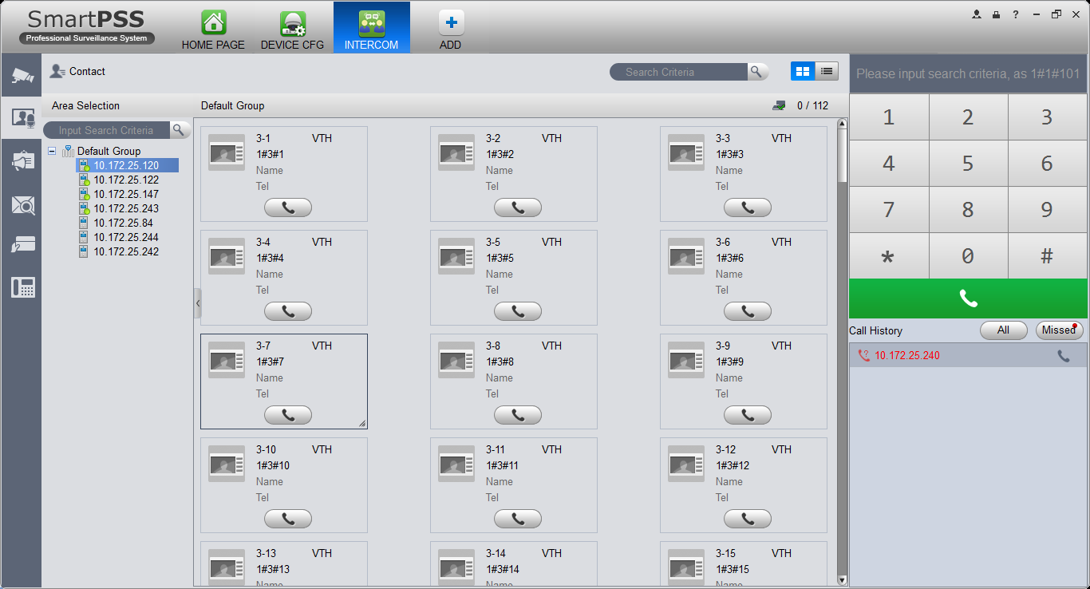
Figure 4-41
Click VTO.
It shows detailed VTH under fence station and VTO, shows status of device registration to client and VTH online number and total, if failed, then you can talk to VTO/fence station/VTH; user can click to switch VTH display mode, see Figure 4-42.

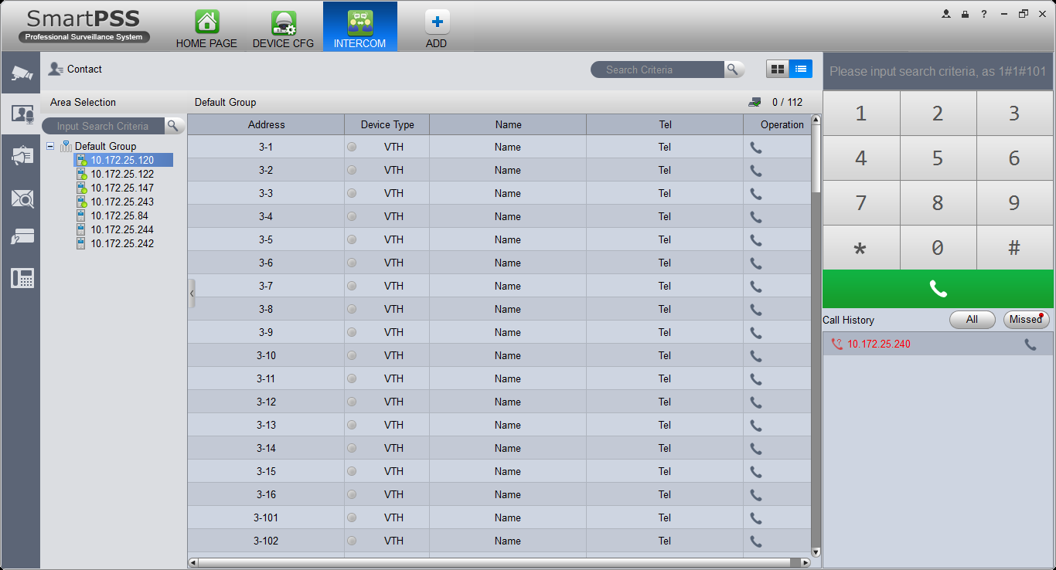
Figure 4-42

- If client needs to call VTO in a certain unit.
  - Right click VTO and select shout.
System pops up a box, see Figure 4-43.
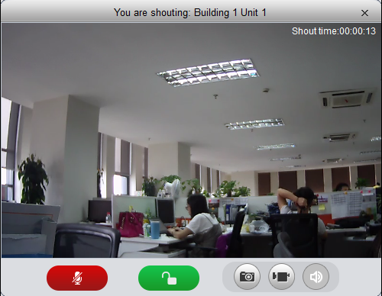
Figure 4-43
  - Click .
  - System pops up dialogue box, click OK.
You can remotely unlock VTO.
  - Click , to stop existing call.
Call window will not close.
- If client needs to call a VTH in a specific room and unit.
  - Click on VTH name card.
Please note client and VTH can talk to each other as a bidirectional talk.
System pops up a box, see Figure 4-44.
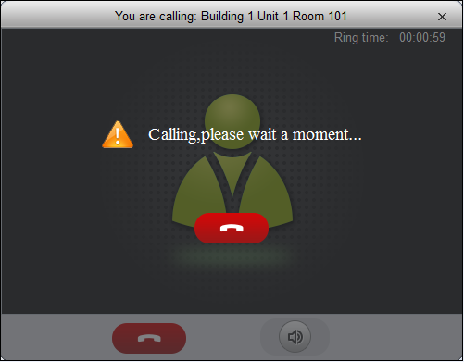
Figure 4-44
  - When VTH picks up, client can talk with VTH.
See Figure 4-45.

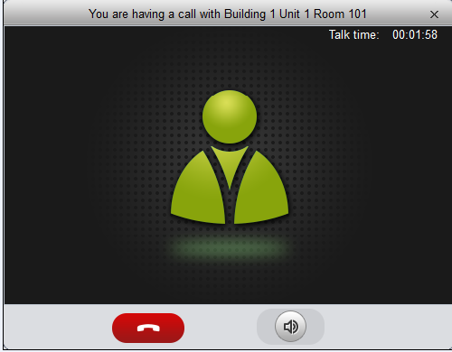
Figure 4-45
- If VTH does not answer over 60s, then client pops up a box to ask if you want to dial again. You can click to re-dial.
- If the VTH is busy or hang up call, client will ask you to try again later.

- If VTO is calling client.
Client pops up VTO call box, see Figure 4-46.
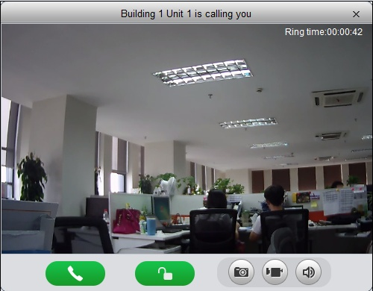
Figure 4-46
You can click to answer VTO call, and start a bidirectional talk.
You can click to unlock.

- If VTH is calling client.
Client pops up VTH call box, see Figure 4-47.
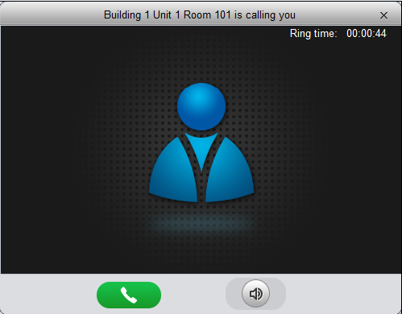
Figure 4-47
You can click to talk with VTH.

If there is missed call, in talk interface, in the lower-right, missed calls are shown here. See Figure 4-44.
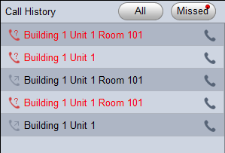
Figure 4-48
You can view all call histories.
Click to call missed call.

When you search in , it requires accurate building no., unit no., and fuzzy room no. For example, input “1#1#” as to search all devices under unit 1, building 1. If input “1#1#10” as to search all VTHs under room no. 10.

You also can set name and telephone phone number on each device name card and when search, directly input “building no.#unit no.#name keyword” to search.

On the right, you can directly dial 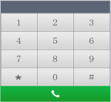 to callVTO as a one-way talk, to call VTH as a bidirectional talk. Example: dial 1#1#6901, as to call Building 1 Unit 1l enter 1#1#101 as to call Building 1 Unit 1 Room 101 VTH.

Announcement
Click announcement tab.
Input title, contents, see Figure 4-49.
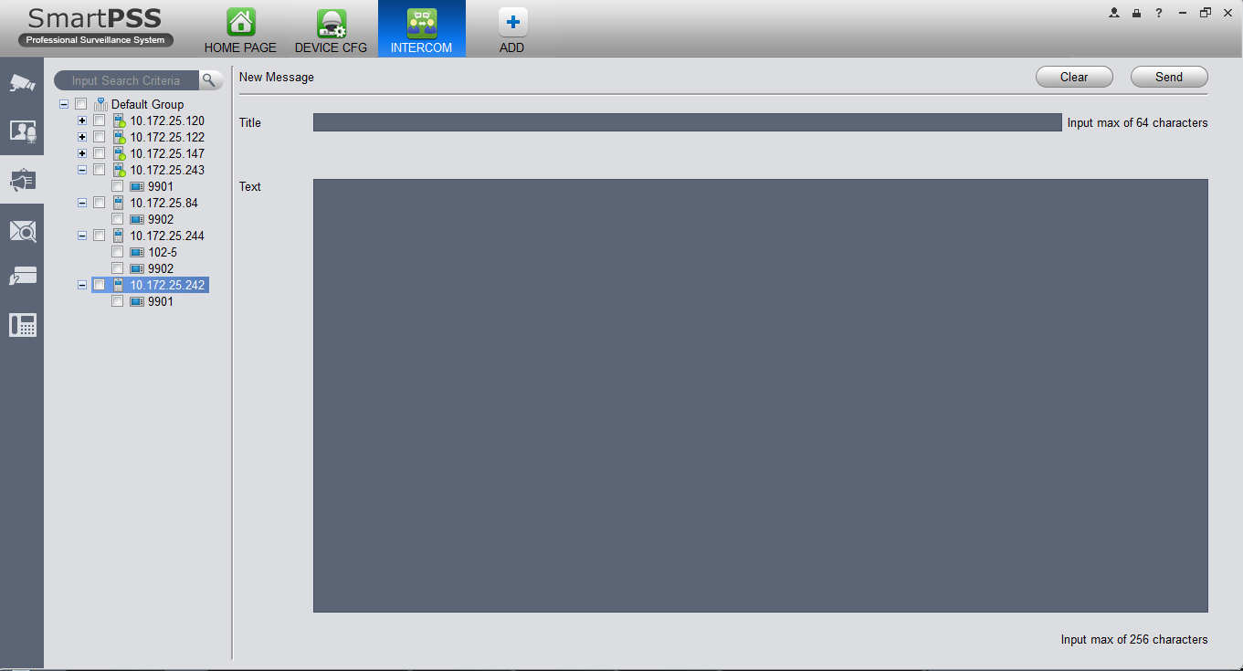
Figure 4-49

In the device list on the right, check one or more VTHs, click send.
During sending, the send button is grey, and if you want to continue to send announcement, you shall wait until the send button resumes. You can view announcement information on VTH.

Info Search
Click Info Search tab, sub tab includes alarm record, unlock record and call record.
Alarm record user can search VTO and VTH alarm event, support pop-up display of VTO alarm event, see Figure 4-50.
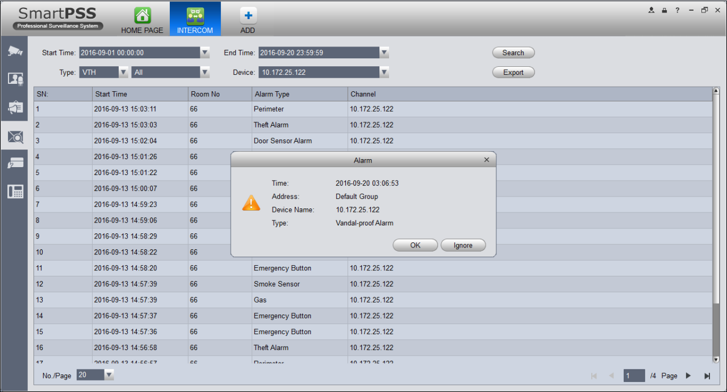
Figure 4-50
Unlock record allows user to search VTO unlock record, see Figure 4-51.
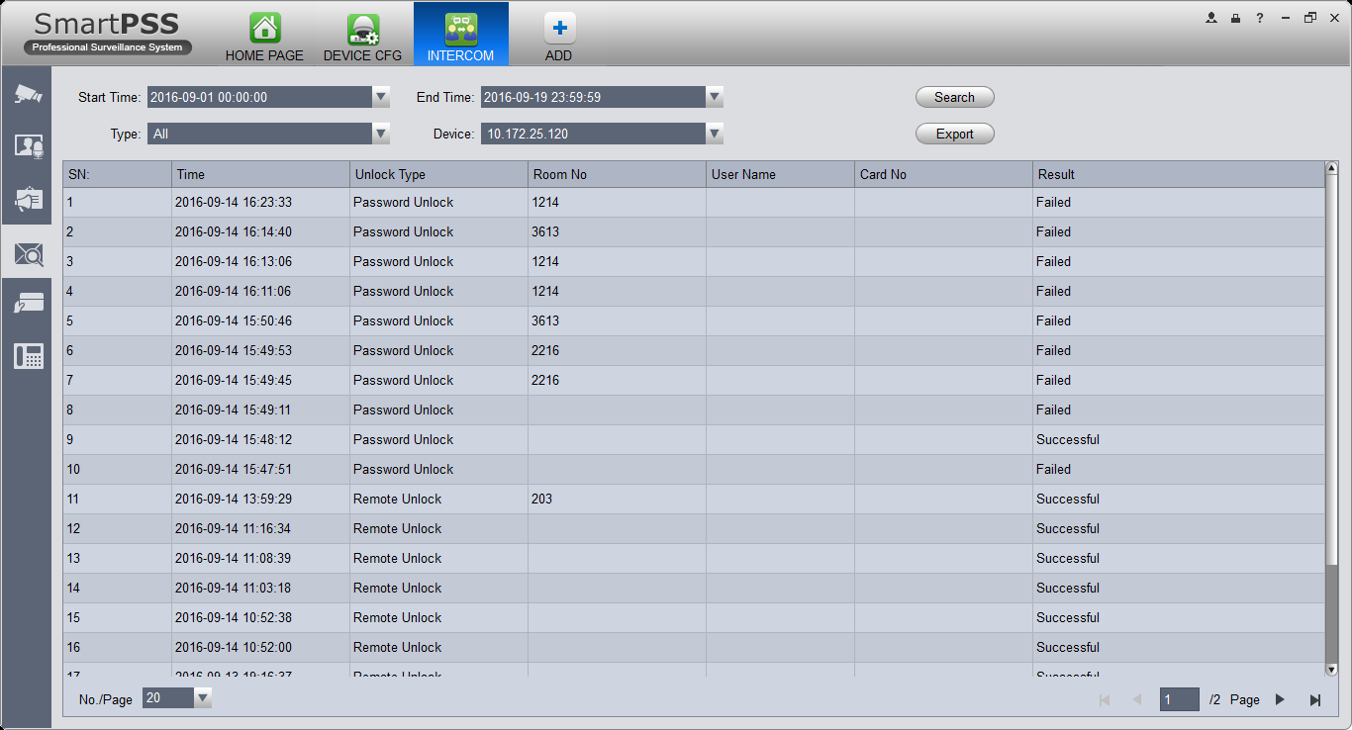
Figure 4-51
In call record, user can search VTO call record, see Figure 4-52.
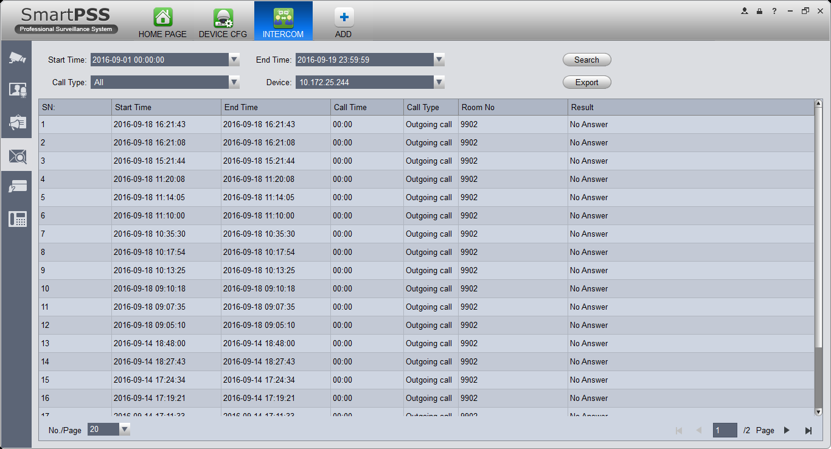
Figure 4-52

Issue Card
Click Issue Card tab, see Figure 4-53.
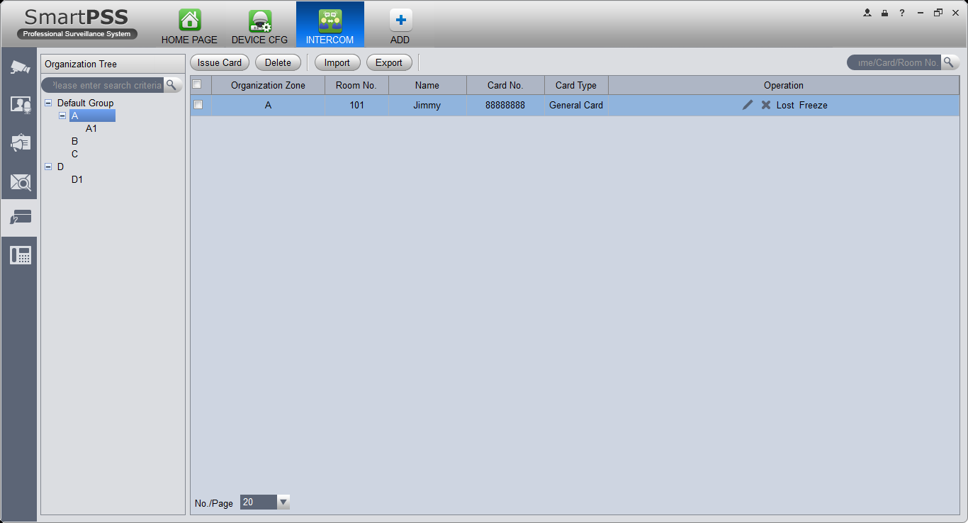
Figure 4-53
In search, room no., room no. shall be accurate but name support fuzzy search.
When a user selects node where the user issuing card is, then click Issue Card, see Figure 4-54.
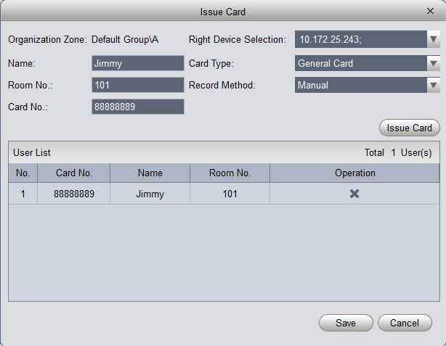
Figure 4-54
Operation steps:
- User can select device to authorize, click the dropdown list of device, check device (fence station is checked be default); user also can give priority to group config and authorize right to device under this group, and click Link Device on the right of organization node, to select default device.
- Fill in username.
- Select card type: user card, administrator card.
- Fill in room no.
- Select record method:support manual input and card issuer. Manual issuing requires user to fill in card, and click Issue Card button. If via card issuer, user click Start Read, when card is successfully read, the system will auto link user to card issuer list; if card eixsts in device, it will fail.

Access
SmartPSS integrates access control device with effective management and configure of device. It achieves modularization of access business and integrates access with video link and e-map.
Note:
Access controller must be added into SmartPSS client, please refer to device adding steps in Ch 3.5.
Access device default port no.: 37777, username: admin, password: 123456.
Added access controller are all configured in SmartPSS device, please see:
- General-Network (refer to Ch 3.6.1.1), support device IP setup.
- System Maintenance-User (refer to Ch 3.6.4.1), support device password setup.
- System Maintenance-System Maintenance (refer to Ch 3.6.4.2), support device time setup and upgrade.
After device is added, in SmartPSS client Access interface, in device tree on the left, device tree is auto created.
In BASIC area in homepage, click 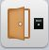 to enter Acess interface.

Console
In Access interface, you can click  on the left to enter Console interface which can monitor and control all access control devices. See Figure 4-55.
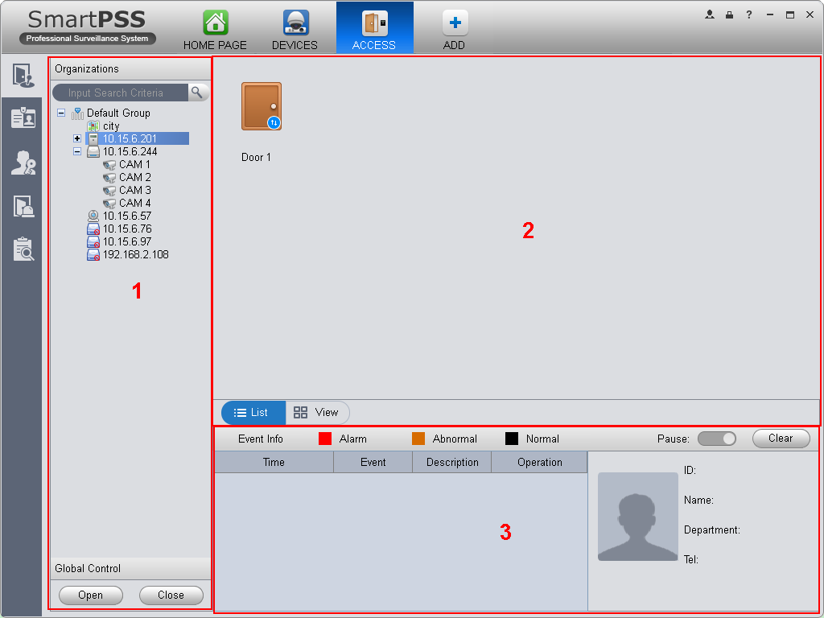
Figure 4-55

No. | Parameter | Note
1 | Organizations/Zones | Organizations：according to device（channel）, set group and e-map.  Zones：axcording to channel, set group, e-map.  By default, it shows organizations, you can go to Homepage-Settings-General-Basic, to set organizations.  Search support keyword of each node.
2 | List/View | List：Access status displsy and control.  View: Video/e-map preview and control.
3 | Event | Access event：view alarm event, abnormal event and normal operation.  View event：device info and user info.

Organizations/Zones
You can right click New Group at node, to drag device or channel into different groups for management, and right click on node, see Figure 4-56.
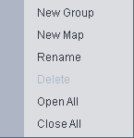
Figure 4-56

Parameter | Note
New Group | Create sub group, rename group and delete group.  Note:  Only when group node is null, you can delete it. You cannot delete default group.
Open/Close All | Open\Close accesses under all groups.
New Map | Create e-map, click New Map, enter map name and select picture to enter map edit, see Figure 4-51.  - Access/video channel dragging  - Video monitoring range setup  - Monitoring range opacity setup  - Add hot zone, max 3 hot zones  - Edit map  - Save map

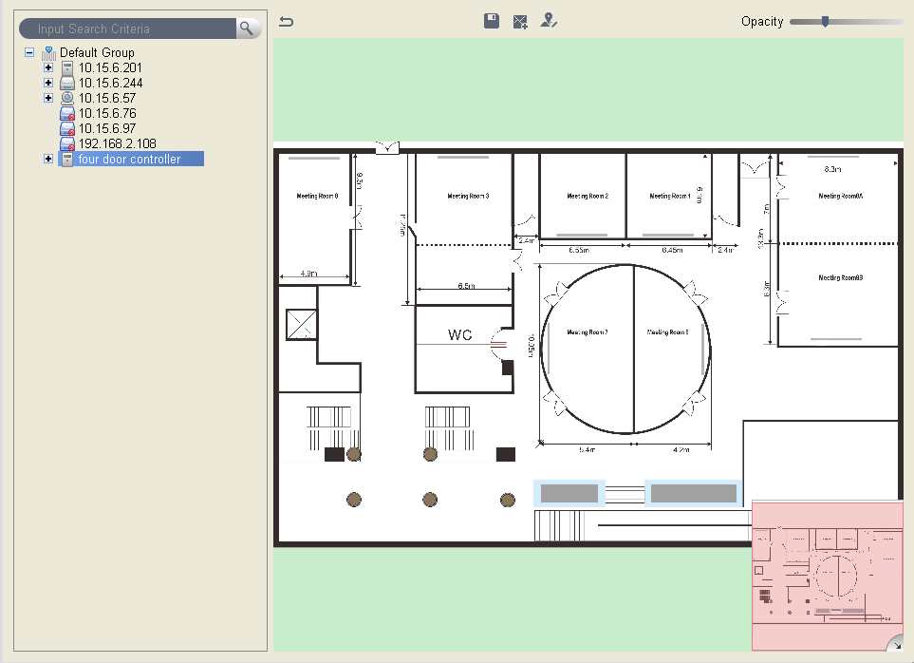
Figure 4-57
You can right click at access device node and operate device, see Figure 4-58.

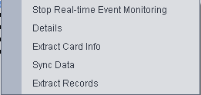
Figure 4-58

Parameter | Note
Real-time Monitoring | Real-time extract device event info.
Details | Device details search, including: device name, device IP, device type, device model, device status, SN, and version.
Extract Card Info | Extract device stored card info and fingerprint info, support to export
Sync Data | Delete all device info（excluding card record and alarm record），sync user data with device, the data include right, （user-related, period）, anti-pass back, inter-lock, first card unlock and multi-card unlock.
Extract Records | Extract device card records and alarm records within 30 days
You can right click at access channel node, and operate device, see Figure 4-59.

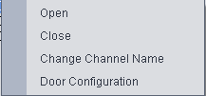
Figure 4-59
Parameter | Note
Open/Close | Client remotely open/close door.
Change Channel Name | Edit channel name
Door Configuration | Door parameter setup, please see Figure 4-60.

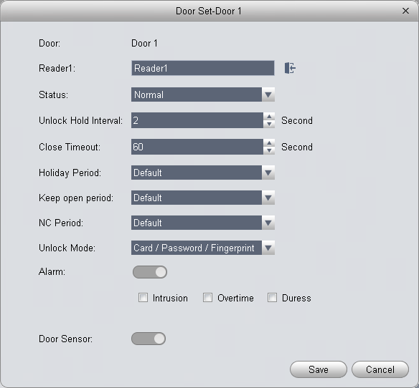
Figure 4-60

- Reader (card reader): support naming of reader, and setup of entry/exit status. The following is default setup.
  - Single door one-way: 1 in 2 out.
  - Dual door two-way: 1/3 in, 2/4 out.
  - Four door one-way: 1/2/3/4 in
    - Access status: normal, NO, NC
    - Door lock hold time: 1s~600s.
    - Door not locked timeout: 1s~9999s.
    - NO period: within access period, door is normally open; close by default.
    - NC period: within access period, door is normally clock; close by default.
    - Holiday period: within access period, in holiday period, holiday period has priority; null by default.
    - Unlock method: support card, password, fingerprint, card+password, card+fingerprint, card or password or fingerprint, by period.

Note:
When a door is set to multi-card unlock, unlock method is invalid, see Ch 4.6.3.17.
    - By period: support Monday-Sunday, four periods per day, each period supports a different unlock method.
    - Alarm enable:
Duress: forced to swipe card, alarm occurs
Intrustion: instrusion, alarm occurs
Timeout: door not locked, alarm occurs
    - Sensor enable: door open status is judged according to door sensor

You can right click within tree range to achieve one-level directory grouping and tree sequence, see Figure 4-61.
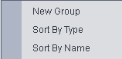
Figure 4-61

Parameter | Note
New Group | Level 1 directory grouping.
Sort by Type | Sequence according to device/channel type.
Sort by name (default) | Sequence according to name.

You can right click in e-map node, and edit, delete and rename e-map.
Global control can achieve one-click NO/NC of all access channels under emergency.

List/View
In list mode you can achieve access live preview and monitoring, see Figure 4-62.

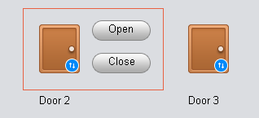
Figure 4-62

You can preview video and e-map in view mode, see Figure 4-63.
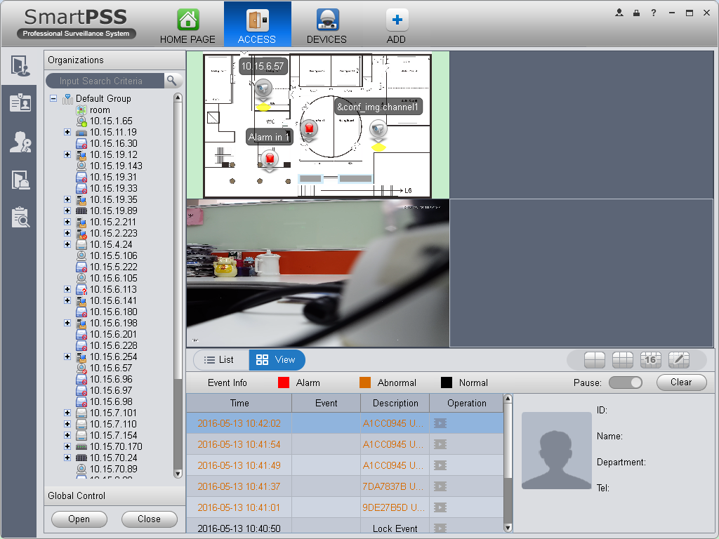
Figure 4-63
- Video preview: please refer to Ch 4.1.1.
- E-map preview: After you edit map, you can drag e-map into video window for preview. Scroll your mouse to zoom in/out; click (or move mouse to range within camera) camera icon on mao to open video, right click access control on mao to enable/disable access.
- Right click in e-map preview window, see Figure 4-64.
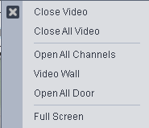
Figure 4-64
Parameter | Note
Close Video | Close current e-map window.
Close All Video | Close all video windows.
Open All Channels | Open all channels on e-map
Video Wall | Output all video channels in e-map to video wall
Open All Doors | Open all accesses on e-map
Full Screen | Display current window in full screen

You can click 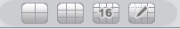 to siwtch video format. The first three formats are standard formats in your favorites, click to split interface, see Figure 4-65.
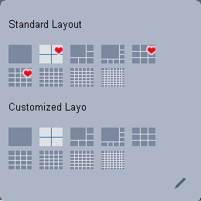
Figure 4-65

You can click add to favorite icon (red heart) to add format into favorties.
Standard split: 1, 4,6, 8, 9, 16, 25, 36, 64.
Custome split: there are 9 types of custom split, see Figure 4-66.
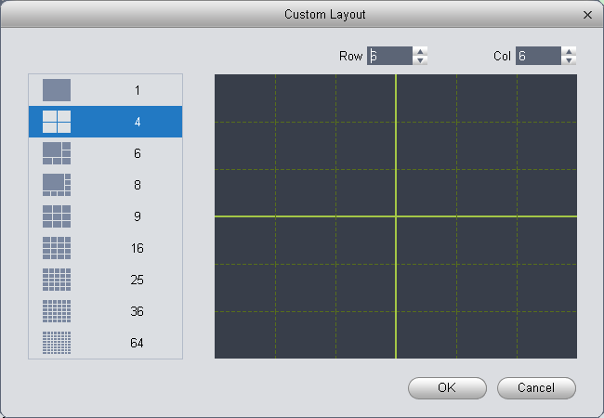
Figure 4-66

Event
You can view all live preview access events and their details of monitored device, see Figure 4-67.
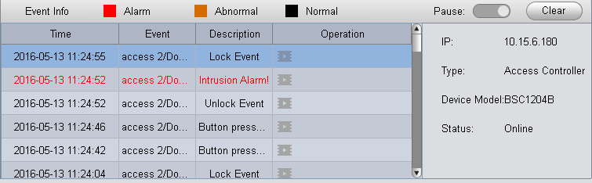
Figure 4-67

Parameter | Note
Lock | Lock event in current event info, during the period the locked event will not be shown in list but user can search for it in log.
Clear | Clear event in current event info, not delete it from log.
User Info | User info: photo, name, department, tel
Device Info | Device info：device IP, device type, device model, device status（online, offline）

User Management
In Access interface, you can click 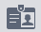 on the left to enter User Management interface, to manage all users. See Figure 4-68.
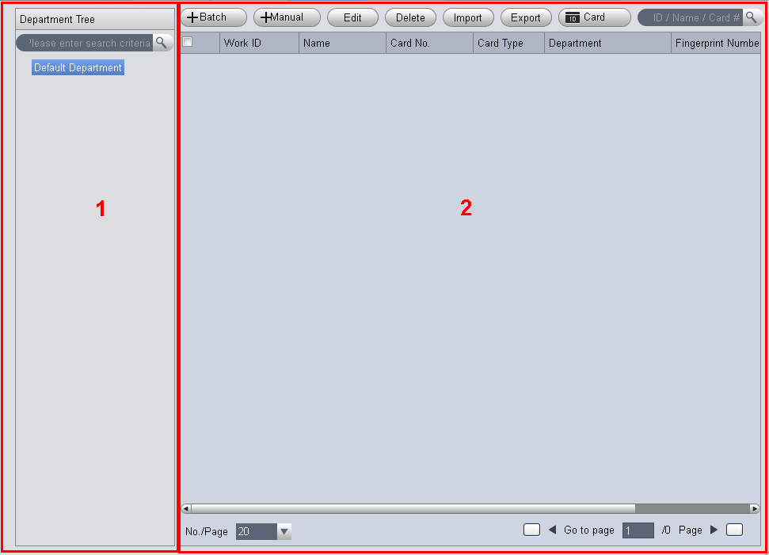
Figure 4-68

No. | Parameter | Note
1 | Department Tree | Department management, support to add/delete/edit department organization
2 | User Info | User management, show corresponding user info under department node. Sort card issuing, lost, frozen, edit and etc. of user.  Sort user.

Department Management
At department node or blank area in department tree, you can right click to operate, see Figure 4-69.
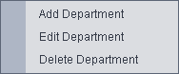
Figure 4-69

Parameter | Note
Add Department | Add department sub node or level 1 department node.  Name of departments at same level cannot be repeated.
Edit Department | Edit department name.
Delete Department | Delete existing department.  You cannot delete department which contains user.
Search Department | Support search of department node keyword

User Management
In User Management interface, you can click button, select type of card you use, see Figure 4-70.
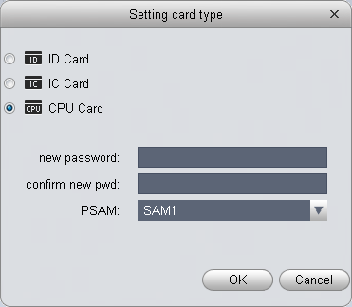
Figure 4-70

It supports ID/IC/CPU cards, and CPU can be encrypted.
Warning:
If card type and card reader do not match, then you cannot read card no.!

In User Management, youc an click button to manually add user info. User info mainly includes basic info, fingerprint, details, see Figure 4-71 to 4-73.
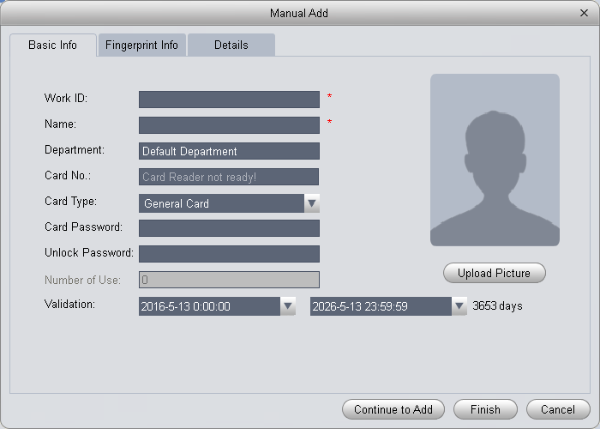
Figure 4-71

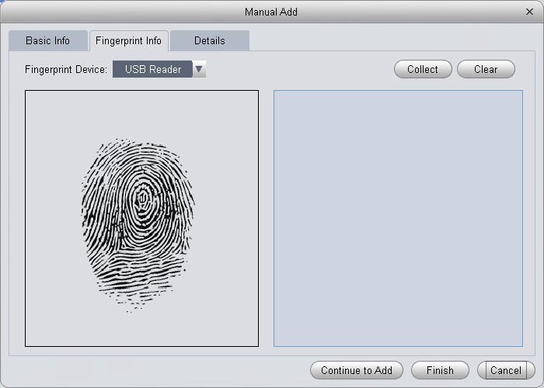
Figure 4-72

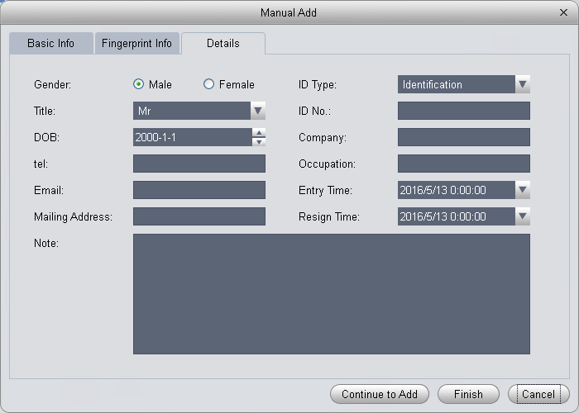
Figure 4-73

Parameter | Note
Basic Info | Word ID【mandatory】  Name【mandatory】  Department【auto associate】  Card no.：input by card reader and manually  Card type：general card, VIP card, guest card, blacklist card, patrol card, and duress card  Unlock password：only used for unlock via password  Card password：used for card+password unlock  Number of use：only for guest card  Validity：card validity, 10 years by default  Picture：user photo, max 120K
Fingerprint Info | Collect fingerprint via fingerprint device and reader  V1 fingerprint: Each user can have up to 3 fingerprints  V2 fingerprint: Each user can have up to 2 fingerprints  Support input of fingerprint name
Details | Gender, title, education and etc.

Warning:
Word ID and card no. cannot be repeated!

In User Management interface, you can click button to batch issue card, see Figure 4-74.
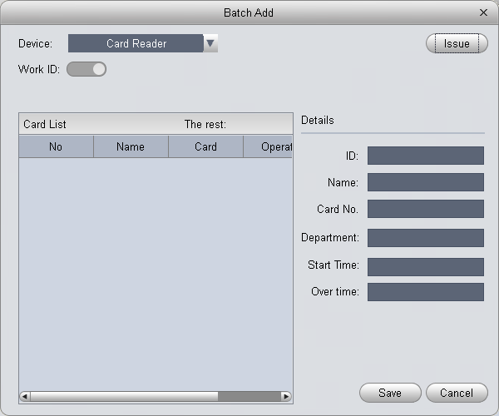
Figure 4-74

Parameter | Note
Batch Issue Card by User | Step：  Manually check user to want to issue card to 【auto filter out users already have card】  Click Batch  User select card issuing device: support card issuer and card reader of controller.  Click read card no, and device starts to read.  Place card on device, link user to card no. one by one.  Click save to complete card issuing.
Batch Issue Card by Work ID | User click to batch issue card  Enable  Enter starting word ID【auto filter out users already have card】  Click to get user and complete adding user to have card.  Click read card no., so device starts to read card no.  Place card on device one by one to link card to work ID by sequence.  Click save to complete.

In User Management, you can click button to edit user, see Figure 4-75.
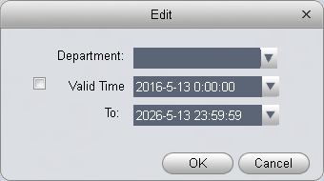
Figure 4-75

Parameter | Note
Department | Check user you want to edit.  Click Edit.  Select new department.  Click OK.  Complete.
Validity | Check user you want to edit.  Click Edit.  Check valid time.  Set time.  Modified valid time will be sent to device.  Complete.

In User Management interface, click button to delete user. Check user you want to delete, click Delete. Confirm that all information and rights of the user you are doing to delete will be deleted from the device.
You can click either of to import/export user info.
Import/export info includes: work ID, name, card no., card type, department, fingerprint name, fingerprrint name.

Note:
During data importing, it auto generates department.

Warning:
If imported data (word ID/card no.) already exists, it will not import the information.
In User Management interface, you can click .
Parameter | Note
 | Modify user info.
 | Delete user info.
 | Clear user card no. and delete card info in device.
 | Freeze card no. in device. You can click unfreeze if you want to restore frozen card.
In User Management interface, you can click to search keyword of user.
Note:
Work ID and name suopport fuzzy search.
Card no. supports accurate search.

Permission Management
In Access interface, you can click  on the left to enter Permission Management which allows management of right about user issuing card.

Door Group Right
In User Management interface, you can click door group right, and set a specific period of time, a specific door or door group can be unlocked via verification, see Figure 4-76.
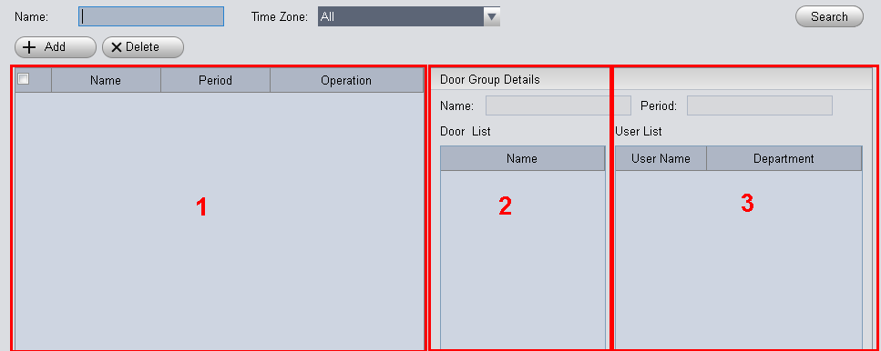
Figure 4-76
No. | Parameter | Note
1 | Door Group Info | Client door group info list
2 | Door Group Details | Details of current door group
3 | User Info | User right info of current door group

In Door Group Right interface, click , see Figure 4-77.
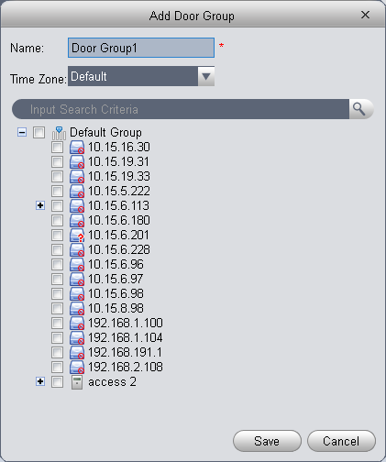
Figure 4-77

  - Enter name of door group, which cannot repeat existing door group name.
  - Select access period.
  - Check door, click Save.

Click button to re-edit door group info.
Wanring:
Door group name cannot be repeated!
In Door Group Right interface, lcick to add use right, see Figure 4-78.
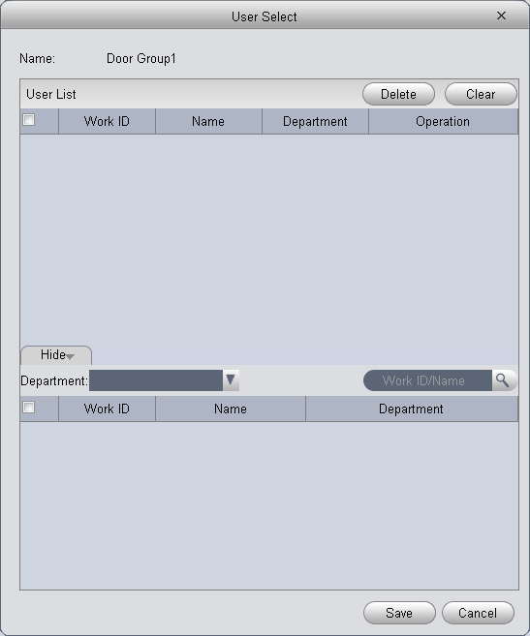
Figure 4-78
No. | Parameter | Note
1 | User List | Existing user info with door group right
2 | Search List | Info of user without door group right

- In search list dropdown list, select department of user you want to add or directly enter Word ID or name.
- In search list check searched user and add to list.
- You can delete user who already has right.
- Click Save, to complete the selected user into all door groups.
Note:
In search list filter out user who do not have card no. info.
In Door Group Right interface, you can click button to delete all information and right of the door group in the system.

Warning:
During right issuing process, please sure client and device are will connected.

User Right
In User Management interface, you can click in User Right interface to add specific user into access right list, or delete specific user from list.
- Check or cancel checked door group.
- Click OK as to confrim cancellation or adding of personal user right.

First Card Unlock
In Permission Management interface, click First Card Unlock, you button to set within specific period, only when user with first card unlock right pass verifiction for the first time, door status will be normal or NO and will be close after this period ends, see Figure 4-79.
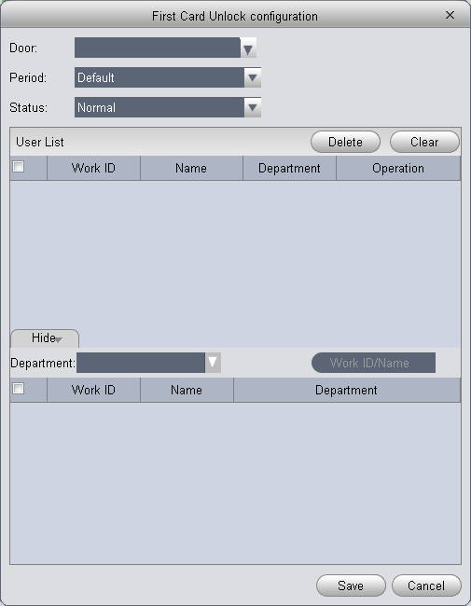
Figure 4-79
- Select to enable first card right door.
- Select period.
- In search list, selete user with first card right.
- Check user.
- Click Save.
Wanring:
For user who is auto filtered out in search list due to lack of right of the door, he/she must be given right of this door by first card right holder.

Multi-door Lock
You can click Multi-door Lock to set that a specific door can be unlocked only when specific users of a group all pass verification in a specific order. Before verification is passed, the users must verify in the designated order. You can click User Group Management button to set group info. See Figure 4-80.
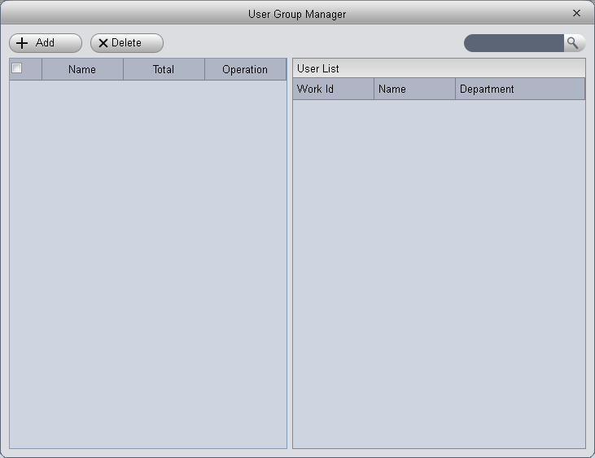
Figure 4-80

- In User Group Management interface, click , see Figure 4-81.
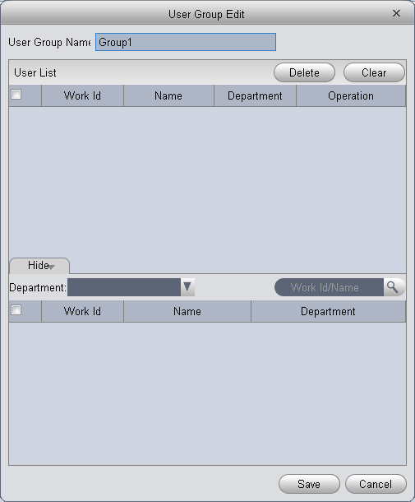
Figure 4-81

- Select group member.
- Save to complete adding.
- In Multi-door Unlock interface, click .
- Select door you want to enable multi-door unlock.
- In Multi-door unlock setup interface, check group.
- Fill in valid number of user for each group.
- Select unlock methof for each gourp. (card, password and fingerprint).
- Click to adjust sequence of unlock.
- Click Save.

Note:
A group can contains up to 64 users.
A door with enabled multi-card unlock supports up to 4 groups to verify at the same time, total number of user cannot exceed 64; total valid user cannot exceed 5.

Anti-pass Back
In Permission Management interface, click Anti-pass Back to set verification user. A user verifies at door A must verify at door A again when exits since card record must match one to one. If a user does not verify when enters, he/she will not pass verification when exits.
You can click in Anti-pass Back interface. See Figure 4-82.

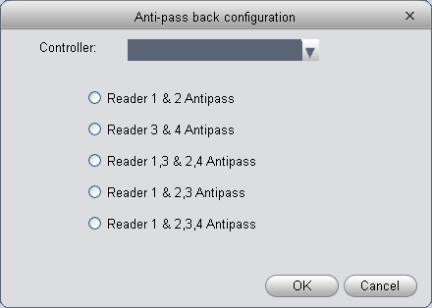
Figure 4-82

- Select access controller to use anti-pass back.
- Select anti-pass back rule according to access controller.
- Confirm.

Note:
Rule of anti-pass back:
Unit/single door controller: door reader anti-pass back.
Dual door controller/four door controller: reader 1 and 2 anti-pass back, reader 3 and 4 anti-pass back, reader 1/3 and 2/4 anti-pass back, reader 1 and 2/3/4 anti-pass back.
Four door controller: reader 1 and 2 anti-pass back, reader 3 and 4 anti-pass back, reader 1/3 and 2/4 anti-pass back, reader 1 and 2/3 anti-pass back, reader 1 and 2/3/4 anti-pass back.

Inter-door Lock
In Permission Management interface, click Inter-door Lock, to set inter-lock between two doors on one access controller. When one door is unlocked, other doors will be locked. If you want to unlock one door (under normal status), all of the others shall be locked, otherwise you cannot unlock this door.
You can click in Inter-door Lock interface. See Figure 4-83.
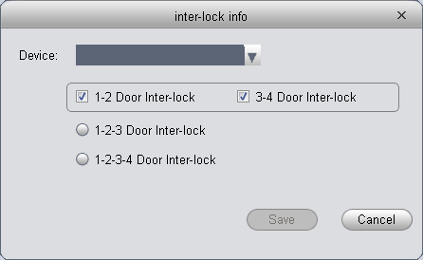
Figure 4-83

- Select access controller to inter-lock.
- Select rule of inter-lock.
- Confirm.

Note:
Role of inter-lock:
Single door controller has no inter-lock.
Dual door controller: 1-2 door inter-lock.
Four door controller: 1-2 door inter-lock, 3-4 door inter-lock, 1-2-3 door inter-lock, 1-2-3-4 door inter-lock.

Remote Verification
In Permission Management interface, you can click Remote Verification to ask the client to let user who passes verification enter within certain period, and admin will judge whether to unlock or not. You can click in Remote Verification interface. See Figure 4-84.
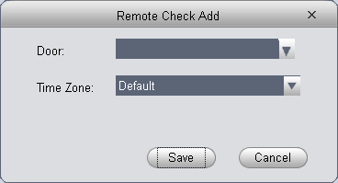
Figure 4-84

- Select door and time to enable remote verification.
- Save.

Period Setup
In Permission Management interface, click Period Setup to set specific reader to be valid with specific period and not valid on other periods, as well as set that user can only access a specific door within a specific period. Period is used for NO period, holiday period, first card period, remote verification period, door group right period; you can click in Period Setup interface, see Figure 4-85.
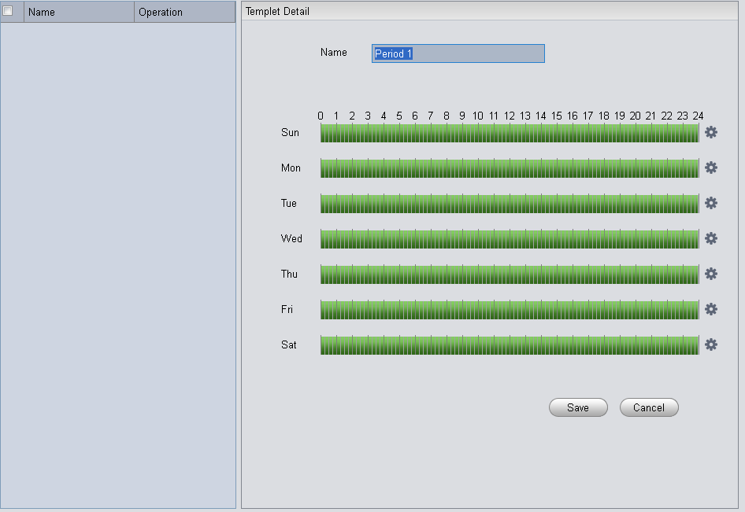
Figure 4-85
- Enter period name.
- Select daily period for Monday to Sunday.
Note:
A device supports to 128 periods setup with daily limit of 4 periods.

Holiday Setup
In Permission Setup interface, click Holiday Setup to set different access period from general period. You can click in Holiday Setup interface. See Figure 4-86.
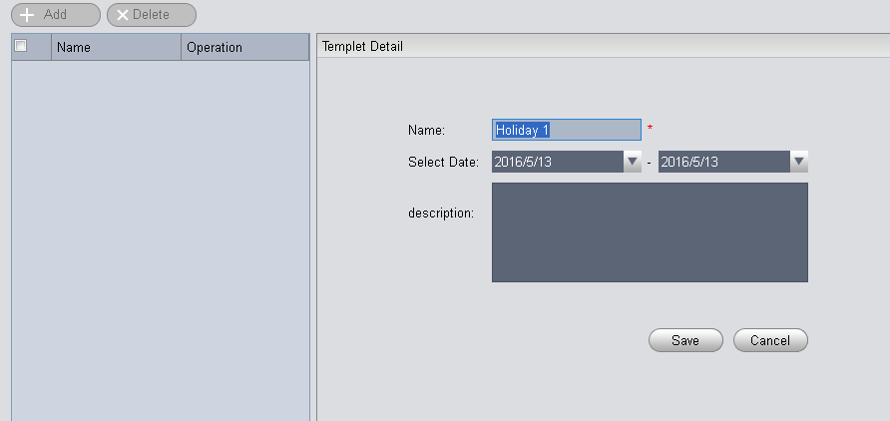
Figure 4-86
Note:
Within holiday period, holiday has priority in execution. Holiday period is for access only.

Event Configuration
In Access interface, you can click Event Configuration. You can set that when a input point inside access system triggers a specific event, client will have video link(live preview/record), link event includes: alarm, abnormal, normal event, link event pop-up plus display in log.
Please refer to the following for configuration of event scheme.
- Click Add.
- Set name and event type, select channel and check Enable. Event type includes alarm event, abnormal event and normal event. See Figure 4-87.
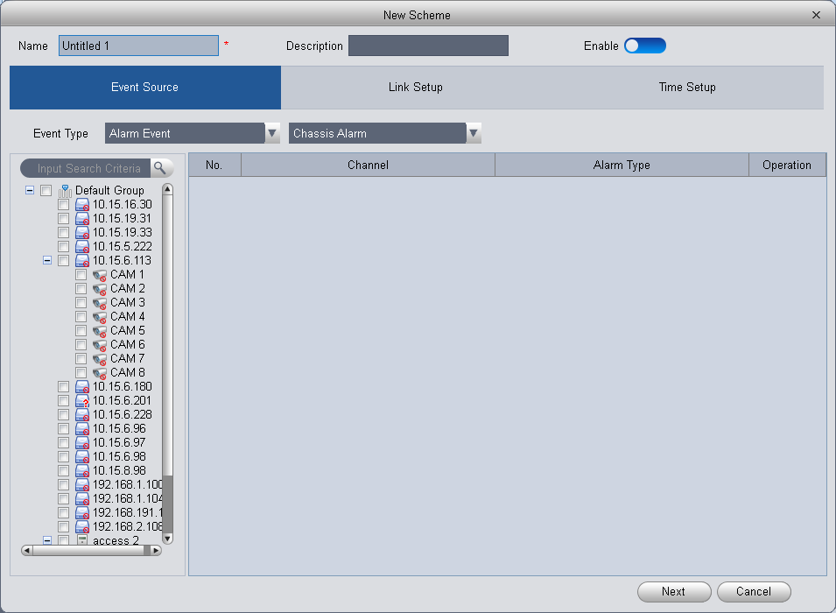
Figure 4-87
- Click Next, set link video channel.
- Under Link Setup tab, drag channel and set link channel, window no., stay time and etc. of link channel. See Figure 4-88.
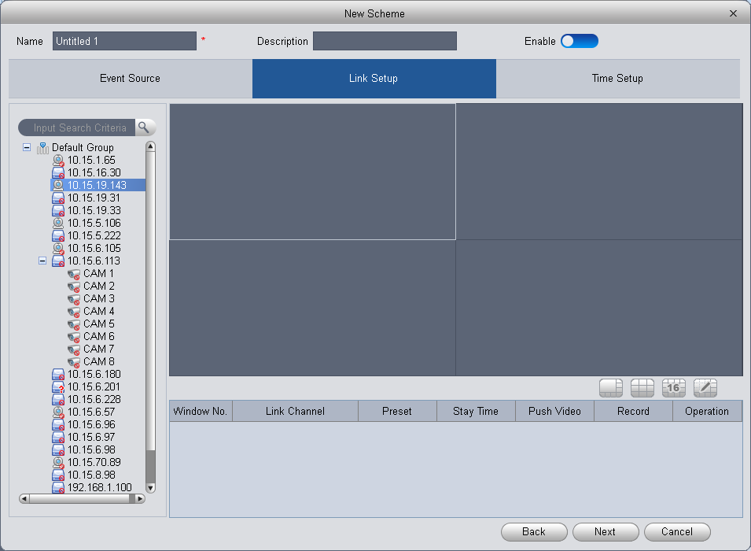
Figure 4-88

Note:
Stay time range is 5s to 180s.

- Click Next and configure scheme time. See Figure 4-89.
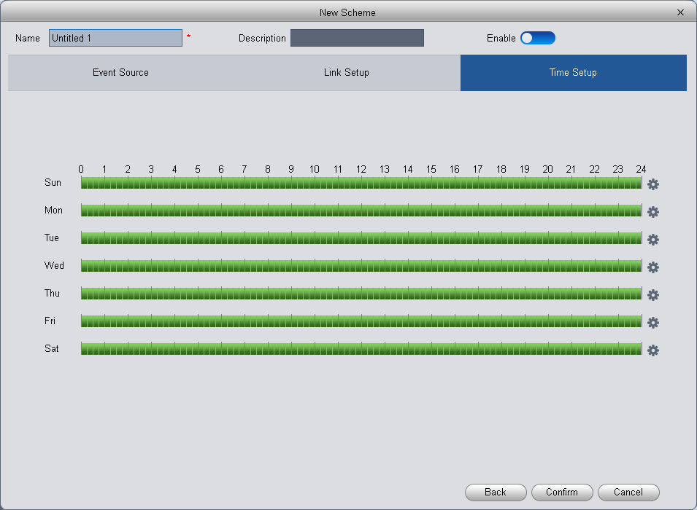
Figure 4-89
- Behind each week, there is , click it to set accurate time each day.
- Click Confirm. See Figure 4-90.
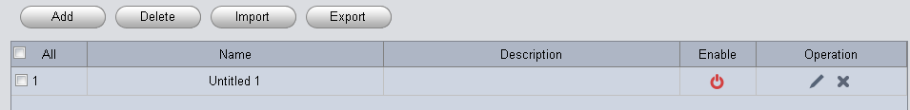
Figure 4-90
You can modify, delete, disable, enable scheme, as well as batch impoty/export scheme.
Event Type | Description
Alarm Event | Chassis alarm：alarm triggered when card reader of the controller is forced to be removed.
Alarm Event | Intrusion alarm：Excluding normal door open conditions, other door open conditions detected by door sensor 1
Alarm Event | Duress alarm：Alarm triggered when door is opened by duress card (fingerprint).
Alarm Event | Door left open alarm：door remained open exceeding set time
Alarm Event | Blacklist alarm：Alarm triggered when door is opened via card on balcklist.
Abnormal Event | Unauthorized or card lost: alarm triggered when the card has no right to unlock this door or it has been reported lost.
Abnormal Event | Card suspended：After the card is suspended, it cannot be used. Event is triggered at verification.
Abnormal Event | Unlock mode error：Event triggered when verification method and unlock method do not match.
Abnormal Event | Card validity error：Alarm is triggered when current time is not within card validity.
Abnormal Event | Period error：Alarm is triggered when verification of current period is not in access period.
Abnormal Event | Holiday unlock period error：Alarm is triggered when verification of current period is not in holiday period.
Abnormal Event | Incorrect first card：enable first card right, alarm is trigged when user unlock not using first card.
Abnormal Event | Inter-lock mode：Door with set inter-lock rule is unlocked, alarm it triggered when the other door is unlocked.
Abnormal Event | Anti-pass back mode: When one enters via verification but exits without verification, alarm is triggered at his/her next verification for entry.
Normal Event | Lock event：triggered when auto lock or door sensor detects door is locked
Normal Event | Card unlock：Triggered after passing card verification, door is unlocked
Normal Event | Fingerprint unlock：Triggered when door is unlocked after passing fingerprint verification.
Normal Event | Card + fingerprint unlock：Triggered when door is unlocked after passing card and fingerprint verification.
Normal Event | Card +password unlock：Triggered when door is unlocked after passing card and password verification.
Normal Event | Password unlock：Triggered when door is opened via password.
Normal Event | Button unlock：Triggered when door is opened via button.
Normal Event | Multi-card unlock：Triggered when the first card in multi-card unlock mode passes verification.
Normal Event | Remote verification：Triggered when a user passes device verification and is asking for client verification for door under remote verification.

Log
In Access interface, you can click Log. You can search for log according to criteria.
- Select start time and end time. Max interval between start time and end time is 2-day.
- Enter name or work ID of user.
- Select verification method.
- Select user entry/exit status.
- Select device and door you want to search.
- Select detailed event you want to search.
- Click Search, see Figure 4-91.
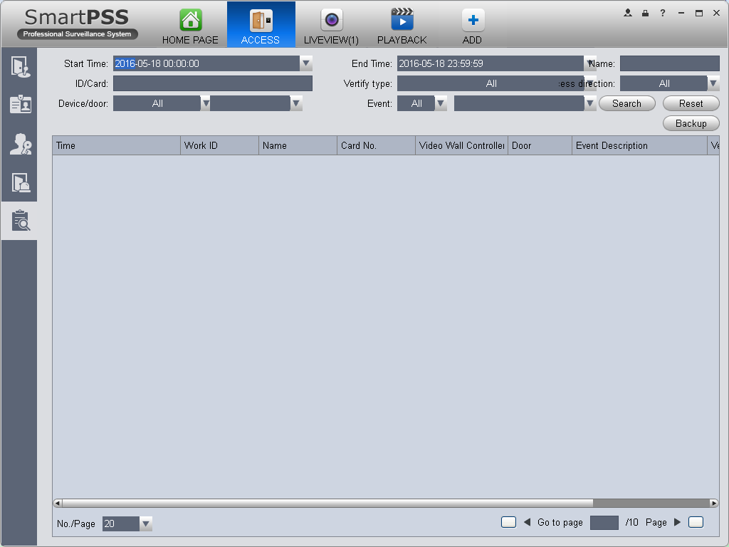
Figure 4-91

You can reboot search criteria, export search result and view record.
- , reset criteria.
- , export searched log.
- , view record.

Attendance
In Attendance interface, click , you can set attendance info to achieve user shift and statistics.

Attendance
You can customize attendance rule, multiple period, holiday setup, attendance device to meet different scenes.
- Attendance Device
Attendance device is used to set user sign in range, validly and effectively count important data.
You can check channel on the left in organization tree as attendance device. The system auto set the selected channel into attendance device, see Figure 4-92.

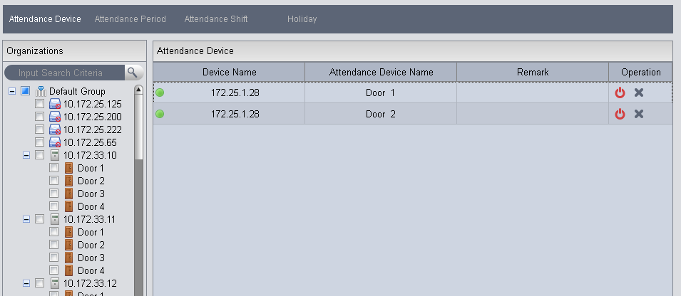
Figure 4-92
Note:
Up to 20 attendance devices.

- Attendance Period
Attendance period is used for user to account different sign in/out, late, early leave, absence, and etc. You can click Add button to enter period name. See Figure 4-93.
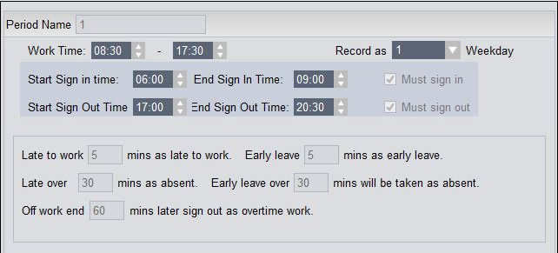
Figure 4-93

Note:
Start time must be within the range between start sign in and end sign out time.
End time must be within the range between start sign out and end sign out time.

Cross Day
See Figure 4-94. When end sign out time is earlier than start sign in time, the system is in cross-day mode be default.
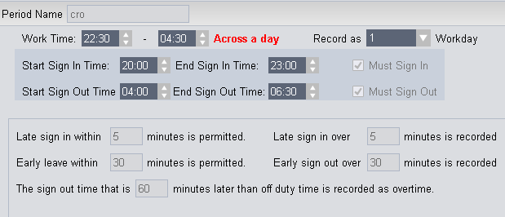
Figure 4-94

Dual Period
See Figure 4-95 and Figure 4-96.
Figure 4-95
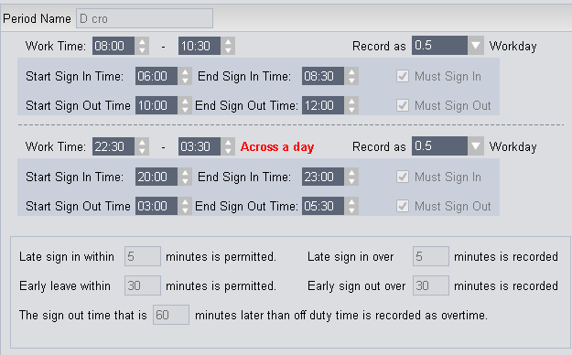
Figure 4-96
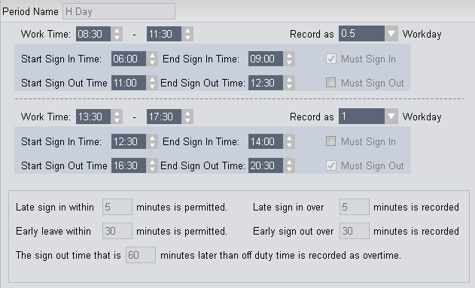

Note:
When the first sub period crosses one day, you cannot add the second sub period.

- Attendance Shift
Attendance shift is used to link period within cycle peiord, it supports cycle by week, month and day. See Figure 4-97.
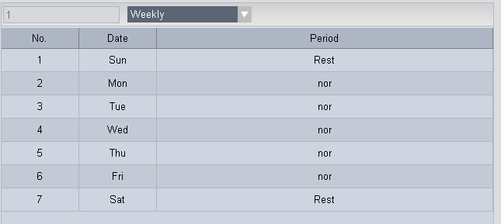
Figure 4-97
- Attendance Holiday
Holiday setup is used for unified employee woek off within the range of holiday, see Figure 4-97.
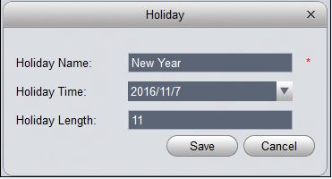
Figure 4-98

User Shift
You can set user shift in Shift Select, as well as batch set temporary arrangement:
- Check shift user on the left.
- Click button on the right.
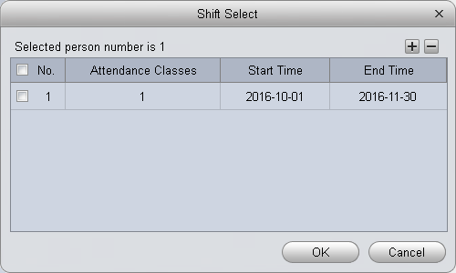
Figure 4-99

- User click button to add user shift info. Set hift user times and start/end date, click OK. See Figure 4-100.
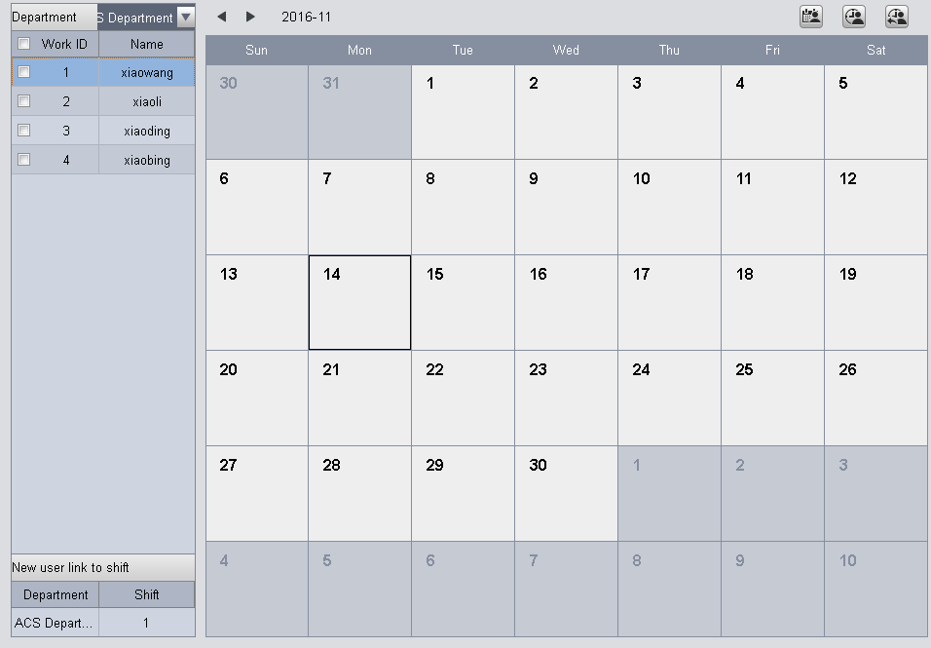
Figure 4-100

- You can link new user shift of this department. When a user has set linked shift, all new users under this shift will be auto arranges in shift from the date of setup, vallid time period is 10 years.

Note:
If this department does not have linked shift of new user, its father node become valid.

Temporary Shift
You can select user you want to add for temporary shift. Double click date of temporary shift in calendar, or batch check users and then select date of temporary shift , click ， see Figure 4-101.
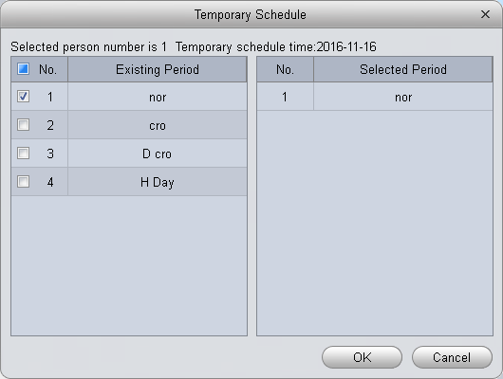’
Figure 4-100
Re0select or cancal period cancelled for temporary setup, see Figure 4-102.
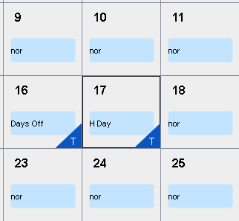
Figure 4-100
You can select user, right click date with existing temporary shift, select to cancel temporary shift; or batch check users who you want to cancel their temporary shift and then select date with existing temporary shift , click
Note:
If no period selected, it is days off.

Report Search
You can directly view attendance data in report search, see Figure 4-103 and Figure 4-104.
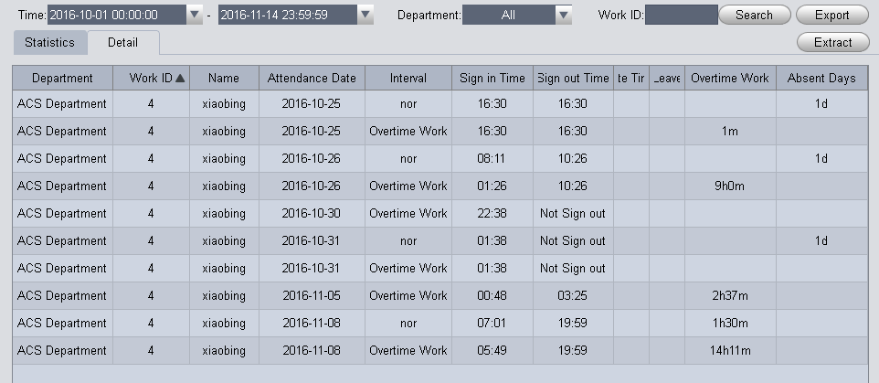
Figure 4-100

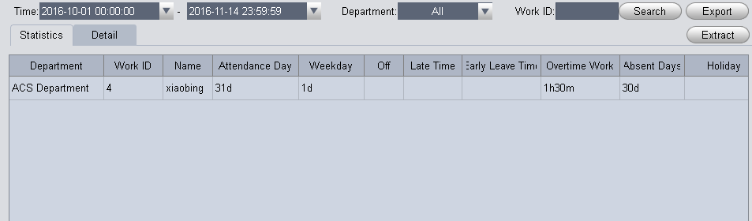
Figure 4-100

Note:
When the client if close so cannot get attendance data, a user can Extrat. The system will ectract data of all attendance devices. Please be patient, this process can be long.

Extension

Video Wall
After you set video wall setup (chapter 3.10 ), you can output video to the video wall. You can follow the steps listed below to set.
- Click icon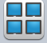 on the homepage, you can go to the following interface. See Figure 5-1.
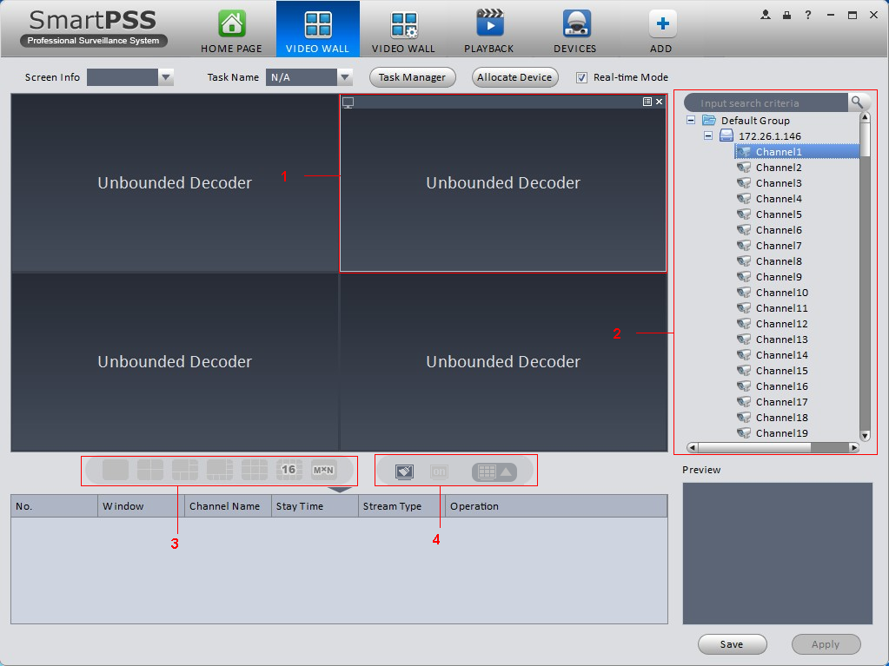
Figure 5-1

SN | Item | Function
1 | Video window | Connect to NVD：Video window is fixed, cannot be dragged.  Connect to M30 ：Video window can be moved, max is 16.
2 | Video channel | -
SN | Item | Function
3 | Video open window | Connect to NVD: Select one video window, click 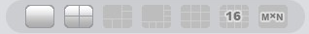to open 1*1, 2*2, 3*3, 4*4 layouts of windows.  Connect to M30：Click 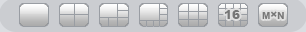 to open 1*1, 2*2, 3*3, 4*4 or M*N layouts of windows.
4 | Clear screen, open/close window | ：Clear all video channels or layouts on screen.  ：Screen on/off setup，to open/close TV wall displsy.  ：Clear screen and open window.

- Select corresponding video wall from the screen information dropdown list. You can check to select real-time mode if necessary. Once you enable real-time mode, system automatically output the video to the video wall after you complete the setup. Otherwise, it does not output the video to the video wall.
- Drag the channel on the right pane to the corresponding screen and then binding.
You can view details of binding video in Internet Explorer.
- In IE, enterM30 or NVD device’s IP address.
- Download web service pack.
- After download is complete, system pops up login interface.
- Enter username and password, click Login to view details of bound video source.
Default username and password is admin/admin.

- Click save as task button, you can see system pops up a dialogue box for you to input task name.
- Please input task name and click Save button.
- Click Output video.

Please note:
  - You can select video wall task from the task name dropdown list and then click the Output video button to view the video.
  - Click task manager, you can view current task status. Or you can select one task and click or to modify or delete current task.

Data Report
The system supports to view flow chart statistics, and generate report for data comparison.
- Click  in Advanced area.
- Check channel on the left, set search time, click Search.
See results in Figure 5-9.
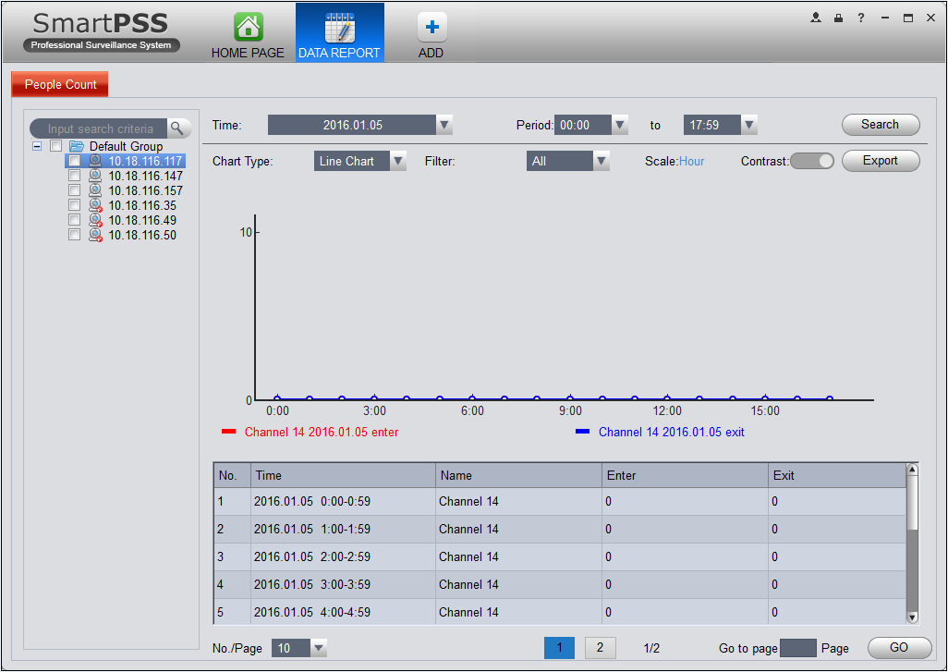
Figure 5-2
- Chart Type：line chart and histogram.
- Time：today, this month, this year, optional.
- Filter：filter inflow and outflow.
- Contrast：Contrast by time or by channel, max 5 records of contrast data.
- Export：can export flow statistical data in format of excel file.

Log
Log interface is shown as in Figure 5-9.
- In homepage, click in BASIC area.
- Select Client log and select start time/end time, and select type from the dropdown list. Click Search button, you can see the log information.
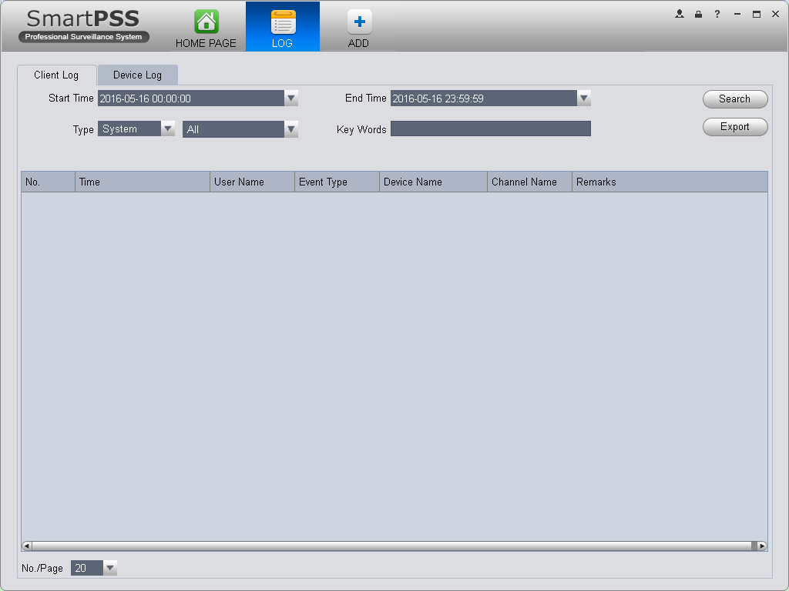
Figure 5-3

- Click Search. See Figure 5-10.
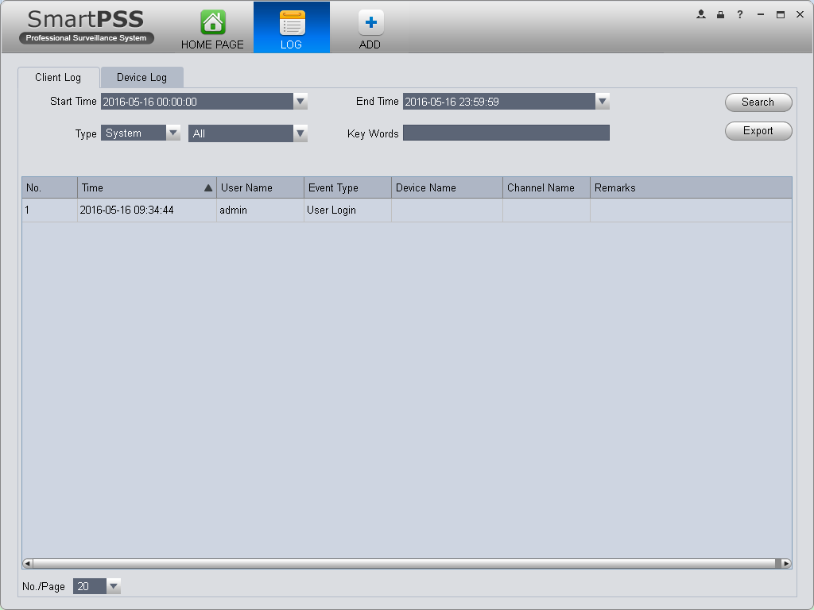
Figure 5-4

- Click Device log tab.
- Select start time/end time, type and device name from the dropdown list.
- Click Search button. See Figure 5-11.
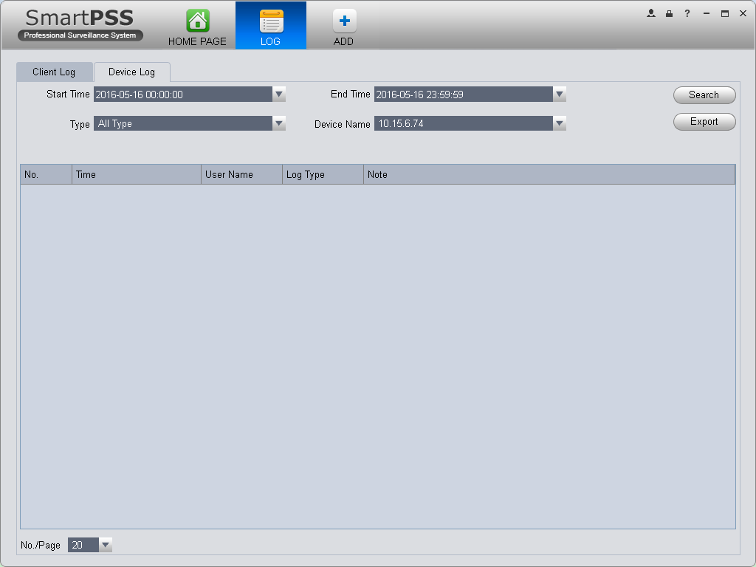
Figure 5-5

Note:
- This manual is for reference only. Slight difference may be found in the user interface.
- All the designs and software here are subject to change without prior written notice.
- All trademarks and registered trademarks are the properties of their respective owners.
- If there is any uncertainty or controversy, please refer to the final explanation of us.
- Please visit our website or contact your local service engineer for more information.

